# **VIRTUALSHRINE: AN INTERACTIVE MUSEUM WEBSITE FOR CASA REAL SHRINE**

___________________________

A Capstone Project Paper Presented to the Faculty of the

College of Information and Communications Technology

Bulacan State University

___________________________

In Partial Fulfilment of the Requirements for the Degree of

Bachelor of Science in Information Technology  
___________________________

By:

**Claro, Sharvien Paul M.**

**Gabutina, Carlo Elijah R.**

**Mergal, Jhan Mar D.**

**Mauricio, Angelo D.**

**Nacional, Kristine Joy S.**

**Navarro, Rovi Keith Y.**

**Tapang, Jhel Ansel D.**

1st Semester 2022-2023

# **APPROVAL SHEET**

In partial fulfillment of the requirements for the degree of Bachelor of Science in Information Technology, this capstone project entitled **“VIRTUALSHRINE: AN INTERACTIVE MUSEUM WEBSITE FOR CASA REAL SHRINE”** has been prepared and submitted by **SHARVIEN PAUL M. CLARO, CARLO ELIJAH R. GABUTINA, ANGELO D. MAURICIO, JHAN MAR D. MERGAL, KRISTINE JOY S. NACIONAL, ROVI KEITH Y. NAVARRO, AND JHEL ANSEL D. TAPANG** who are hereby recommended for oral examination.

**MA. RUBY ANGELA CRISOSTOMO, MSIT**

Adviser

Approved in partial fulfillment of the requirements for the degree of **Bachelor of Science in Information Technology** by the Committee on Oral Examination.

**LYKA DL. SAN PEDRO**

Critic/Member

**TERESITA S. MANGAHAS, MEP CPE**

Critic/Member

**MAYLEEN DORCAS B. CASTRO, DIT**

Capstone Project Coordinator

**LILIBETH G. ANTONIO, MSIT**

Chairman

Accepted in partial fulfillment of the requirements for the degree of **Bachelor of Science in Information Technology**.

**KENO C. PIAD, DIT**

College Dean

**GABRIEL M. GALANG, MSIT,**

**GK-CDPO, PCEP, CLE**

Area Chair, Web and Mobile Applications Development Track

**DIGNA S. EVALE, LPT, DIT**

Department Head, BSIT Program

**1st Semester 2022-2023**

# **ACKNOWLEDGEMENT**

To these people, who made all of this work possible, we reach our deepest and sincerest gratitude. Without them, our capstone would not have been working well and properly or worse, unfinished.

First and foremost, the proponents would like to acknowledge our capstone adviser, Angela J. Crisostomo who with her guidance, arrangements and advice that led us through all obstacles that put a hindrance in our progress and made possible through her arrangements that the proponents needed most.

To our capstone coordinator, Ma’am Mayleen Dorcas Castro, with her teachings and always reminding how we can be more professional in our work and proper ethical way of conducting our research. We thank you.

For the staff of Museo ng Kasaysayang Pampulitika ng Pilipinas, we thank you for agreeing to be our client and giving us the opportunity to make a website with our creative freedom towards developing it, Thank you all.

To our parents, we would like to acknowledge them for their non-stop support towards our goal and to our daily lives. Having them by our sides, guiding us always and their love for us.

Last but not the least, we thank you God for blessing us every day on our journey in developing our system and for answering our prayers and giving us strength despite all the odds that may have affected our will to push, we thank you so much.

***The Proponents***

# **DEDICATION**

This thesis is dedicated to my family, friend and my groupmates who have meant and still mean the world to me. Despite the fact that they are no longer among us, their memories still guide my life. It is also dedicated to our brothers, sisters, advisors, students, and employees who helped us with this effort and provided us with encouragement and advice. The work is then dedicated to the All-Powerful God. We are appreciative of your strength, bravery, and wisdom. We now hand them up to you all.

*S.P.M Claro*

I dedicate this thesis to my family, with their unwavering support, and friends who have meant so much to me. groupmates who, through their dedication and commitment to this thesis, have made it available to all. Lastly, our professors and advisers, with their guidance to teaching. To all of our family, friends, classmates, groupmates, professors, and advisers, who offered their support, guidance, encouragement, and patience that helped us to complete our work.

*C.E.R Gabutina*.

This work is devoted in its entirety to my dear parents, who have continuously provided their moral, spiritual, emotional, and financial support, served as a sources of inspiration and strength when I felt like giving up. To all of my brothers, sisters, family members, mentors, friends, and classmates who offered their support and encouragement in order for us to complete our study. Above all, I am grateful to God Almighty, who has blessed us abundantly in every aspect of our lives. In particular, we are grateful for His strength, courage, patience, wisdom, timing, and guidance as we completed this job.

*A.D Mauricio*

I dedicate this thesis to my family, who have always supported me no matter what. I want to express my sincere gratitude to Marvin and Janette, my devoted parents, for having faith in me to complete this thesis. To my devoted siblings who have never left me. To my partner, Elisha Joy, for being my biggest supporter and for reassuring me that I can complete this work. To our advisor and professors, who helped us finish our work by providing support, advice, encouragement, and patience. I really want to thank God, who made everything, for this thesis. He has given me the ability, knowledge, and wisdom necessary to complete this work.

*J.M.D Mergal*

I would like to dedicate this capstone project to my family and friends who have been a constant source of support, encouragement and love throughout this journey. From helping me brainstorm ideas to being my biggest cheerleaders, I can’t thank them enough. I am extremely grateful for my mentors who have guided me and helped me shape my thoughts and ideas throughout this project. I would like to thank my colleagues who provided me with valuable insights and feedback to make this project a success. Finally, I would like to thank all the individuals who have provided me with their feedback and expertise on the various aspects of this project. Their feedback has been invaluable and has helped me to take this project to the next level. Thank you all for your help and support!

*K.J.S Nacional*

I dedicate this study wholeheartedly to my parents, who have served as my inspiration and have provided me with strength when I felt like giving up. Who continually provide their moral, spiritual, emotional, and financial support. I also thank my brothers, sisters, relatives, mentor, friends, and classmates for their words of wisdom and encouragement as we worked to complete this study and extended their help in the midst of problems while doing this work. Finally, I give thanks to Almighty God for his direction, strength, courage, patience, wisdom, power, and guidance in realization of this work. We present all of these to you.

*R.K.Y Navarro*

This study is the result of the hardship of the researchers that are willing to share their knowledge to other people. This thesis is dedicated to my family who always supports me in my needs. You are an inspiration to me, and also to all my group mates who sacrifice their time and give their best to finish this study. A am also thankful to my friends, relatives, loved ones, proctor and adviser, who give us a support and guidance that we need and not giving up on us despite of the hardship that we encounter, their trust in us is our inspiration to finish and complete this work.

*J.A.D Tapang*

# **ABSTRACT**

This study was developed in order to assess the daily operations and its encountered problems of NHCP Museo ng Kasaysayang pampulitika ng Pilipinas, Casa Real. These problems were addressed and analyzed in the developed Casa Real Shrine website and web-based admin information and content management system of cases. The project covers the creation of interactive website, managing of contents uploaded on the website, user management, and reports generation. This study also covered resolving common IT-related problems upon implementation of the web-based management information system. This study was evaluated using standard web evaluation criteria by its intended users and experts.

The proponents conducted observations, interviews, and surveys to acquire the objectives of this study. The research methodology utilized in this project was the quantitative approach. Quantitative approach was applicable to this study as it aims to collect and understand the behavior of Casa Real Shrine’s visitors and how the proponent applied the results in the implementation of the VirtualShrine website. On developmental research, the proponents studied a process systematically, developed, and evaluated processes that met the set criteria for user’s acceptance to the developed system. The researcher used the Agile Software Development methodology to develop the web-based system. It was used to quickly produce the desired output while allowing the researcher to go back past phases without finishing the whole cycle.

For the acceptability of the developed Casa Real Shrine website, the researchers consulted with IT professionals from different fields, IT instructor from Bulacan State University, and the end-users or clients of the developed system such as the museum staff, students, local and foreign tourist. The evaluation form has the following criteria for software quality evaluation as follows: (1) functional suitability; (2) performance efficiency; (3) usability; (4) reliability; (5) security; and (6) portability. The researchers conclude that the developed website is usable and functional and provides a user-friendly UI/UX design to end-users and also proves that the system is reliable and secured based on the data gathered. The system is a catalyst in booking, storing, and protecting the records of the Casa Real Museum. With this, the following recommendations were drawn that can be a basis for future researchers who would want to develop the same type of museum website. (1) An enhance VR control capabilities in virtual tours that could focus on improving the user experience and accessibility of VR technology; (2) A Museum maps that could focus on exploring the use of augmented reality (AR) technology to enhance the visitor experience; (3) QR codes for audio guides in museums could focus on studying the effectiveness of this technology as a tool for enhancing visitor engagement and understanding of museum exhibits; and (4) Calendar integration for museum closures could focus on studying the effectiveness of different notification systems and strategies for informing researchers and other stakeholders about unexpected closures.

# **TABLE OF CONTENTS**

TITLE PAGEi

APPROVAL SHEETii

ACKNOWLEDGEMENTiii

DEDICATIONiv

ABSTRACTvi

TABLE OF CONTENTSvii

LIST OF TABLESx

LIST OF FIGURESxi

LIST OF APPENDICESxiv

**CHAPTER I. INTRODUCTION**

Project Context**1**

Purpose and Description**2**

General Objectives**3**

Specific Objectives**3**

Scope and Limitations of the Study**4**

**CHAPTER II. REVIEW OF RELATED LITERATURE/SYSTEM**

Related Literature**5**

The utilization of Interactive Website to Museums**5**

Online Booking Admission**6**

Virtual Gallery**7**

Virtual Tour Guide**8**

Digital Learning**8**

Related System**8**

**CHAPTER III. TECHNICAL BACKGROUND**

Project Methodology**12**

Conceptual Framework**13**

Conceptual Process of the System Development **14**

Initiation Phase**14**

Planning Phase**14**

Design Phase**15**

Development Phase**15**

Testing Phase**15**

Project Evaluation**16**

Implementation Phase**16**

Gantt Chart**16**

Requirements Analysis and Documentation**17**

Maintenance Phase**17**

System Specifications**17**

Hardware Requirements**18**

Software Requirements**18**

System Design and Processes**19**

System Flowchart**19**

Context Diagram**23**

Conceptual System Design**27**

System Architecture**27**

Security Matrix**28**

The Online Booking Reservation Process**29**

The Walk-in Admission Process**29**

Network Infrastructure**30**

The Developed System**31**

**CHAPTER IV. RESULTS AND DISCUSSION**

Part I. Development of VirtualShrine: An interactive

museum website for Casa Real Shrine**62**

1.1 Online Booking Reservation**62**

1.2 Virtual Museum Tour**64**

1.3 Gallery Collections**66**

1.4 User Assisting Features**69**

Part II. To design and develop a Management System**71**

2.1 Manage User Admins**71**

2.2 Accept and Reject Visitor Booking**73**

2.3 Upload Website Content**75**

2.3.1 Collections**75**

2.3.2 Exhibits**78**

2.4 Generate and Print Admin Activity Record**81**

2.5 Booking Confirmation through email

after reservation**82**

Part III. Software Quality Evaluation of the VirtualShrine:

An Interactive Museum Website for Casa Real Shrine**82**

**CHAPTER V. RESULTS AND DISCUSSION**

Summary of Findings**93**

Conclusion**95**

Recommendations**96**

**REFERENCES97**

**LIST OF TABLES**

1Hardware Requirements for the System**18**

2Software Requirements for the System**18**

3Security Matrix**28**

4Total Number of Respondents **83**

55-Score Likert Scale **84**

6Frequency Distribution and Descriptive Measures in the

Evaluation of the Developed Website in terms of

Functional Suitability **84**

7Frequency Distribution and Descriptive Measures in the

Evaluation of the Developed Website in terms of

Performance Efficiency **85**

8Frequency Distribution and Descriptive Measures in the

Evaluation of the Developed Website in terms of

Compatibility **86**

9Frequency Distribution and Descriptive Measures in the

Evaluation of the Developed Website in terms of

Usability **87**

10Frequency Distribution and Descriptive Measures in the

Evaluation of the Developed Website in terms of

Reliability **88**

11Frequency Distribution and Descriptive Measures in the

Evaluation of the Developed Website in terms of

Security **89**

12Frequency Distribution and Descriptive Measures in the

Evaluation of the Developed Website in terms of

Maintainability **90**

13Frequency Distribution and Descriptive Measures in the

Evaluation of the Developed Website in terms of

Portability **91**

14Overall Mean **92**

LIST OF FIGURES

Figure Page

1 Conceptual Model of the System Development**13**

2 VirtualShrine: An Interactive Museum Website for

Casa Real Shrine of Malolos Gantt Chart **16**

3Booking Admission Flowchart**20**

4Content Management Flowchart **21**

5Admin View VTOC **22**

6Context Diagram (Level 0)**23**

7Data Flow Diagram (Level 1)**24**

8Use Case Diagram **25**

9Entity Relationship Diagram (ERD)**26**

10The Client’s Access to the Website **27**

11Online Booking Process **29**

12Walk-in Admission Process **29**

13The Network Infrastructure **30**

14VirtualShrine Homepage **31**

15Data Privacy Issue disclaimer **32**

16Data Privacy Issue disclaimer – Warning Message **32**

17 VirtualShrine Booking Form **33**

18Booking Confirmation page **33**

19Access to the Virtual Tour Page **34**

20Virtual 360° **35**

21Virtual Tour Lobby **35**

22Virtual Tour Infor Popup **36**

23Virtual Tour Controller **36**

24Gallery Page **37**

25Galleries Collection Page **38**

26Display Description page **38**

27Plan Your Visit page **39**

28Exhibitions Page **40**

29Exhibition Overview Page**41**

30Exhibition Objects Page **42**

31Exhibition Objects Description Page **43**

32Audio Guide Page **43**

33Audio Guide Player **44**

34About Page **45**

35VirtualShrine Admin Login Page **46**

36VirtualShrine Admin Dashboard **46**

37VirtualShrine Assistant Admin Management Panel **47**

38Add Assistant Admin form **47**

39Edit Assistant Admin Information form **48**

40Pending Booking Panel **48**

41Booking Details**49**

42Attached File preview **49**

43Reject Booking form **50**

44Approved Bookings Panel**50**

45Rejected Booking Panel **51**

46Cancel Booking Panel **51**

47CMS – Collection Panel **52**

48Add Content form **53**

49Edit Content form **54**

50CMS - Exhibit Display panel **55**

51Add Exhibit Display form 5**6**

52Edit Exhibit Display **57**

53Gallery Category panel **58**

54Add Gallery Category **58**

55Edit Gallery Category form**59**

56Exhibits Panel **59**

57Add Exhibits panel **60**

58Edit Exhibit form**60**

59User Report panel **61**

60Print User Report **61**

61Booking Consent Form**62**

62Booking Form **63**

63Booking Submitted Confirmation Page **63**

64Access to the Virtual Tour Page **64**

65Casa Real Shrine Virtual 360 **65**

66Casa Real Shrine Lobby Virtual 360 **65**

67Galleries Page **66**

68Galleries Collection **67**

69Display Description **68**

70Plan your visit Page **69**

71Audio Guide **70**

72User Management **71**

73Edit User Information **72**

74Add New User **72**

75View All Pending Bookings **73**

76View More Booking Details **74**

77Attached File Preview **74**

78Content Management System - Collections **75**

79Content Management System – Edit Collection Information **76**

80Content Management System – Add new Collection **77**

81Content Management System – Exhibit Display **78**

82Content Management System – Add new Exhibit Display **79**

83Content Management System – Edit Exhibit Display **80**

84Activity Report **81**

86Printing Report **81**

87Email from the Administration **82**

**LIST OF APPENDICES**

Appendix Page

ALetter of Request for Capstone Adviser**100**

BLetter of Request for Capstone Panel Member**102**

CLetter of Invitation for Proposal Presentation**106**

DLetter for Client**111**

ELetter of Invitation for Final Capstone Defense**116**

FPanel Report **121**

GEvaluation Criteria for Software **128**

HRelevant Source Code**132**

IPlagiarism Certification **149**

JPlagiarism Certification (IMRAD)**151**

KIMRAD Certification (Adviser) **153**

LIMRAD Paper **155**

MCurriculum Vitae **162**

# **CHAPTER I**

**INTRODUCTION**

**Project Context**

The internet's global expansion over the years has impacted human activities through digital media, museums are evolving to adapt to the change and encourage young netizens to access and use museum materials (Chen, T. L., Lai, W. C., & Yu, T. K., 2021). However, capturing and maintaining the attention of visitors is an absolute challenge in today's world, where information can be found online. Along with the digital revolution, visitor expectations have shifted somewhere along the way, and museums are striving to meet the difficulties posed by this new wave of digital expectations from their visitors (Balanchine S., 2018).

In order to adapt with the changes in technology, museums need a visually appealing, informative, and entertaining website to attract visitors. According to Butler J. (2017), digital communications has created an opportunity for many museums around the world to create connections, communities, and relationships. It gives museums new avenues to share information about their exhibits and collections with a vast number of audiences and at the same time, allows them to understand visitor experience. To create a website that accurately depicts what makes a museum unique is to implement an engaging and interactive feature into the website (Charr M., 2020)*.* An interactive website is one that allows users to engage with and communicate with the website's content. It takes a unique and entertaining approach that is sure to catch the interest of its users.

 According to Madriaga, Virto, & Blaso (2017), the websites of museums were originally intended to provide basic information such as hours of operation, location, and costs. But because of the evolution of digital media, websites now provide a variety of interactive capabilities, like virtual galleries as well as a variety of materials to help visitors navigate better.

  Most museums around the world offer the opportunity to purchase or book tickets online because of the threat of Covid-19 virus, museums and galleries are required to have a booking system to limit the visitors visiting the museum at the same time. This way, the spread of virus within the museum could be prevented (Billock J., 2020)

 The Casa Real Shrine is one of Malolos oldest structures that was built in 1580 and has witnessed most of the Philippines political history, which is why today, it functions as a museum of Philippine political history. The museum displays the exhibits, printing press of Malolos, Miniature dioramas, theatrical backdrops, interactive terminals, and original artifacts recreate these periods, from the earliest communities to the Spanish and American colonial periods through the Second World War until the present. It is recognized as one of the country’s most notable museums and is one of Bulacan’s pride. (National Historical Commission of the Philippines, 2022).

The Casa Real Shrine plays an important role in the preservation of the local culture and history. Its existence also shapes knowledge by putting together visual cultural narratives that build views of the past and consequently of the present. Which is why it is important that they be able to clearly convey knowledge and information to their visitors all the while accommodating all visitors' needs during their visit. The Casa Real Shrine is popular amongst local and foreign visitors that want to learn about the Political History of the Philippines. The museum also caters educational tours for students and researchers.

 Over the years, the Casa Real shrine has used conventional techniques to spread information, generally through live exhibitions of artifacts where people must first visit the physical museum, but in this modern day and age, new trends have emerged, overshadowing the traditional way of attracting visitors. The proponents proposed the development of an Interactive website for casa real which is suitable for adapting digital advancement in the museum and be able to satisfy the needs of the visitors.

 The implementation of the Casa Real Interactive Website has benefitted both the Casa Real management and the visitors. Through the Casa Real interactive website, Visitors who want to visit the museum could inquire and book for admission online, the website could serve as the visitors’ digital itinerary and virtual tour guide as they venture into the museum making their visit hassle free. During the testing phase, feedback from end users was gathered and used in identifying recurring issues while also further improving the development of the website. Following the observation of these issues at Casa Real Shrine, the proponents would like to design and develop an Interactive Website for Casa Real Shrine.

**Purpose and Description**

The study aims to propose a web base system and bring the Casa Real Shrine to the virtual world as a virtual museum. The study also aims to utilize technology to freely walk and virtually visit the museum of Casa Real Shrine.

Proposing a virtual museum is the main concern of the proponents to develop an interactive museum that is user friendly, interactive and provides additional information through the web for Casa Real Shrine is the main concern of this study.

VirtualShrine is expected to provide significantly detailed information about the shrine. Besides providing information, the proposed system aims to create an interactive environment for the visitors where they can interact with virtualized versions of the shrine's artifacts to maximize their experiential learning. Additionally, the system is expected to feature other features like audio guides, 360 visualizations of the museum and museum galleries, and digital archiving of records and documents.

It is the goal of the study to create a user-friendly system that is easily maintainable, easy to use and as cyber secure as possible. The system is also mobile friendly so people can use it no matter where they are.

Finally, the study focuses on providing an overall better experience for anyone who wants to interact with the Casa Real Shrine virtually. By enabling easy access to its artifacts, scripts, works and other historical documents, the VirtualShrine aims to bring the shrine closer to the people it serves.

**General Objective**

The main purpose of this study is to design and develop a “VirtualShrine: An Interactive Museum Website for Casa Real Shrine” that was utilized to virtualize Casa Real Shrine. The purpose is to deliver more knowledge to the online museum user by improving users' experience, interactivity, and comprehensive knowledge.

**Specific Objectives**

The specific objectives were considered in developing the Interactive Website:

1. To develop a website that can perform functionalities such as:
   1. Online Booking reservation;
   2. Virtual Museum tour;
   3. Gallery Collections;
   4. User assisting features.
      1. Plan Your Visit
      2. Audio Guide
2. Designed and developed a Management System that performed functionalities such as:

2.1 Manage User Admins

2.2 Accept and Reject Visitor booking;

2.3 Upload Website Content

2.3.1 Collections

2.3.2 Exhibits

2.3.3 Blog

2.4 Generate and Print Admin Activity Report

2.5 Booking confirmation through email after reservation

1. Evaluated the level of acceptability of the proposed system using the software quality standard ISO 25010 instrument in terms of the following criterions:

3.1 Functionality Suitability;

3.2 Performance Efficiency;

3.3 Compatibility;

3.4 Usability;

3.5 Reliability;

3.6 Security;

3.7 Maintainability; and

3.8 Portability

**Scope and Limitations**

The main concern of this study is to design and develop “VirtualShrine: An Interactive Museum Website for Casa Real Shrine”. This study helped to improve the current situation and promoted the benefits of using an Interactive Website to improve museum operations. The main advantage was its accessibility at any time since it was web-based.

The proponents considered several system functionalities which were incorporated into the proposed system as follows: (a) Online Booking Admission; (b) Virtual Museum Tour; (c) Email confirmation after reservation; (d) Create Educational and Informative Contents; (e) User assisting features; and (f) Report Generation.

In addition, the proposed system had offered features like a virtual gallery, number code to access the audio guide.

Website requirements were also considered in its design and development. The website was developed using Visual Studio Code, software under the Visual Studio .NET. PHP and JavaScript were used as the main programming language in developing the system.

For the analysis of the system, Agile Software Development was used. It was an iterative approach to project management and software development that helped teams deliver value to their customers faster and with fewer headaches.

The level of acceptability of the proposed system was measured using the following criterions: (1) Functionality Suitability; (2) Performance Efficiency; (3) Compatibility; (4) Usability; 5) Reliability; (6) Security; (7) Maintainability; and (8) Portability.

As a part of the limitation of the study, the study would only address the improvement of Casa Real Shrine in integrating a web based interactive museum website. Other areas or matters affecting the structure and maintenance of the museum were not part of the research study.

A beta test was utilized to observe its purpose, potential changes, and any hazards towards the user. By this method, the proponents were able to come up with information that was vital to the research that could help improve the development of the system.

# **CHAPTER II**

**REVIEW OF RELATED LITERATURE/SYSTEM**

This chapter presents a review of related literature and systems to help the proponents develop an understanding and insight into previous work and compare the findings of other similar studies. It assists the proponents in finding a guide for formulating the conceptual framework and preparing the research design, methodology, sampling techniques, instrumentation, and statistical analysis.

**Related Literature**

To improve this project, related literature that is relevant to this study was studied and assessed. These texts also aided the organization, interpretation, and interpretation of the various concepts that may emerge during this project.

**The utilization of Interactive Website to Museums**

New technologies are changing the way businesses communicate and interact with customers, and the tourist sector, and museums are no exception. As a result, the usage of digital communication tools has become widespread, considerably broadening the horizons of communication (Fernandez, Crespo, & Fernández, 2022) and at the same time, it has provided alternative visitor interactions and many advantages (Kabassi, 2017).  The main focus of this study is to design and develop a website that could improve the visitor experience. The proponents discovered that there is no existing website for Casa Real Shrine that could efficiently highlight the museum's uniqueness and services to its target audience.

Over the years, website operations have changed, based on modern web technologies, responsive web pages were designed to be interactive and dynamic. Museums, which were present in the global network, sought to present to their visitor’s information about their collections and cultural activities in an increasingly interactive and innovative manner, as did any institution tuned into the dynamics that had changed since the emergence of technology in our daily lives. The goal of this study was to develop an interactive museum website for Casa Real Shrine. At the time, the museum had a Facebook page that only displayed basic information about the museum. Being able to attract visitors at the first glance of the website was important in order to effectively encourage them to visit the physical museum, thus why the proponents prioritized the interactivity of the website.

Cultural Heritage Professionals (CHP) are becoming more involved in the development of interactive technology. The growing access and affordability of digital technology enables CHPs with less experience in interactive technologies to develop content for and incorporate these technologies into their museums (Maye, Bouchard, Avram, & Ciolfi, 2017)*.* The Casa Real Shrine has already begun to adapt interactive elements and services within physical museums, and the museum's interactive website

would be able to assist the museum to further adapt to technological advances and at the same time, attract bigger numbers of visitors. According to the findings of Raimo, De Turi, Ricciardelli, & Vitolla (2021),the adoption of digital technology stems from a desire to attract more visitors, decrease expenses, improve the visitor experience, and adapt to competition

The internet is critical in advertising and attracting museum visitors (Cristóbal, Ramón, Daries, & Serra, 2021) for this reason, the Casa Real Shrine also try to boost visitor loyalty by redesigning their services through the implementation of the museum website in order to delight visitors with pleasant experiences that would help distinguish them from other competions*.* According to Madriaga, Virto, & Blaso (2017) The museum websites were originally intended to provide basic information such as hours of operation, location, and costs. But because of the evolution of digital media, websites now provide a variety of interactive capabilities, like virtual galleries as well as a variety of materials to help visitors navigate better. In order to adapt to these new trends, the proponents designed the website according to the preferences of website users and the new trends in the industry. The availability of web-based materials has opened museums to a broader and more diversified user base, resulting in a huge increase in the number of visits to museum websites (Walsh, Hall, Clough, & Foster, 2020).

Researchers have attempted to understand and improve several aspects of audience online and offline experiences over the last two decades, including identifying factors that motivate individuals to visit museums, elements of the visit that influence their overall satisfaction, what is retained following their visit, ways to improve online visitors' website experiences, and understanding how all these combines to encourage visits to museum websites (Chen, Lai, & Yu, 2021). Through web-based interfaces, museums are improving access to their collections and enabling enhanced user experiences (Walsh et al., 2020)*.* However, Kabassi (2017) stated that for a website to attract more people to the museum, it must be useful and functional. It is indeed important to make sure that the website would appeal to the visitors therefore, the proponents designed the website according to the rules of web design, at the same time, the proponents have considered the importance of the functionality of the applied design

**Online Booking Admission**

One of the proposed website features is the online booking admission. According to Garcia (2019), when the first Electronic Online Booking was created in 1995 by SAS for their airline the way of selling tickets was much faster and avoided the problem that the ticket was being sold out. In the year 2019, the Online Booking had some minor enhancement like having an online payment, fast processing, and even paying online with cryptocurrencies that you can also book online with just a few taps using your mobile phone. The Online booking system is one of the features that helped Casa Real Virtual Museum visitors when they visited Casa Real Shrine.

Providing a hassle-free museum visit experience to the museum visitors is one of the goals of the Casa Real Shrine and scheduling a visit ahead of time helps lessen the need to process a visiting pass through a walk-in process. Online Booking is a system that allows the customer or people to self-book and pay through a website to secure their spot on the place that they want to go (Steeves K., 2020). That’s why businesses are using online booking because this helps save people’s time.

There are many features to consider in creating an online booking system. Some examples of this are: (a) Online booking in real time may help the customer to see the available dates or if that date is fully booked. (b) Various Currencies and Language features might be considered one of the needs in an online booking system because if a customer is from another country, they can still use the system as it supports different languages and accepts other currencies in payment. (c) Intelligent Calendar/Diary, this feature provides the user with a summary of all bookings. This helps avoid unnecessary work. (d) Booking management via Smartphones and Tablets is much more convenient instead of using PCs. These features can help customers access the system easily using their smartphones. (Ruiz, 2020)

Incorporating an online booking admission system into the proposed website helped both visitors and the client. The online booking system allows a systemized visitor admission as opposed to the current manual booking system in the Casa Real Shrine, where visitors would be able to schedule or book for a visit once they arrive at the onsite museum.

**Virtual Gallery**

A virtual gallery is one of the features of the proposed website, this feature allows the Casa Real Shrine to display their collections online for the viewing of the website visitors. The researchers Tambahani, G. S., Wenas, M. B., & Somya, R. (2016) created an Online Virtual Gallery using the most recent technology, HTML5, to store files such as drawings, paintings, sketches, films, games, etc. As a result of this research, a virtual container was produced that could allow the program to hold exhibition files effectively online. It is relevant to the study since it has the same features as the proposed website, such as storing files like museum collections, relics, and more.

A virtual gallery is meaningless without its online visitors. The author Stefano, C. D., and Battisti F. (2017) designed a framework that allows the user to visit a virtual museum in which all canvases painted by Caravaggio and conserved in Rome are displayed. The synergistic collaboration between Art History and ICT provided this project with a unique goal, combining the interests and demands of both disciplines to create a Digital Humanities project. One of the goals of proposing the Casa Real Shrine website is to engage people online using the proposed website, to showcase museum displays in a virtual gallery, and to encourage museum website visitors to visit the physical museum.

**Virtual Tour Guide**

  Recent events took the world to a new norm of virtual interactions, including all business. Using web-based Virtual Tours and the resource of the museum has the academic and educational approach the students need for research (Wang Y., Stash N., Sambeek R., Schuurmans Y., Aroyo, L., Schreiber, G., & Gorgels, P., 2019). Famous museums had provided these services online with the prediction that more people would visit with more personalized and engaging new or old visitors. The focus of the study was to create a virtual Casa Real Shrine with virtual tours to completely immerse the visitors in a whole new virtual world of Casa Real Shrine.

According to the article about a common fear that apparently “remains the biggest fear” for people, Mortality Threat, and technology effects on tourism (Nanni, A., & Ulqinaku, A., 2020). A troubling thought through people wanting to visit museums in the middle of a pandemic and are afraid to catch something, affecting the mental and actual well-being of the person. The ideal solution is the virtual museum with a more in-depth virtual tour for the visitors to resolve the conflict of the visitor. The main study is to tackle the common threat and issues of the visitors and give a proper solution with no compromises to the visitors' well-being by creating the virtual tour.

**Digital Learning**

Learning via digital resources such as desktop computers, laptops, tablets, and smartphones is known as digital learning. The proposed website is designed to be responsive, thus, it can be accessed with the use of either desktop or mobile. The interactive opportunities provided by the devices, rather than the equipment themselves, are what make digital learning engaging. By allowing the learner to choose and control the flow of information through mouse-clicking or screen-tapping, certain digital tools engage the learner. In multimedia learning, these characteristics are referred to as interactivity (Chong, C., & Smith, D., 2017).

Digital technology has played a large role in shaping the new learning opportunities because digital content is far more engaging, easier to update, and it is portable and cheaper. Digital learning has the ability to maximize information absorption and excel at building higher order critical thinking abilities (Aldrich, E., Bessette, K., Mueller, P., & Prakash, M., 2016). One of the objectives of the proposed website is to be able to provide learning through the use of digital media.

**Related System**

These Related Systems were researched from books, articles, research journals, electronic sources and other works that helped this research to make it more meaningful and easier to understand the purpose of the research.

Li J., Nie J-W, Ye J. (2022) conducted a study entitled,” Evaluation of virtual tour in an online museum: Exhibition of Architecture of the Forbidden City” which evaluates the purpose of how to try to construct a set of user experience evaluation methods for online museum virtual tours; and to evaluate, as a case study, the Exhibition of Architecture of the Forbidden City (EAFC), to further demonstrate and develop the proposed method.

There have been notable research evaluations of virtual museum tours, in which it describes user preference in order to enhance users' experience, navigation functions, control options, and information acquired during the virtual museum tour. These are also being evaluated as three critical qualities which are usability, entertainment, and learning. These critical qualities are simple, and the scope is limited. Kabassi (2017) made a study in a museum in Italy and concluded that the three most important parts in a three-dimensional museum are coordination of movements and performance, support of navigation, direction, and support of learning.

  To meet the purpose of this study, Li J., et’al (2022) applied a quantitative approach to this work consisting of a pre-test and an official test, and SPSS was used for reliability analysis of the data.  The pretest was gathered from January 4 to January 13, 2020, with 22 subjects; 18 valid questionnaires were collected, and the reliability test results showed that the Cronbach’s α coefficient was 0.815 (> 0.7). The official test ran from January 15 to February 20, 2020, and Cronbach's α coefficient of all valid questionnaires was 0.932 (> 0.7). The above results prove that the scale had high reliability. This result confirmed that the virtual tour provided a poor navigation experience, but a good experience in terms of reality and other aspects.

The study supports the current proposed system in which it helps the proponents on how to make the proposed system effective by enhancing users' experience, navigation functions, control options, and information acquired during the virtual museum tour. Implementing the most important part which are the coordination of movements and performance, support of navigation direction, and enhancing mode of learning.

Werner Schweibenz (2019) “The “Virtual Museum”: New Perspectives for Museums to Present Objects and Information Using the Internet as a Knowledge Base and Communication System” The relationship between museums and mass media as well as the possible impact of information technology on museums are described. The “virtual museum” is defined as a means to establish access, context, and outreach by using information technology. The Internet opens the “virtual museum” to an interactive dialog with virtual visitors and invites them to make a virtual museum experience that is related to a real museum experience. Some research is described on how the Internet can be used as a knowledge base and trends from surveys how museums and virtual visitors use the Internet as a communication tool.

The use of telecommunication technologies offers interesting perspectives for museums and the opportunity to add a new, digital dimension to the traditional museum, thereby creating a “virtual museum”. The foundations for the “virtual museum” are already laid. Bearman (1995b, pp. 15f) estimates that by the end of this decade over 20 million original objects have been digitized. In this way, museums, and the digital information they offer becomes loadstones of content for the growing multimedia industry and for museum initiatives for outreach to the public (Bearman 1995a, p. 12). As some statistics and research suggest, the public looks for and appreciates museum information on the Internet but has high standards that the museums have to meet. The Internet is a great opportunity which the museums should use to broaden its audience. So, there is a piece of advice for museums concerning the Web: “Be there or be square!”

Technology offers an opportunity to museums. The technology is established to access context, with the use of the internet, out of reach information can be exposed by utilizing virtual museums. Since almost everything is being digitalized, virtual museums can offer digital information. This can be an opportunity to invite virtual visitors to traditional museums.

 According to Liu Z., 1 M., Qi S. & Yang C., (2019) study on the Anti-Theft Technology of Museum Cultural Relics Based on Internet of Things, With the development of society, the museum has exhibited rapidly and more cultural relics, the number of visitors has also increased rapidly, and more criminals have stolen cultural relics due to its vulnerability. The traditional anti-theft methods cannot completely block their pace. This paper proposes a museum anti-theft scheme based on the Internet of Things (IoT) technology, which identifies whether the cultural relics are within the safe range through the passive RFID readers/writers. Once stolen, the cultural relics will leave the effective RFID identification range, which results in immediately alarming, then the system starts the anti-theft plan. The method is free from the drawbacks of the traditional infrared anti-theft, door magnetic detection and the like, the proposed anti-theft method monitoring has the immediacy, and the safety factor is higher.

The traditional museum is vulnerable to thieves, this study helps the clients from drawback of the traditional infrared anti-theft. In which case of the modernized museum in the virtual world the safety factors are higher.

In accordance with the study conducted by Albadawi, Bushra Izzat (2021) with the title “The Virtual Museum VM as a Tool for Learning Science in Informal Environment” where the study aims to verify whether a virtual museum (VM) is a tool for learning science in an informal environment for the lower grades of elementary school from a parent and child perspective. The study is a quantitative and qualitative mix of methods obtained from the main field test phase from the user's (children's and parents' perspective) in Educational Research and Development (R & R & D) methodologies, evaluation tools used as tools for parents. Using the data according to the data, they collected one of the parents for children who conducted a focused interview. The parent evaluation test gave positive feedback and the parent determined that the VM was appropriate. His parents were members of the VM with the same opinion as his degree. The child placement test was positive. The kids felt that the VM was appropriate. Children's comments show a growing interest in learning science using technology through games and multimedia. They were very enthusiastic about using VMs. This allowed him to understand the subject and navigate when searching for scientific information.

Implementing website museums can be beneficial to any age, either children or adults. This study shows a growing interest in learning using multimedia or virtual tours.

Chen, Lai, & Yu (2021) “Participating in Online Museum Communities: An Empirical Study of Taiwan’s Undergraduate Students” In 2019, the Ministry of Culture of the Taiwanese government said that the museum will adopt technology for digital applications, promote cultural participation and utilize friendly access to promote the country's cultural civil society, the digital age. Large museum-related exhibitions and events are dedicated to communication and interaction within the online community. The online museum community is unique and important. Internet-based communication allows you to discuss extended experiences and goals compared to traditional museums. The results show that perceived uniqueness not only slightly increases emotional response, but also slightly improves user engagement. The playfulness perceived by the viewer is a powerful way to increase user engagement, and emotional resonance has a weak but significant impact on user engagement. The interactivity between members and the reaction of the exhibition has encourage the audience to participate in the online community. Such a community is important for museums. Perceived relevance and respect slightly increase emotional resonance and increase user engagement. These results provide researchers and professionals with important insights into the important role that museum managers play in attracting audiences by providing an interactive experience in an online environment.

Traditional museums play a vital role in our society, however as time goes by the number of exabits decreases and the number of visitors decreases as well. Adopting technology to advertise the museum to utilize and promote cultural appreciation and help visitors to engage in museum communities.

# **CHAPTER III**

**TECHNICAL BACKGROUND**

This chapter presents the technical considerations in developing the VirtualShrine: An Interactive Museum Website for Casa Real Shrine. The project approach, conceptual framework, Visual Table of Contents (VTOC) of Casa Real Shrine, conceptual system design, security matrix, and deployment diagrams will be discussed.

**Project Methodology**

The quantitative technique was used in the study to collect data from visitors of the Casa Real Shrine of Malolos. The proponents gathered statistics on visitor satisfaction comparing the present museum operations without the website and the museum operations after the website is implemented.

The research and development element of the design involves (1) analyzing the existing museum operations, (2) innovating and developing a system based on the findings, and (3) testing the efficacy of the innovation.

The approach includes a quantitative examination of the program/system, its components, as well as implementation and outcome data. Essentially, the procedure includes conducting comprehensive documentation analysis.

The study used an agile method for research, it is based on based on iterative development, where requirements and solutions evolve through collaboration between self-organizing cross-functional teams. can help develop the features of the Casa Real Virtual Museum.

Agile has become an integral part of software development due to its ability to quickly adapt to changing requirements and customer feedback while still maintaining high-quality, reliable software on time and on budget. Agile promotes an iterative approach which allows teams to benefit from early feedback and rapid prototyping, resulting in a better software product and a faster time to market Gulati, S., & Sharma, R. (2018). Additionally, Agile reduces the risk of project failure by providing visibility into progress and allowing teams to detect and address any issues early on (Custers M., 2019). Agile also encourages collaboration

**Conceptual Framework**

The Conceptual Model of the System Development is represented in Figure 1. This model outlines the main components and activities involved in the development of a system.

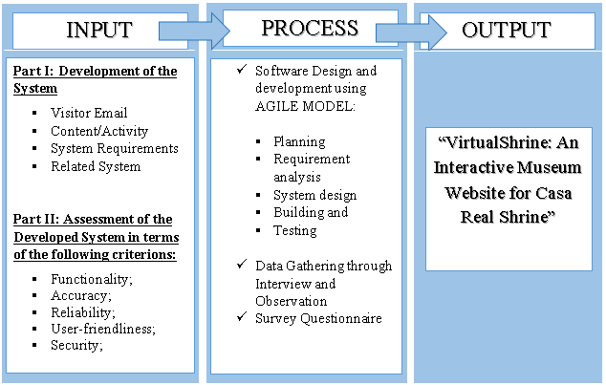

**Figure 1.** **Conceptual Model of the System Development**

The first frame is the input stage wherein it involves the primary data and information of the Casa Real Shrine to develop the system. System Requirements is necessary to have the hardware and software requirements needed to develop the system. Related Systems in books, internet articles, related studies and online research was reviewed.

The second frame is the process stage, wherein this part of the diagram the proponents adopted the System Development Life Cycle (SDLC) is a conceptual model used in project management that describes the stages involved in an information system development project, from a first feasibility study through maintenance of the completed application. SDLC can apply to technical and non-technical systems. In most use cases, a system is an IT (Information Technology) technology such as hardware and software. Project and program managers typically take part in SDLC, along with system and software engineers, development teams and end-users.

In development of the system the proponents used the Agile model. Agile model believes that every project needs to be handled differently and the existing methods need to be tailored to best suit the project requirements. In Agile, the tasks are divided into time boxes (small time frames) to deliver specific features for a release. Iterative approach is taken and working software build is delivered after each iteration. Each build is incremental in terms of features; the final build holds all the features required by the customer.

Agile takes an adaptive approach, rather than relying on exhaustive planning. The focus is on developing features and the team is able to quickly adjust to changing product requirements. Testing is conducted frequently, to reduce the risk of major failures. There are five phases in the Agile Software Development Life Cycle (SDLC): planning, requirements analysis, system design, building, and testing. Agile breaks the product into smaller, incremental builds and is designed to give customers a working software product quickly, while still being able to adapt to the process.

Lastly, for the Output stage, this is the developed system, the VirtualShrine: An Interactive Museum Website for Casa Real Shrine. In order to construct the system, each SDLC phase in the Process stage is discussed below.

**Initiation Phase**

In this study, Virtual Shrine focused on the virtualization of the museum for visitors reassuring the safety of the visitors without compromising any content and added content as well. Adding Online Booking Admission to the system added more security for data.

Popular museums had done online 3D virtual tours around 1999, boosting the number of visitors both online, and in person, using the technology now as an advantage to the system. Through an online web-based system the visitors could take the tour anytime and with the Online Booking making it convenient for any visitors. Attentiveness to the system’s performance made sure the plans proceeded as intended in the project for a higher chance of success.

Upon approval of the proposed system, VirtualShrine: An Interactive Museum Website for Casa Real Shrine used the feasibility study and support documentation to begin the planning phase.

**Planning Phase**

The Planning phase is a step before developing the software. This helped the proponents avoid problems during the early stage of developing the project that might have helped them for the future of the software. In creating the VirtualShrine website, the features of the software were important for the developers. That's why creating a plan was a must for the satisfaction of their audience.

Weedmark (2019) added that a good project plan should describe the project, break it down into tasks, estimate resources, develop a schedule, create a communication plan, and write a statement of work. For Casa Real Virtual Museum, the project goal is to reintroduce the importance of museums to new generations. The project tasks should be divided among the members, and resources such as 360 cameras and computers should be estimated. A schedule should be created to ensure the tasks are done on time, and a communication plan and statement of work should be established. Management at Casa Real Shrine should be consulted for requirements.

**Design Phase**

The System Design Phase is a crucial step in the software development process. It involved the conceptualization, specification, and validation of a system. During this phase, the proponents created a detailed design that met the requirements of the client and users. The proponents used Adobe XD as a prototyping software.

Adobe XD is a powerful platform for creating interactive designs, prototypes, and wireframes. It is a great tool for creating high-fidelity designs that accurately represent the intended user experience. Adobe XD also allowed the proponents to easily share the designs with stakeholders, enabling changes and feedback quickly. This helped ensure that the final design met the requirements of all stakeholders.

**Development Phase**

The development phase of the Casa Real Shrine interactive museum website, VirtualShrine, required a significant amount of technical work. This included coding, programming, and database design. The coding involved writing code to create the website's structure and features.

The programming involved creating the logic and backend systems that made the website run smoothly and securely. Finally, the database design involved creating a database to store the data and information associated with the website. In order to ensure that the website was secure and able to handle high traffic, security protocols were implemented and tested. Data encryption, authentication, and authorization were implemented to protect the website from malicious attacks. Additionally, the website was tested for performance and scalability in order to ensure that it could handle high volumes of traffic.

Finally, the website was tested for usability, accessibility, and compatibility with various browsers and devices. This ensured that users could easily use and interact with the website from any device.

**Testing Phase**

The proponents performed beta test during the testing phase to ensure accuracy of code, desired functionality, and website compatibility. The Testing teams gathered and loaded test data into the testing environment. Testers found faults or errors during the process, and procedures were in place to ensure programmers addressed them quickly and documented changes or revisions. This decreased tester downtime and saved programmer time troubleshooting, while maintaining integrity of program documentation. The data collected during the beta testing process was also used to develop new strategies and improve the overall performance of the application.

**Project Evaluation**

The proponents conducted post-implementation evaluations at the end of the project to confirm that project objectives had been met and to evaluate project management actions. The proponents interviewed all people and staff members who had been actively involved in the operational usage of the product or document and addressed any issues that were discovered.

**Implementation Phase**

The implementation phase involved an approved website into production environments. In this stage, the primary tasks included the implementation schedule, training end users, and access to the website.

In addition, Casa Real Shrine had input and verified data, configured, and tested system and security parameters, and conducted post-implementation reviews. Verifying the input data and security parameters for accuracy was an important element of the implementation process. Organizations frequently ran a new system alongside an old system until the new system's quality and reliability were verified. During the verification process, employees documented any programming, procedural, or configuration changes.

**VirtualShrine: An Interactive Museum Website for Casa Real Shrine of Malolos Gantt Chart**

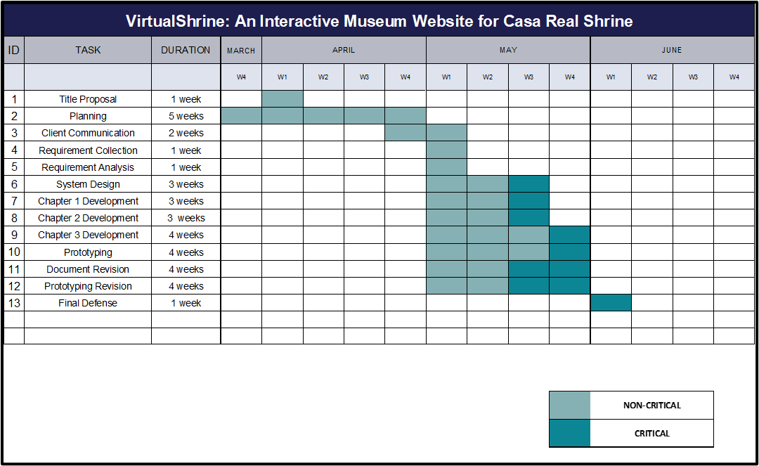The Gantt Chart, as illustrated in Figure 2, displays the schedule that the system's proponents followed during its development. The Gantt Chart was used to track the progress of the system's development.

**Figure 2.** **VirtualShrine: An Interactive Museum Website for Casa Real Shrine of Malolos Gantt Chart**

The timeline for the title proposal was allocated a duration of one week and began in the first week of April. Following this, planning was conducted from the last week of March to the whole month of April, with a duration of five weeks. After planning, two weeks were allocated for client communication from the last week of April to the first week of May. Subsequently, one week was allocated for requirement collection, and another for requirement analysis, both in the first week of May. System Design was then conducted for three weeks, from the first week to the third week of May. Chapter 1 and 2 development was conducted for three weeks, from the first week to the third week of May. Chapter 3 development was conducted over the whole month of May, with a duration of four weeks. Prototyping, document revision, and prototyping revision were conducted over the whole month of May, with a duration of four weeks. Finally, a one-week duration was allocated for the Final Defense, which was conducted in the first month of June.

**Requirements Analysis and Documentation**

The proponents conducted an interview with the museum curator, Mrs. Ma. Antonia T. Jimenez to determine the system requirements and to gain an understanding of the client’s needs and expectations for the project. The proponents also observed the museum operation such as the visitor walk in admission process in order to develop a plan for the online booking process.

**Maintenance Phase**

It entails making changes to software and documentation to support its operational effectiveness throughout the maintenance period. It entails making modifications to improve a system's or website's performance, resolve issues, increase security, and meet user needs. The museum should implement suitable change management standards and procedures to guarantee that alterations do not disrupt operations or harm a system's functionality or security.

**System Specifications**

The web application was developed using HTML, PHP, and JavaScript. The application was built on a MySQL database. The application utilized AJAX for dynamic page loading. Additionally, the application included various front-end libraries such as jQuery and Bootstrap for improved user interfaces and responsiveness. Furthermore, the application included a secure login system and intuitive user experience.

NA

**System Design and Processes**

**Front Office:** The website's front office consists of the following menus: (1) Home. The Home page is the system's default web page. The home page displays a welcome banner for visitors, as well as a "book a tour" and "plan your visit" buttons for visitors' convenience. The homepage also highlights featured exhibitions and information, upcoming events, galleries, and group trips. The homepage also includes a footer with basic information about the museum, contact information, quick links, and a list of social media pages that visitors can like or follow. (2) Plan your visit. This website displays information on the museum's operations, such as the opening time, location, and health and safety guidelines that visitors must follow. This website serves as a visitor asistance in preparing for their visit to the museum, this way, they can have a hassle-free visit; (3) Booking Reservation. The visitor can book for reservation for their physical museum visit. Pre-booking is recommended to have a hassle-free visit. The visitor enters the date and time of reservation, and the number of people who will visit; the system will also ask for the representative visitor information such as name, email that were used for the confirmation, mobile number, address, and the name of company, agency, or school if applicable. At the end of reservation, the visitor will receive an Acknowledgement Receipt on the email they provided with the following details:  (a) Reservation Date and Time; (b) Total number of visitors. (4) Virtual Tour. This page displays the virtual tours such as the permanent and current exhibits, virtual gallery with a 360 view of the 5 galleries available in the museum, and the narrated tours.

**Back Office:** The back office serves as the system administrator and website content manager site where they can view booking lists, approve, or decline bookings, update the website content, post an announcement, and add an assistant admin.

**Head Administrator:** The Head administrator is mainly the museum curators. The Back Office of the head administrator is composed of the following menus: (1) Add user. They will be able to register an assistant administrator. (2) Edit user. able to set their own type of user that will handle the back office. (3) Edit user information. able to modify the assistant admin. (4) Remove user. Has the ability to delete assistant user account in the back office. (5) Reservation. Viewing, approving, and declining of reservation done by the visitor. (6) Update Contents. The head administrator will be able to add, update, and delete the content of the front office.

**Assistant Administrator**: The user of this application is mainly the employee of Casa Real Shrine who handles the booking reservations. (1) Log In enables access to other functions with username and password assigned by the head admin (see security matrix Table 5). (2) Reservation allows viewing, approving, and declining of reservation and emails clients regarding status. (3) Update Contents allows assistant admins to update the content on the website.

Figure 3 shows the booking procedure done on the booking reservation website page.

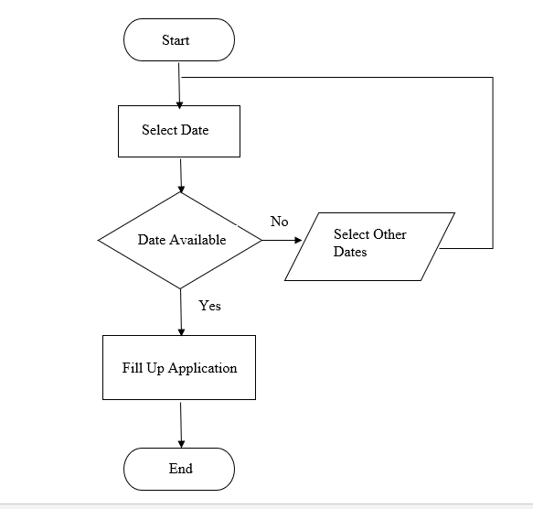

**Figure 3. Booking Admission Flowchart**

This flowchart outlines a booking procedure done on a booking reservation website page. It starts with the user selecting a date they would like to book. If the date is available, they proceed to the next step and fill out an application. If the date isn't available, they go back to the start and select other dates. The flowchart ends when the user has filled out their application.

Figure 4 displays the process on how the admin monitors and updates the website content.

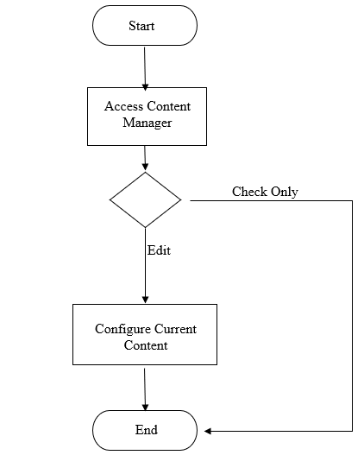

**Figure 4. Content Management Flowchart**

This flowchart outlines the process that an administrator would go through when monitoring and updating the content on a website. It begins with the administrator accessing the content manager. This flowchart provides a helpful overview of the process that an administrator must go through in order to monitor and update the content on a website. It ensures that the content is kept up to date and accurate, which is essential for a successful website.

Figure 5 shows the whole flow of the Admin/Webmaster view of the VirtualShrine website content management system.

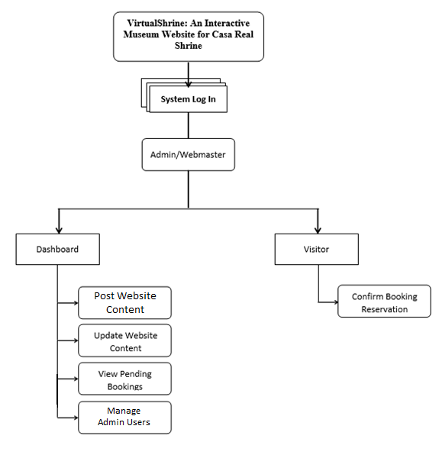

**Figure 5. Admin View VTOC**

This figure outlines the whole workflow, from creating and managing content to editing and managing users. All of these features are accessible from a single admin interface, allowing for quick and easy management of the VirtualShrine website.

**Context Diagram of VirtualShrine: An Interactive Museum Website for Casa Real Shrine**

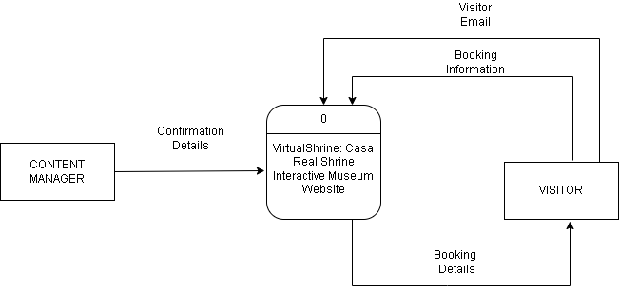Figure 6 illustrates the Level 0 of the Context Diagram; this context diagram shows the entities that interacted with the developed system.

**Figure 6. Data Flow Diagram Level 0**

The diagram shows the VirtualShrine website as the central element, with other entities such as visitors and content managers interacting with it. The diagram also shows the flow of data between these entities and the VirtualShrine website, such as the visitor initiating a booking and receiving confirmation emails and the content manager being able to process the booking and confirmation emails.

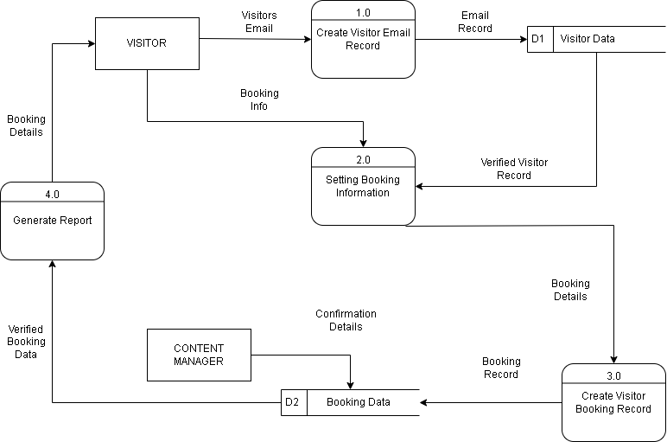Figure 7 shows Level 1 of Data Flow Diagram, the system displays the process specifically from the Visitors to the content manager/admin who will interact with the system.

**Figure 7. Data Flow Diagram (Level 1)**

In the diagram, a visitor initiates a booking process by providing book information to a setting Booking information. The setting Booking information then creates a Visitor Booking record and sends it to a Content Manager who confirms the Details of Booking Data. Once the data is verified, a report is generated with the booking details and sent back to the visitor. Finally, an email record is sent to the visitor.

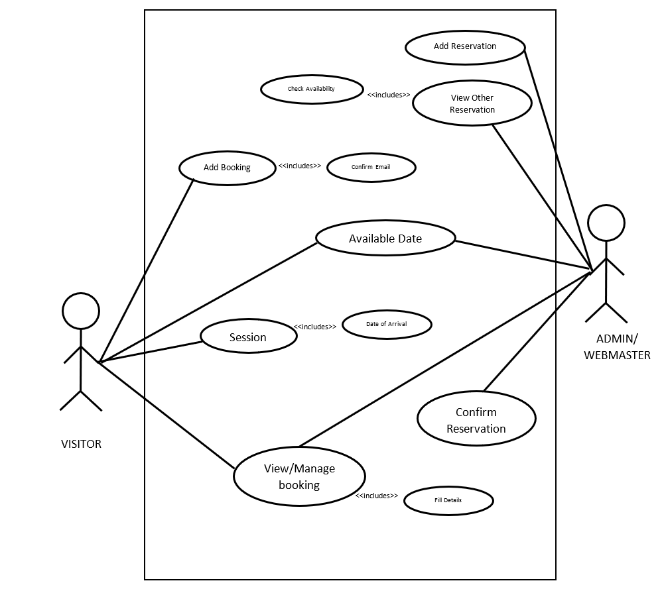 Figure 8 displays a use-case diagram which provides a visual representation of the interactions between a system and its users.

**Figure 8. Use Case Diagram**

This illustrates the context and objectives of the system, showing how the users interact with it in order to achieve their goals. The diagram also serves to identify potential problems and areas for improvement, helping to ensure the system meets user needs and expectations.

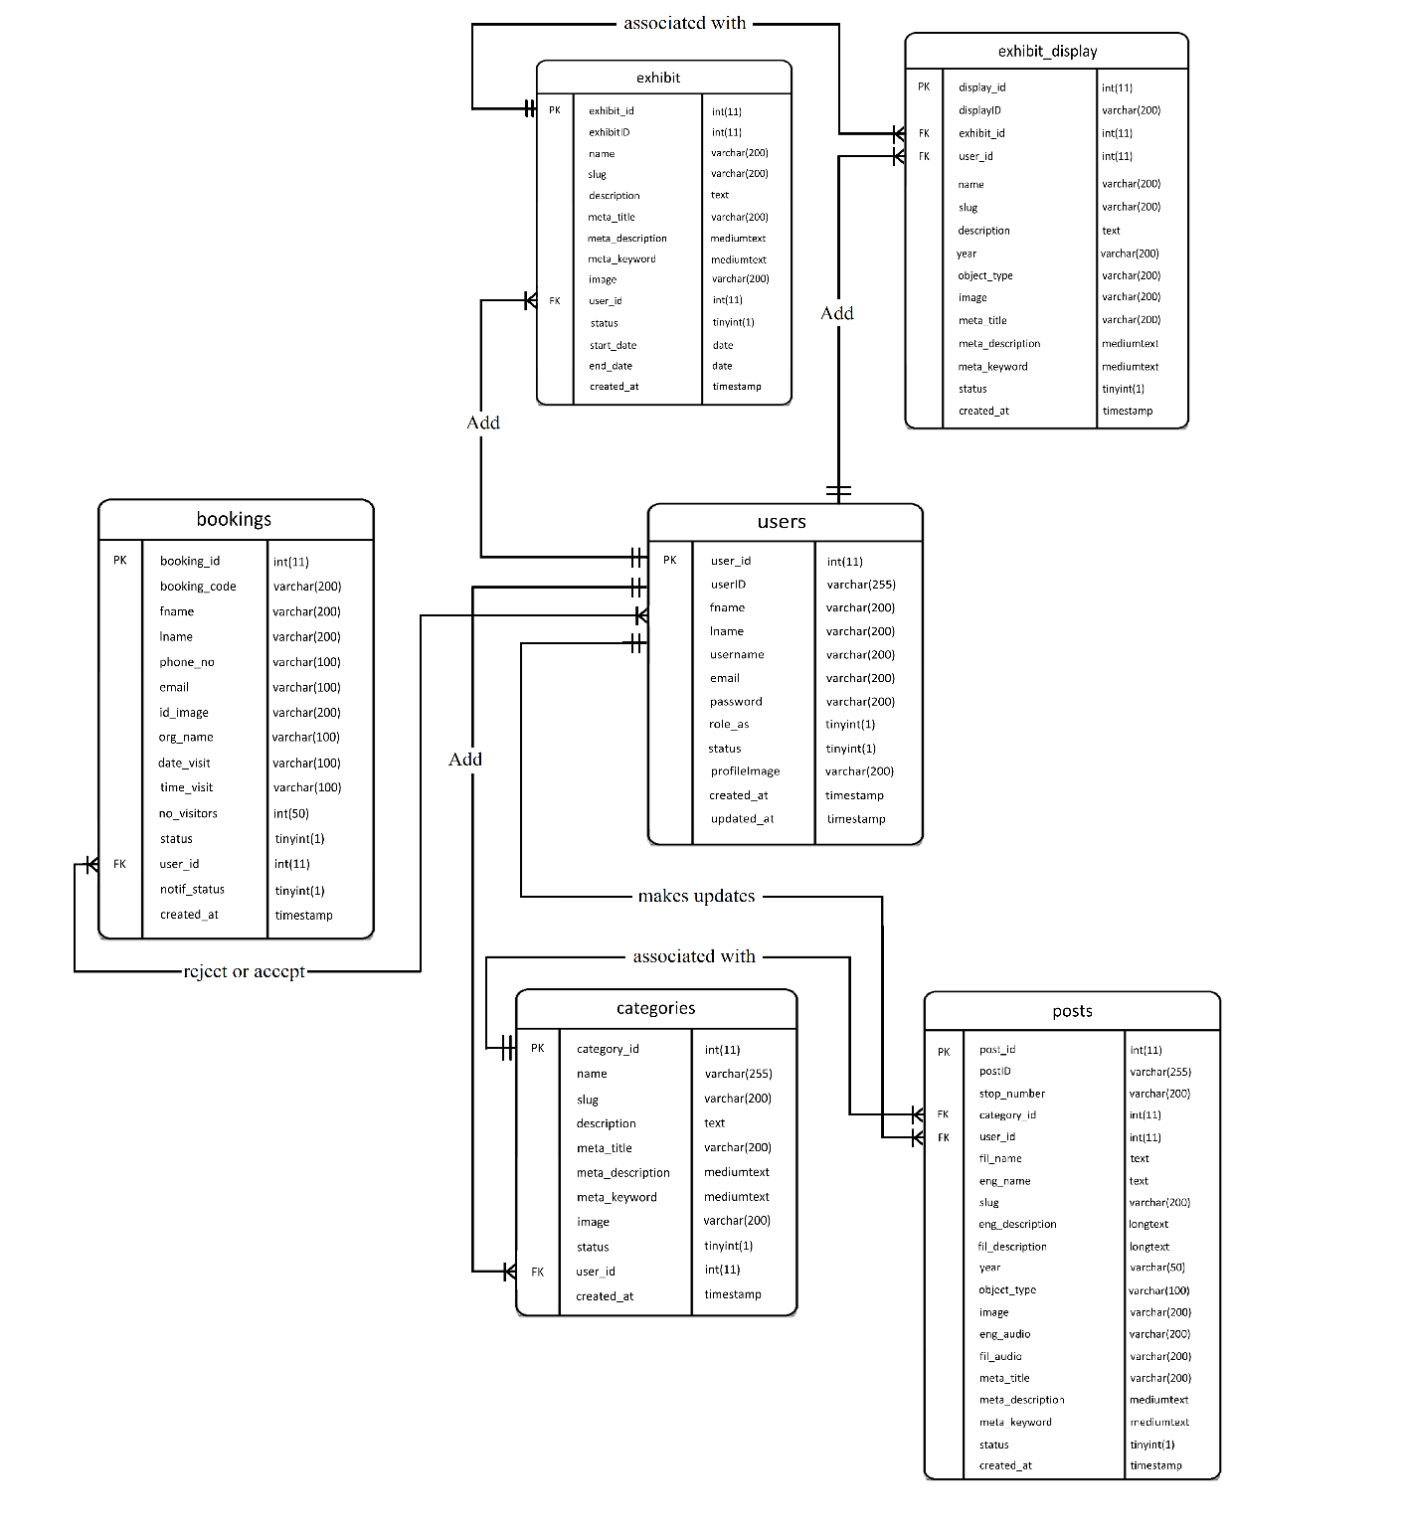Figure 9 shows different types of entities such as users, bookings, exhibit, exhibit display, categories, and posts.

**Figure 9. Entity Relationship Diagram (ERD)**

This figure shows the relationship between each entity and the flow of information inside the system. All the entities are interconnected with each other, providing an efficient way to access information which is essential for a better user experience. Moreover, this diagram also helps to understand how data is stored and managed in the system.

**Conceptual System Design**

The VirtualShrine: An interactive museum website for Casa Real is an interactive website that offers interactive features that would help the museum attract more visitors. One of the functionalities of the system is browsing the features and book reservation for the physical museum visit in the desired date and time of the visitors. Financial Transactions such as selling products from the museum gift shops are not included in this system. The system also does not require the visitor to register for an account, the only time that the system will ask for the visitor’s information is when they book for reservations.

**System Architecture**

**The Client’s Access to the Website**

Figure 10 shows the user’s access to the website via the internet through their computer terminal.

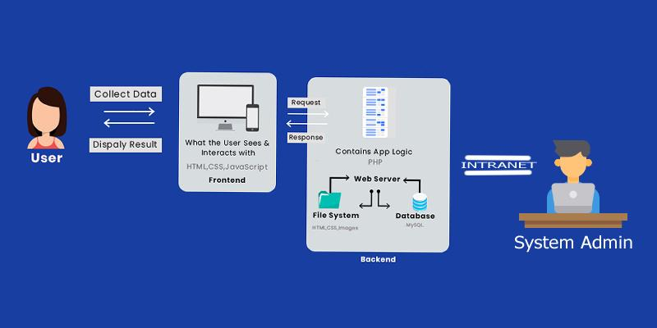

**Figure 10. The Client’s Access to the Website**

The web server replies and saves the client’s request to the database server.

The content manager can access the back office of the system via an intranet connection to maintain and update the system.

**Security Matrix**

Table 3 displays the Security Matrix. This security matrix applies only to the Back-Office application. The matrix shows the accessibility rights of every user of the system.

**Table 3**

**Security Matrix**

|  |  |  |  |
| --- | --- | --- | --- |
| **Module** | **Head**  **Admin** | **Assistance  Admin** | **User** |
| Log In | ✔ | ✔ |  |
| View All Booking Reservation | ✔ | ✔ |  |
| Approve/Decline Reservation | ✔ | ✔ |  |
| Upload/Update website content | ✔ | ✔ |  |
| View Website Content | ✔ | ✔ | ✔ |
| Add User | ✔ |  |  |
| View User Information | ✔ |  |  |
| Edit User Information | ✔ |  |  |
| Archive User | ✔ |  |  |
| Book Reservation | ✔ | ✔ | ✔ |
| Archive Contents | ✔ |  |  |
| Update Personal Profile | ✔ | ✔ |  |

This security matrix outlines the different levels of access that users have depending on the user hierarchy. Super Admins have full access to the system, Assistant Admins have access to Log In, View All Booking Reservation, Approve/Decline Reservation, Upload/Update website content, and View Website Content, and users have access to View Website Content and Book Reservation. This ensures that the system is secure and that the appropriate levels of access are given to the different user types.

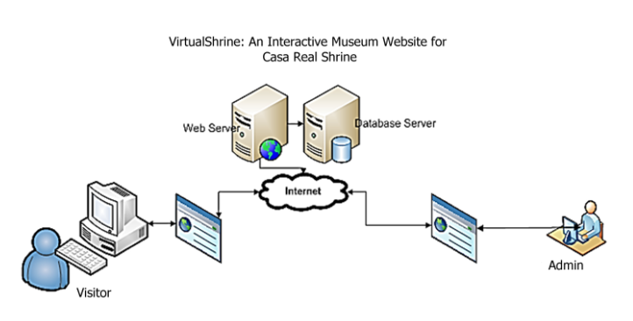The booking reservation process of VirtualShrine can be done through online transactions as shown in Figure 11. However, there are some instances that the visitor is not actually using the internet to make their reservation. They visit the museum as walk-in customers.

**Figure 11. Online Booking Process**

In order to handle the data that will be submitted by the customer, the system will use a database server which is directly connected to a web server for internet connectivity. Maintenance, modifications, and updates can be done by the administrator.

Figure 12 will show the illustration for the walk-in admission process.

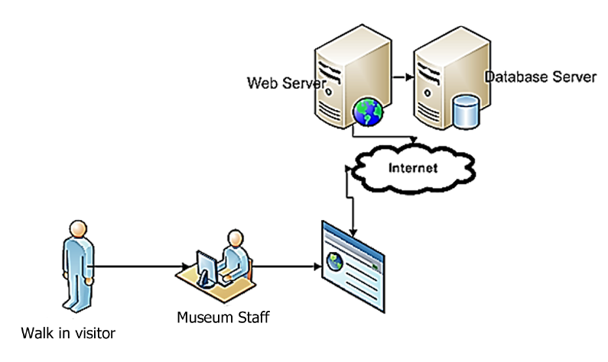

**Figure 12. Walk-in Admission Process**

For the customer to make visiting admission, the following steps must be followed:

Step1: Customer inquiries at the Museum staff about the visiting slot availability.

Step 2: The Museum staff will log in to the System Back Office. He will ask for the date of reservation and what to reserve. Using the System, the museum staff can give the availability of the admission slots.

Step 3: Once the visitor decides to book for admission, the clerk will ask the user the basic information for profiling purposes.

**Network Infrastructure**

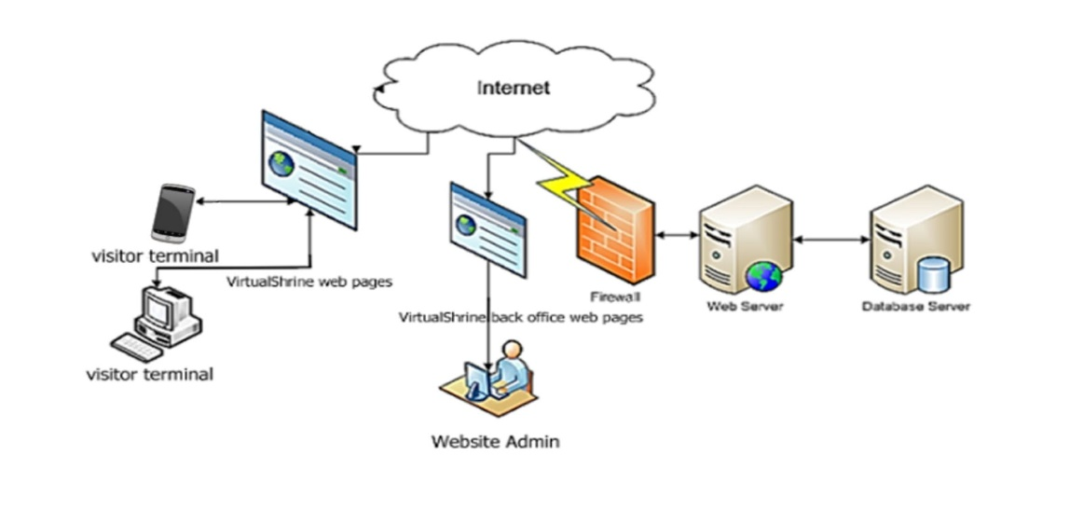Figure 13 will show the network infrastructure of the VirtualShrine Website.

**Figure 13. The Network Infrastructure**

Since the proposed system is an interactive website, Internet connection is particularly important. As can be seen from the figure (Fig. 18), the visitor can browse the VirtualShrine website, and their reservation can be made.

Also, the system allows website visitors to search for museum information such as operation hours and location from the museum website.

On the part of the Administrator (back-office account), the system allows the Website Manager (administrator) to make modifications including updating the contents of the website. They can also approve and reject a booking from the visitor.

**The Developed System**

Development of the VirtualShrine website for Casa Real Shrine included an Online Booking system, Virtual Museum tour, Gallery Collections, and User assisting features, all with user experience in mind. Content and navigation rules were established to make navigating the system easier.

Figure 14 shows the Homepage for the VirtualShrine website, which will act as the entry point for all visitors.

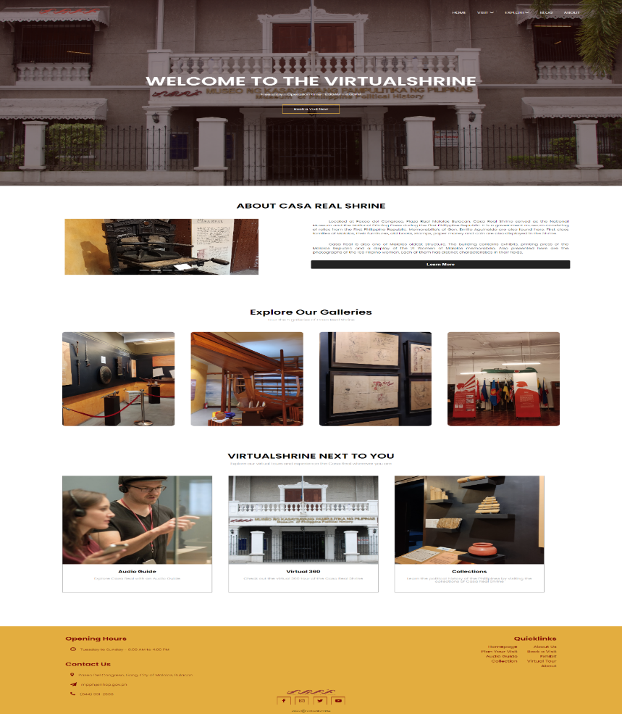

**Figure 14. VirtualShrine Homepage**

This page contains important information about the site, including brief information about the Casa Real Shrine, as well as links to other pages and resources. Visitors will be able to find their way quickly and easily around the site and learn more about the services and offerings the website provides.

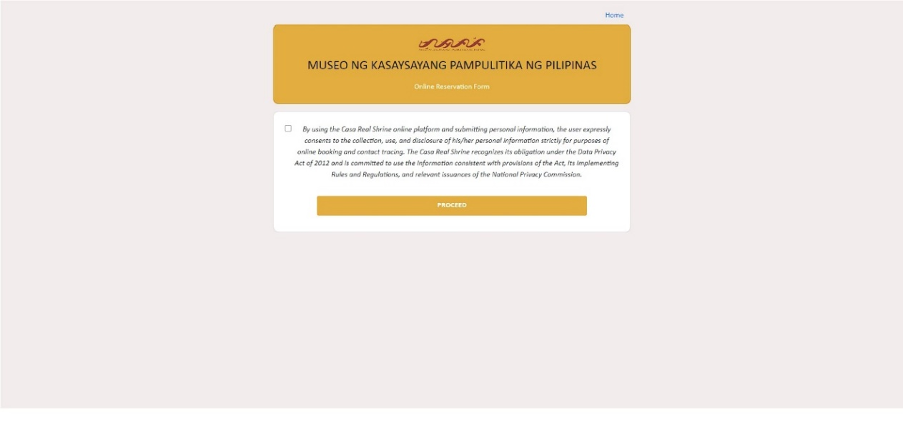 Figure 15 displays the Data Privacy Issue disclaimer. The visitor will be redirected to this page once they click the Book Now button found on the banner of the homepage.

**Figure 15. Data Privacy Issue disclaimer**

This page will provide the visitor with the terms and conditions regarding their booking. By agreeing to the terms and conditions and submitting the form, the visitor will be able to proceed to the next page.

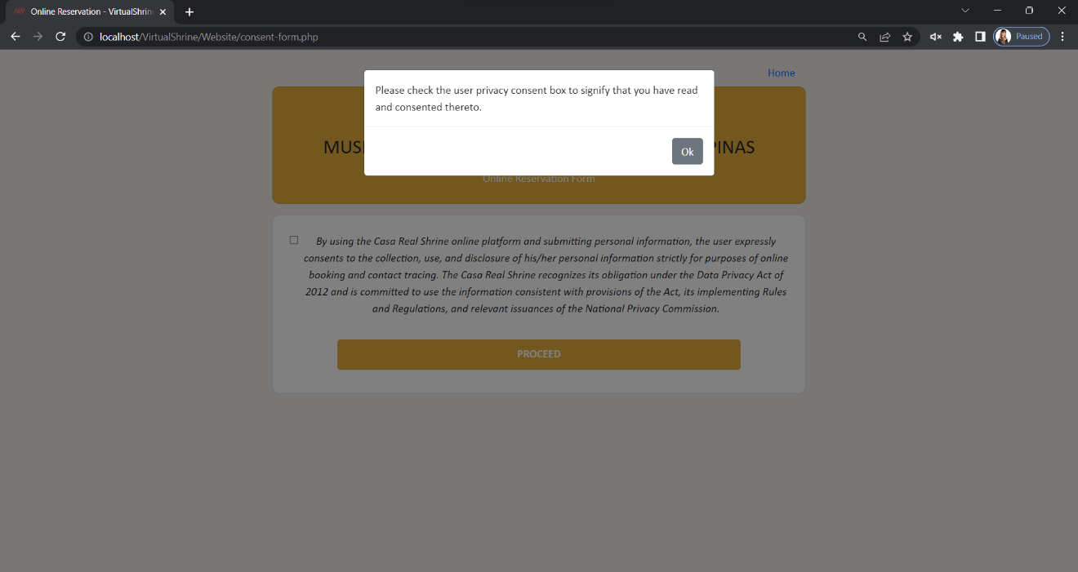 Figure 16 illustrates a popup warning message that appears when a visitor clicks the 'proceed' button without checking the checkbox.

**Figure 16. Data Privacy Issue disclaimer** **– Warning Message**

The popup message appears to remind the visitor to check the checkbox. Once the checkbox is checked, this indicates that the visitor understands the terms and conditions of their booking and has given permission for their personal data to be used.

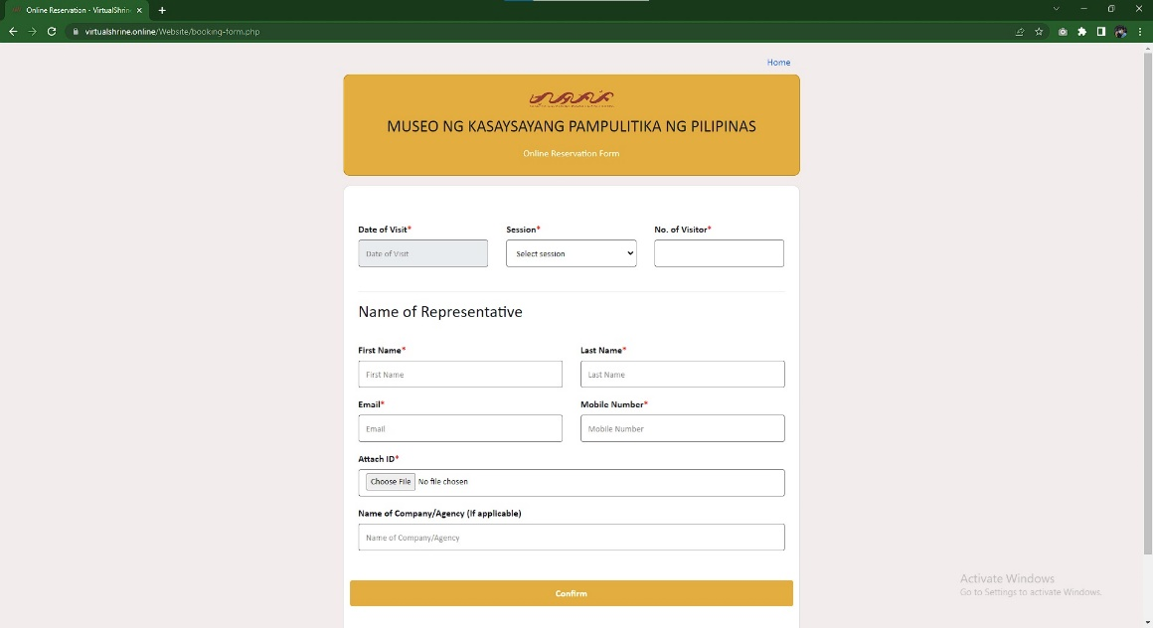Figure 17 displays the Booking form that visitors can complete with all the necessary information to make their reservation.

**Figure 17. VirtualShrine Booking Form**

The form requests Date of Visit, Session, No. of Visitors, First Name, Last Name, Email, Mobile, valid ID photo and organization (optional).

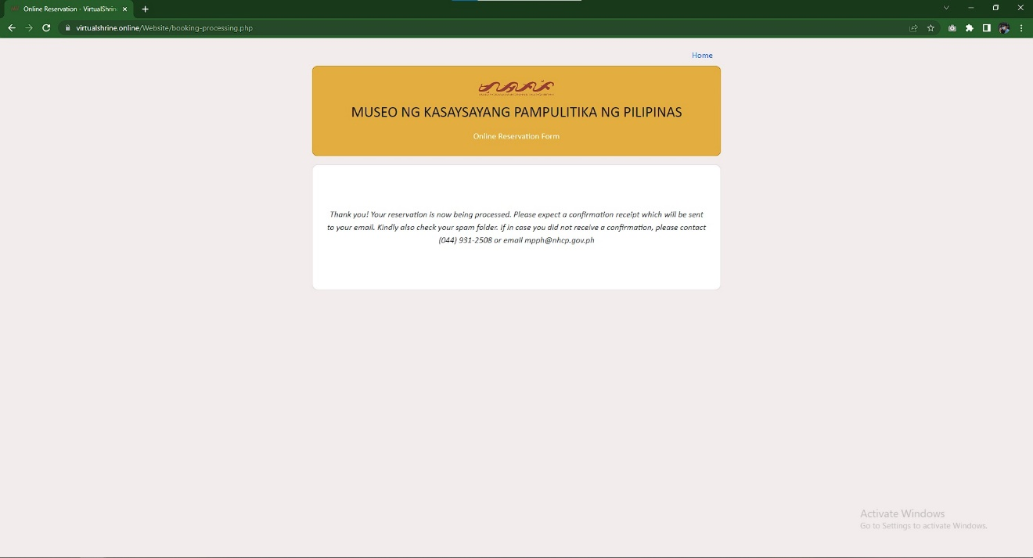Figure 18 illustrates the final page of the booking process, which indicates that the visitor's booking has been received and reviewed by the administrator.

**Figure 18. Booking Confirmation Page**

If all the information provided by the visitor is accurate and valid, the booking can be confirmed.

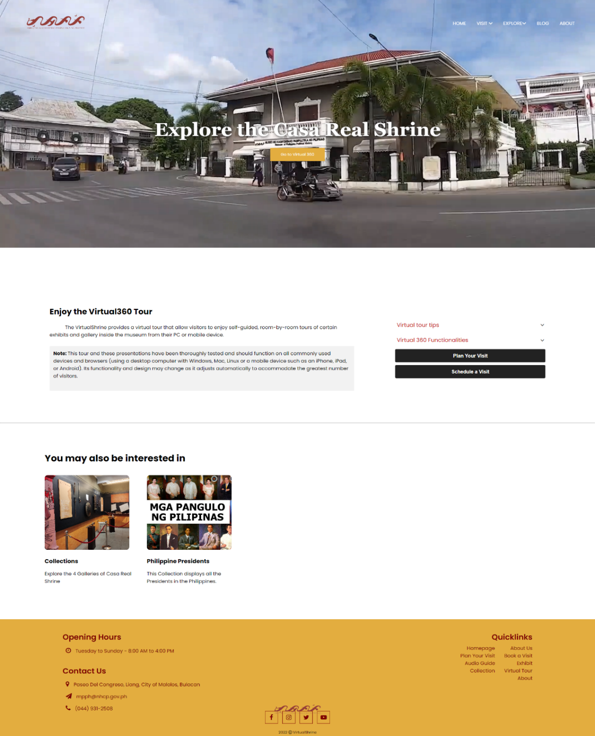 Figure 19 displays the access to the Virtual Tour page.

**Figure 19.** **Access to the Virtual Tour Page**

This page provides a portal to the Virtual 360 view of the museum, giving users an immersive 360-degree view of the museum's many galleries, exhibits, and artifacts. It also includes a brief overview of the features and functionalities of the Virtual Tour, as well as some helpful tips on how to make the most out of the experience.

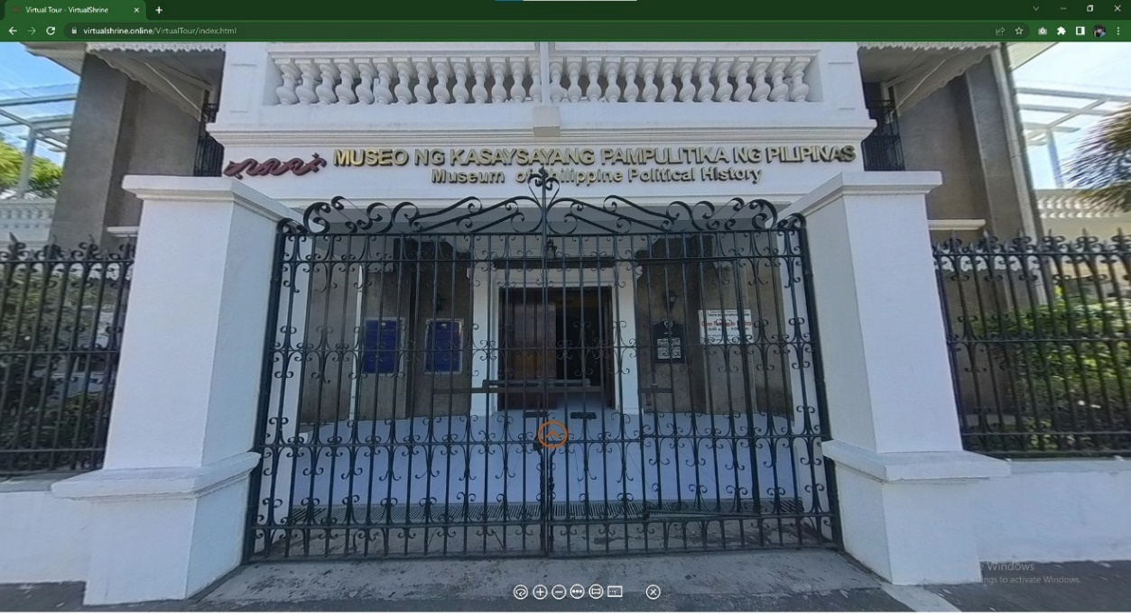Figure 20 displays the landing page when the user opens the virtual tour.

**Figure 20. Virtual 360**

This page showcases the Casa Real Shrine's main gate, with a yellow door icon as the hotspot to access galleries. Visitors can explore the virtual tour at their own pace and see all the incredible sights.

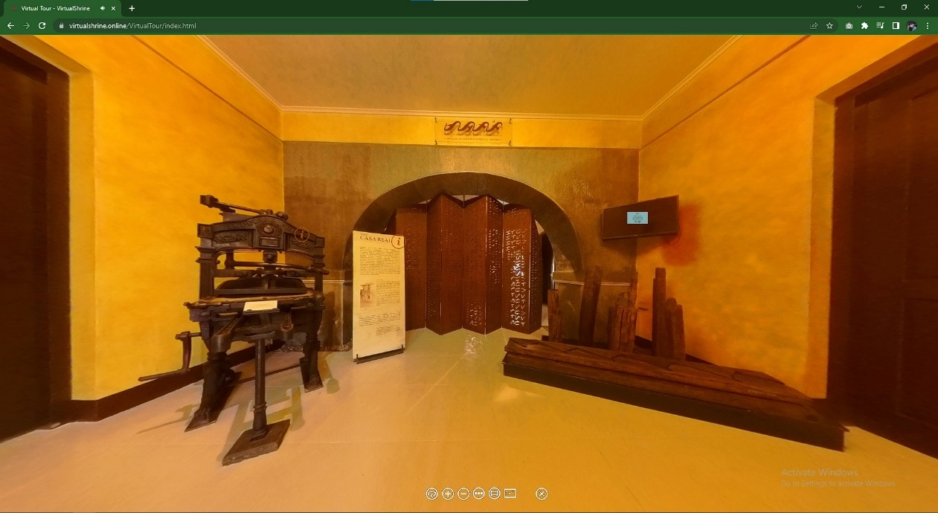Figure 21 illustrates the Virtual Tour lobby; the first room visitors enter when they come to the museum.

**Figure 21. Virtual Tour Lobby**

By swiping left and right, they can take in the sights of the area and interact with the different hotspots available, which provide further information on the museum. If a hotspot is pressed, a pop-up will appear with a definition of the display.

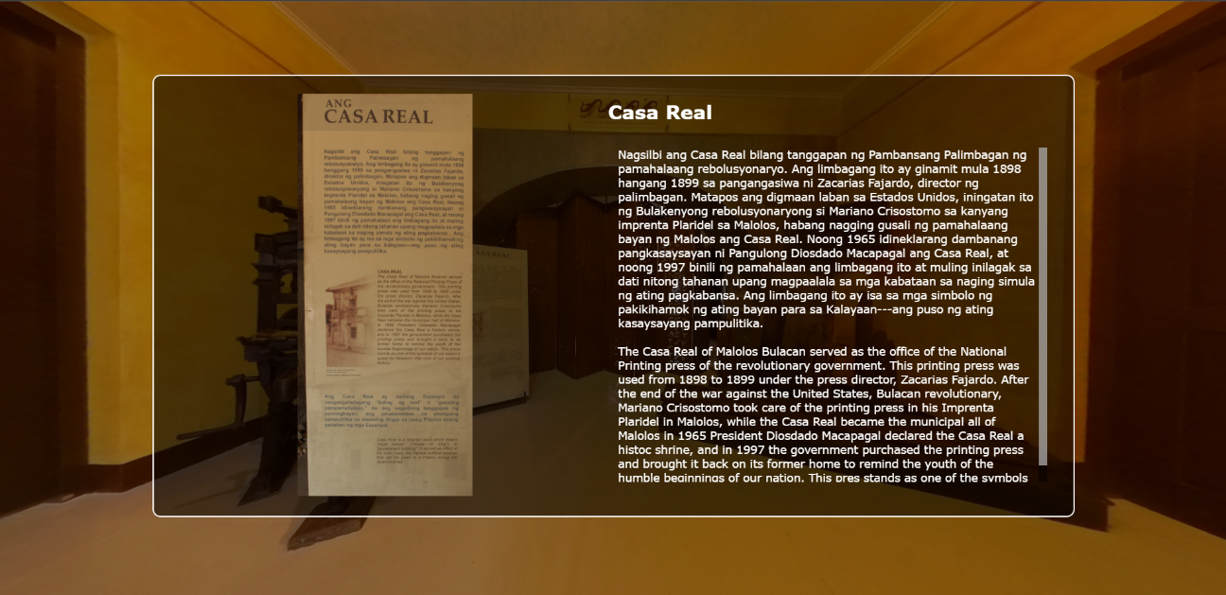Figure 22 displays the info popup which is shown as a small window containing an image and a description of the object displayed.

**Figure 22. Virtual Tour Info Popup**

This hotspot popup is used to provide more context and detail to the virtual tour, making it easier for viewers to learn more about the objects or locations featured in the tour.

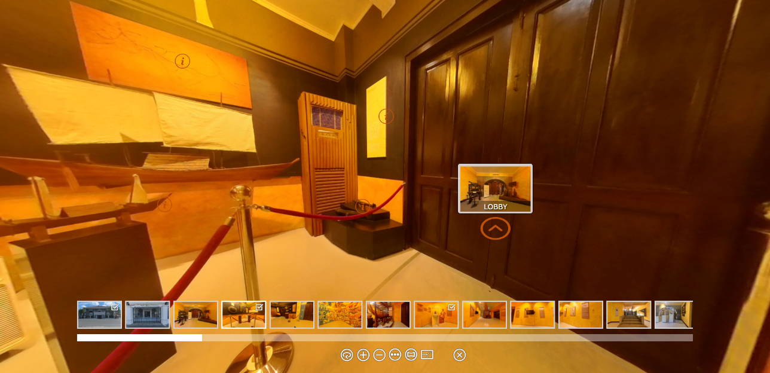Figure 23 shows the Virtual Tour controller found at the bottom of the screen.

**Figure 23. Virtual Tour Controller**

This controller helps visitors navigate the 360° tour. This controller includes Zoom In, Zoom Out, Auto Rotate, Show User Date, Thumbnail Menu, enter to full screen, and exit to virtual tour.

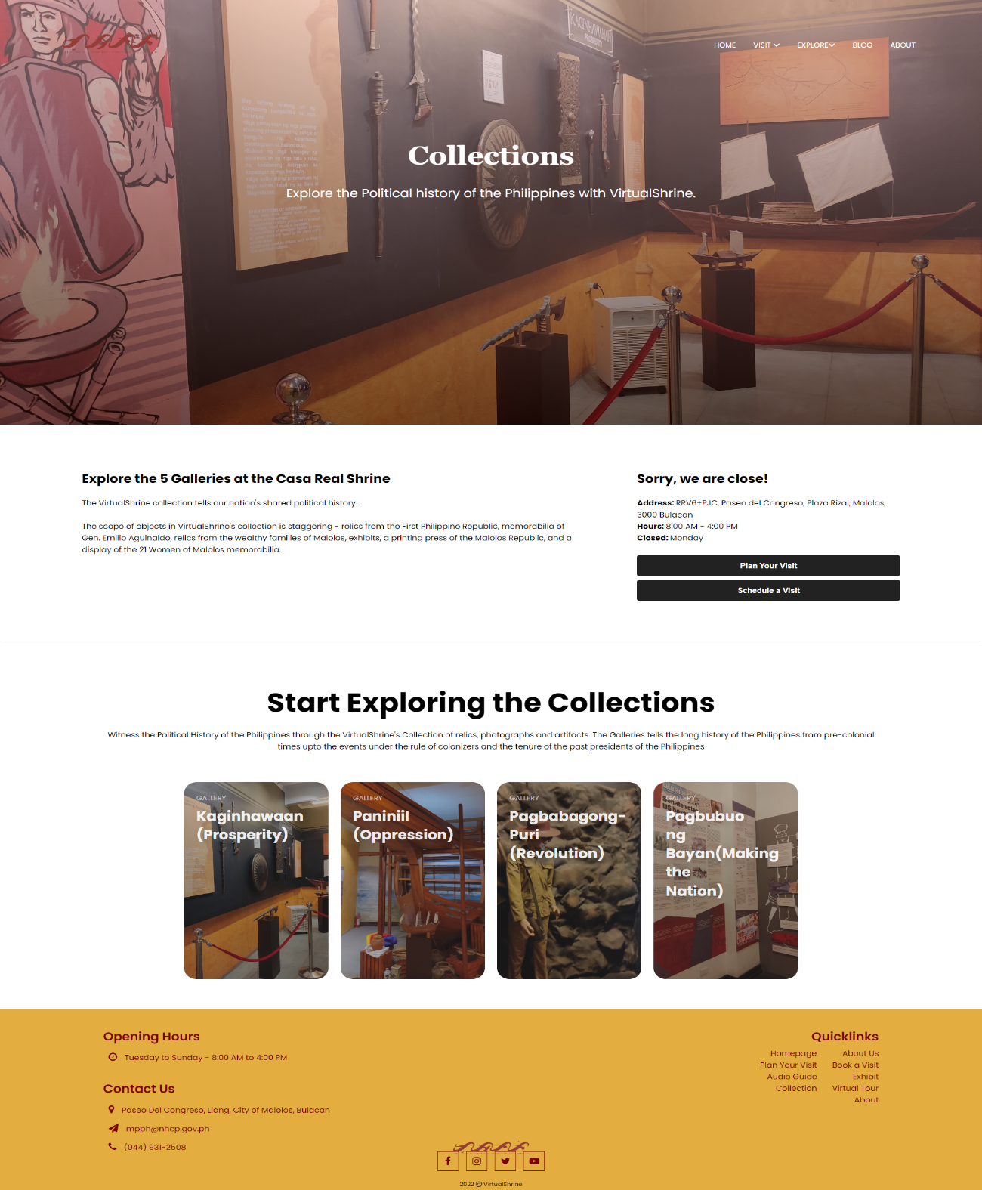Figure 24 shows the Gallery page. This is where different galleries can be accessed by the visitors.

**Figure 24. Gallery Page**

This page displays the 4 galleries in the museum. All cards lead to different rooms in the museum like Kaginhawaan (Prosperity), Paniniil (Oppression), Pagbabagong-puri (Revolution), Pagbuo ng bayan (Making the nation).

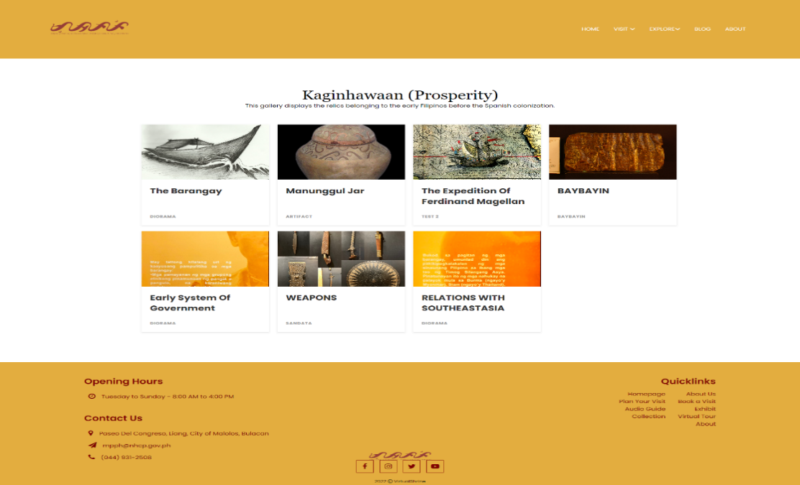Figure 25 displays the Galleries Collection page. This page is where the visitors can view the different collections found on each museum gallery.

**Figure 25. Galleries Collection page**

The page is designed for easy navigation, displaying collections in a grid with each featured as image and title. Clicking on the image provides more info.

Figure 2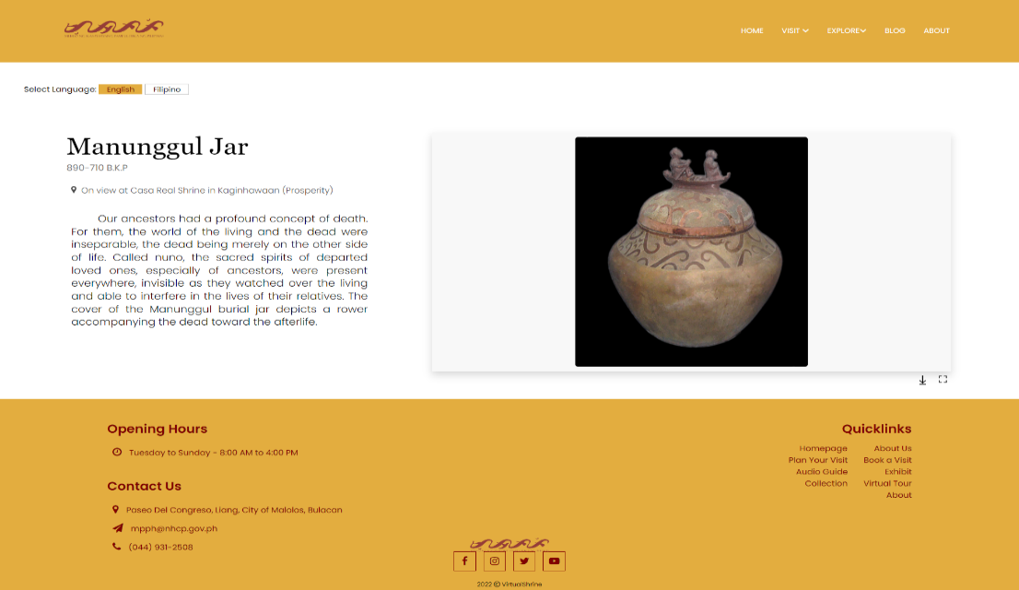6. The visitor will be redirected to the Display Description page as shown in Figure 26 once they click an image title from the Gallery Collection Page.

**Figure 26. Display Description page**

This page provides visitors with detailed information on the display, including the ability to download and print a picture of the artifact and its accompanying description.

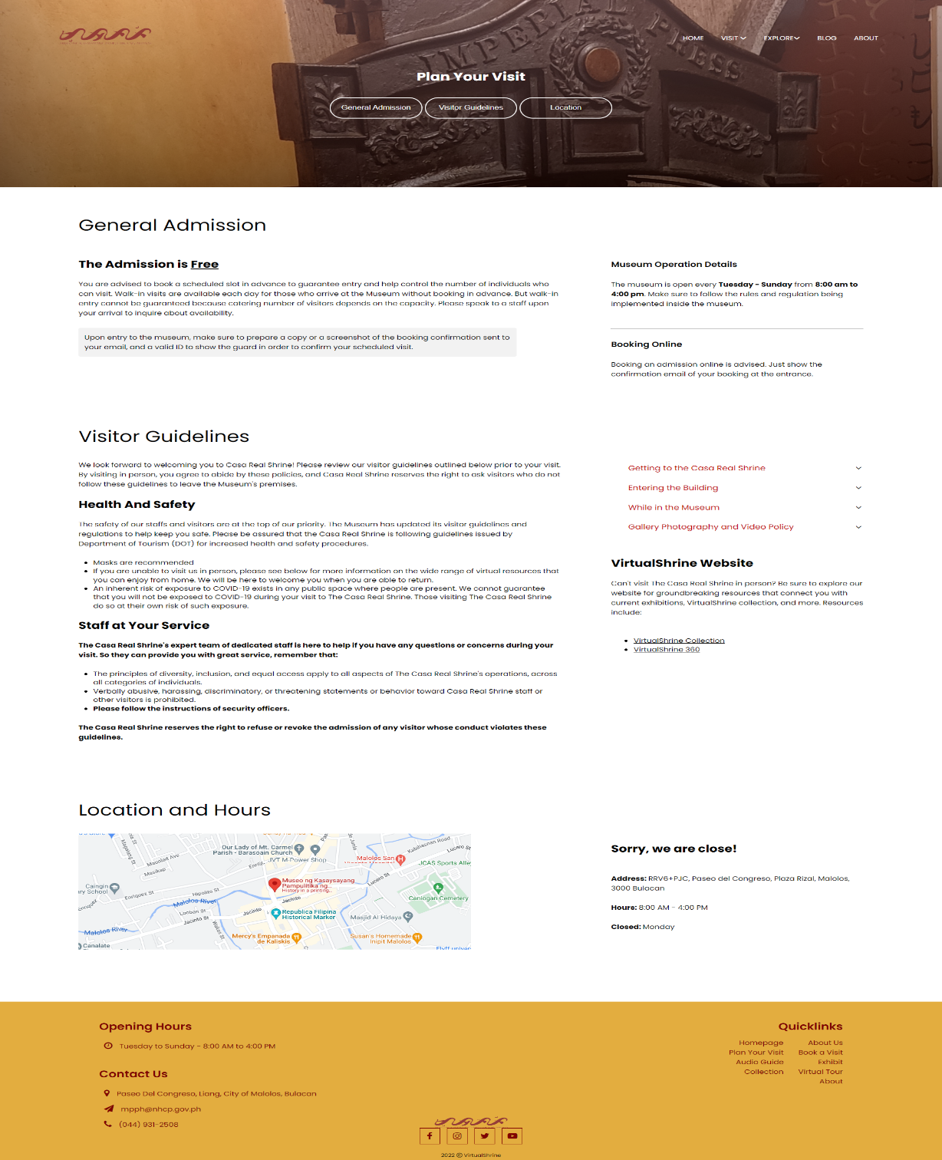Figure 27 shows the Plan Your Visit page of the VirtualShrine, which provides information and resources to help visitors plan their trips.

**Figure 27. Plan your Visit page**

This page allows users to easily find information on hours of operation, admission process, directions, accessibility, and other necessary details they need to plan their visit. This page also outlines the visitor guidelines that visitors must adhere to during their visit. This page is an essential part of the museum-going experience, as it helps visitors plan their visit, get the most out of their experience, and ensure they abide by the museum's visitor guidelines.

Figure 28 displays the VirtualShrine Exhibitions page. This page provides information about the current, upcoming, and past exhibitions in the museum.

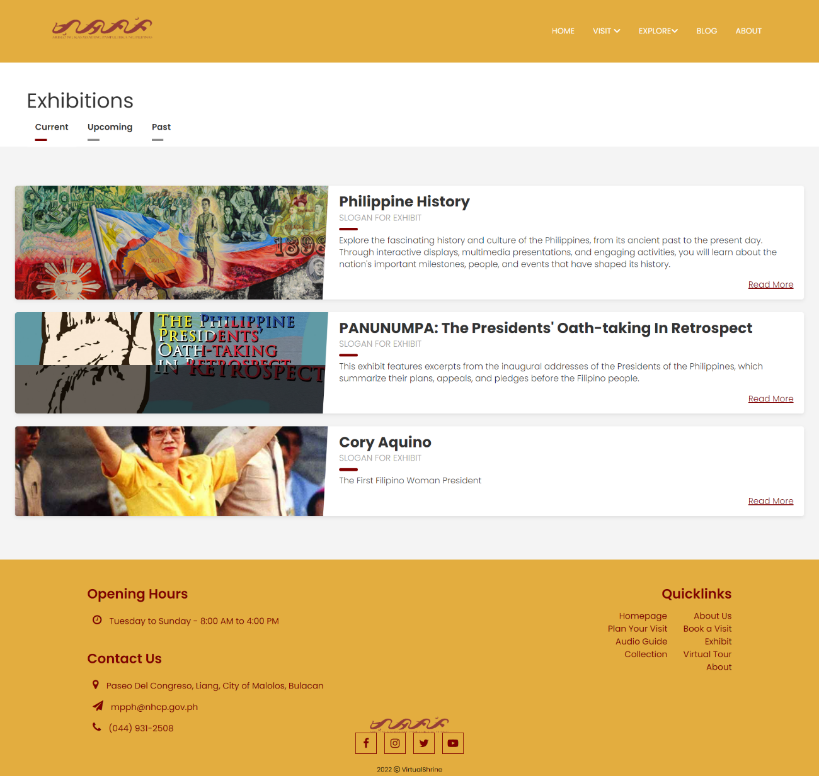**Figure 28. Exhibitions page**

The page is designed in an intuitive way, with the current, upcoming, and past exhibitions all separated into individual tabs, allowing visitors to easily navigate between the different exhibitions.

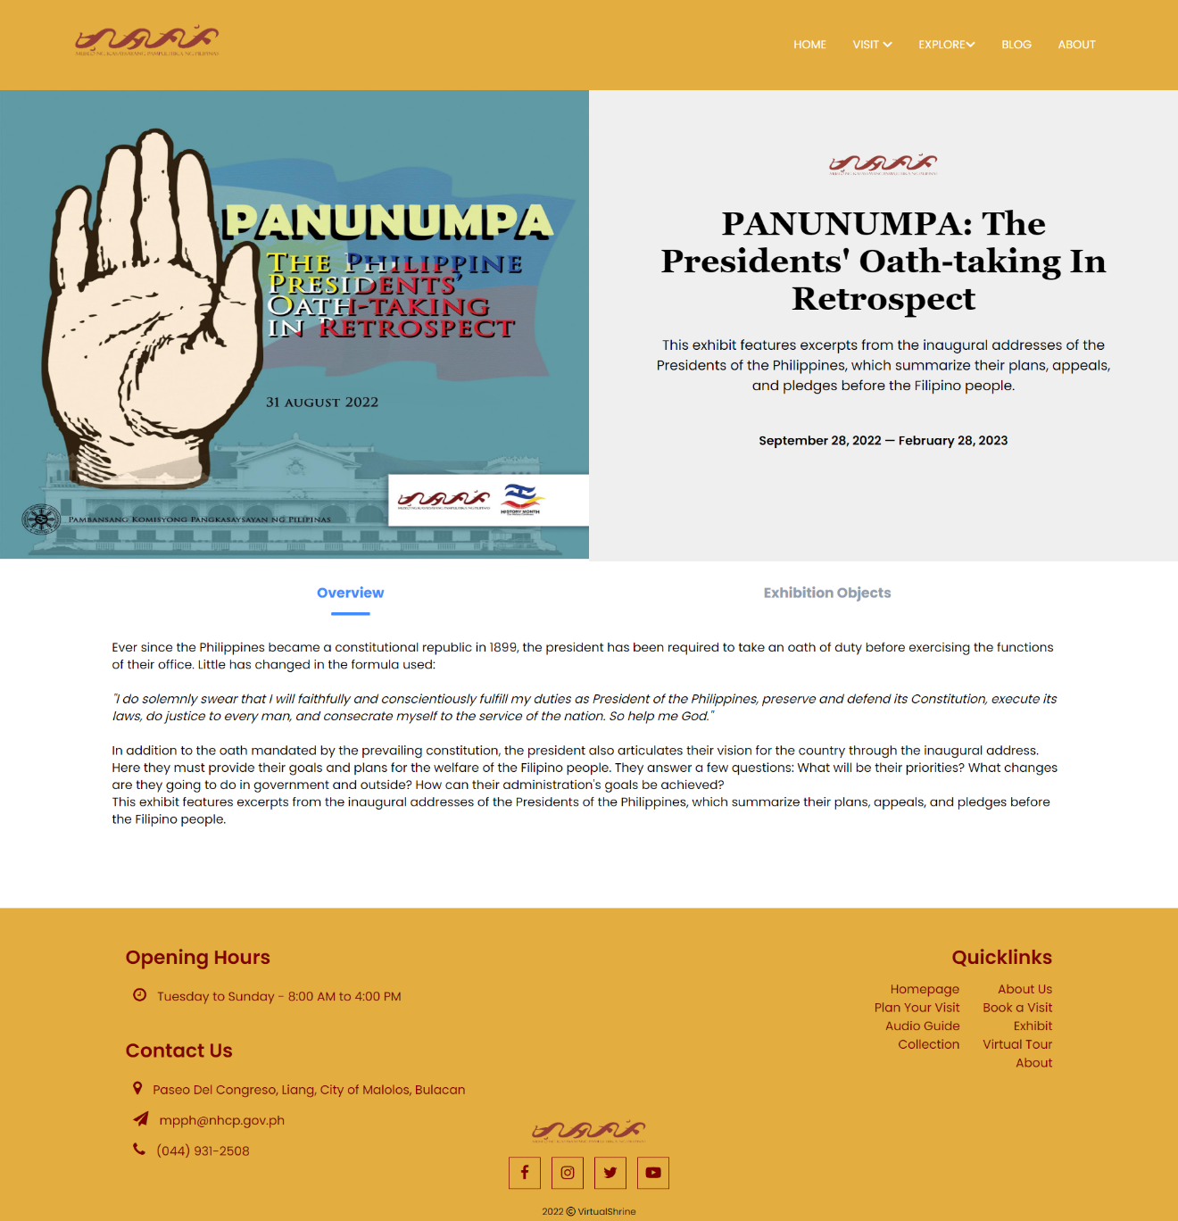Figure 29 displays an overview of the Exhibition, providing attendees with a comprehensive look at the different exhibits and attractions available.

**Figure 29. Exhibition Overview page**

This page provides visitors with a comprehensive overview of the exhibition, including its purpose, content, and displays. It also offers detailed information on the exhibition's historical context. Furthermore, it provides visitors with important information on how to visit the exhibition and any associated events. By exploring this page, visitors will gain an in-depth understanding of the exhibition, allowing them to make the most of their visit.

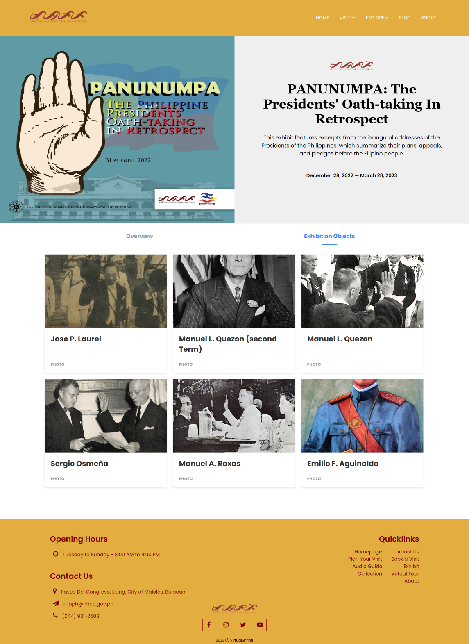Figure 30 shows a page of the objects featured in the Exhibition.

**Figure 30. Exhibition Objects page**

The page is designed to be user friendly and intuitive, providing visitors with an easy means to navigate through the objects. The page features an organized grid of images and titles, with each image representing the object. By clicking on the image, visitors are provided with more information about the object.

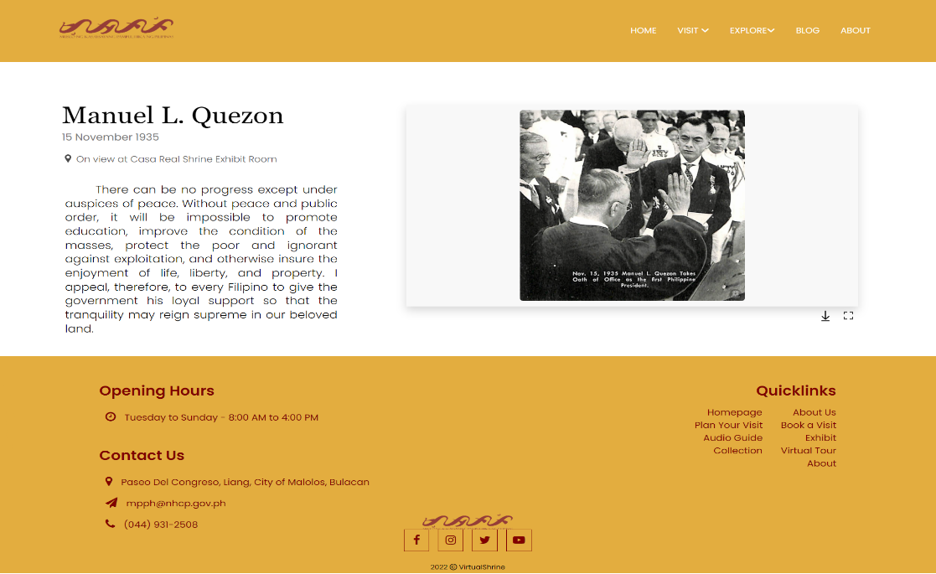When a user clicks an image title on the Exhibition Object Page, they will be redirected to the Exhibit Object Description page, as depicted in Figure 31.

**Figure 31. Exhibit Objects Description page**

This page contains a brief description of the object along with an image associated with it. Additionally, visitors will have the option to download and view a larger version of the image.

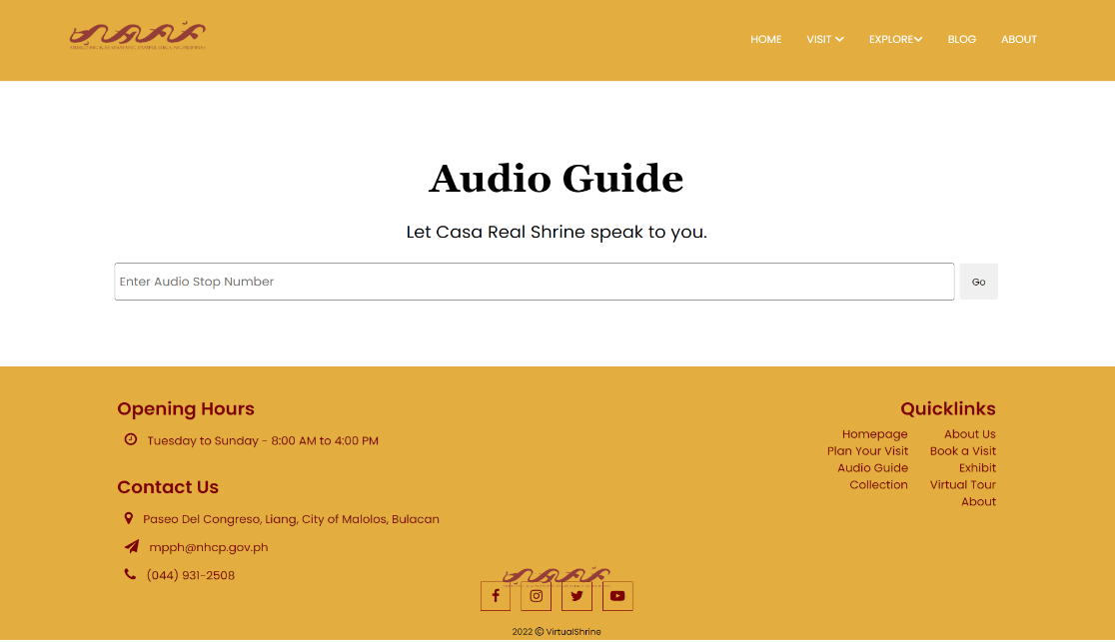Figure 32 displays the Audio Guide page.

**Figure 32. Audio Guide page**

This page provides a search bar for visitors to easily access audio recordings related to each museum display. Simply enter the display stop number to quickly access historical information and gain a deeper understanding of the museum collection.

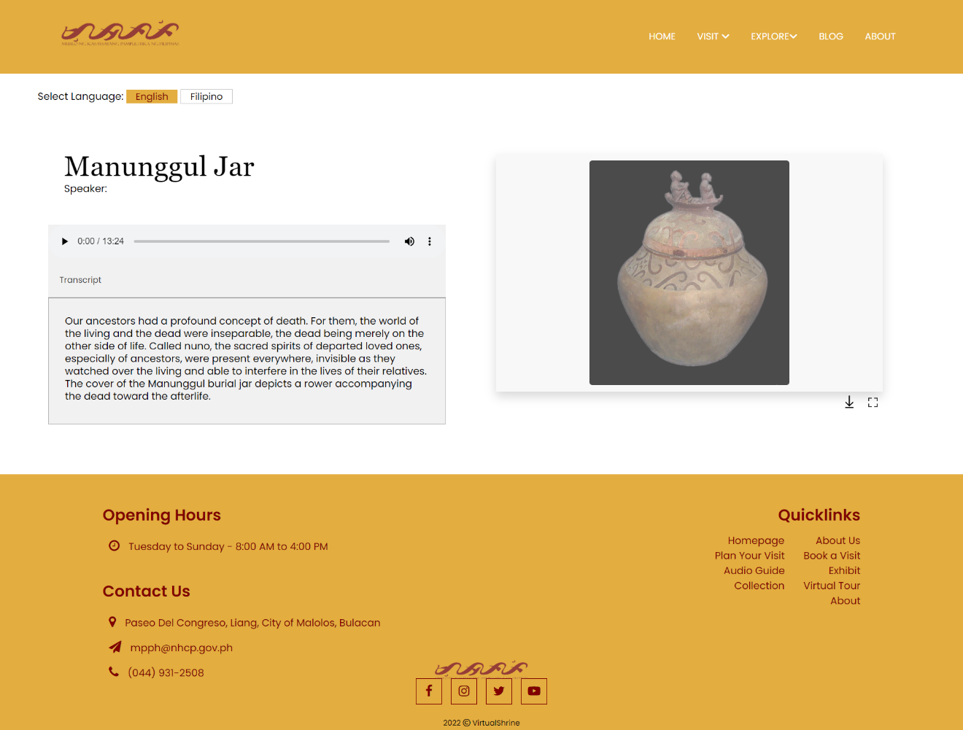Figure 33 displays the Audio Guide Player. This page is where the visitor will be able to listen to the audio related to the displayed object.

**Figure 33. Audio Guide Player**

The page includes an audio player, a preview image of the object, and the option to choose between English and Filipino language. The intuitively designed audio player allows visitors to adjust the volume, pause the audio, and even skip to different parts of the audio, making it easier to enjoy the audio description. Additionally, a transcript of the audio is provided to ensure that all visitors, regardless of their hearing abilities, are able to gain an understanding of the object on display. The transcripts are designed to be easy to read and understand, and the language used in both the audio and transcript will depend on the language chosen by the visitor.

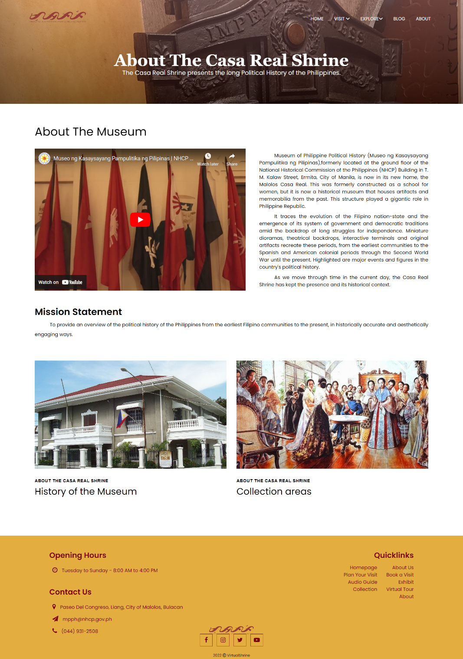Figure 34 displays the About page of the museum, providing visitors with an overview of the institution's history and mission.

**Figure 34. About page**

The mission statement outlines the museum's core purpose, while the brief history highlights the museum's journey to becoming the cultural hub it is today. A video presentation of the museum can also be viewed on this page.

A back-office system was created to manage User Admins, accept/reject Visitor bookings, upload website content, generate/print Admin Activity Reports and send Booking confirmation emails.

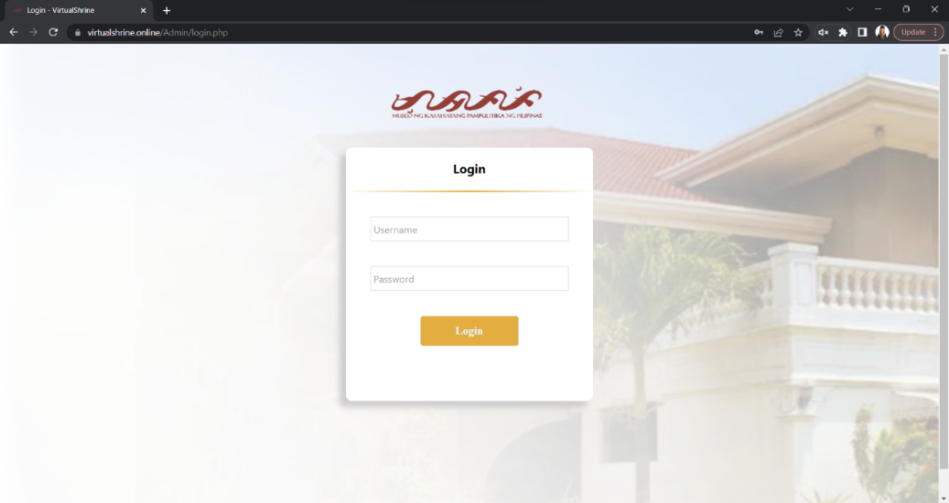Figure 35 displays the Login page of the Admin Dashboard, which allows the user to access the administrative page by entering the credentials they have created.

**Figure 35. VirtualShrine Admin Login Page**

The page features two text boxes where the user can enter their username and password respectively, as well as a 'Log In' button to submit the information.

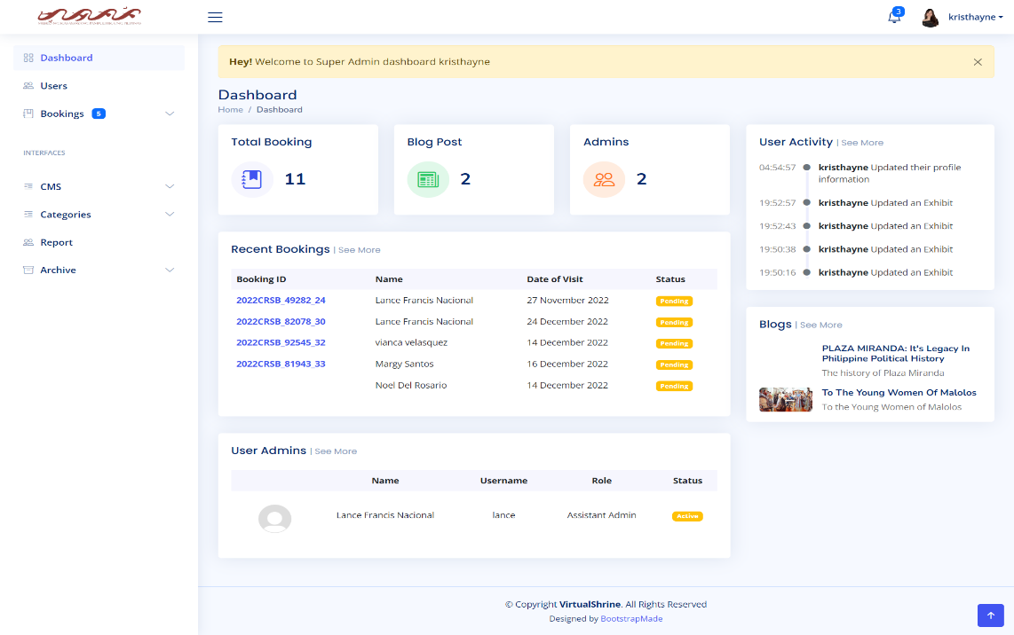Figure 36 illustrates the Admin Dashboard, allowing administrators track user activity, manage system settings, and access other administrative tools.

**Figure 36. VirtualShrine Admin Dashboard**

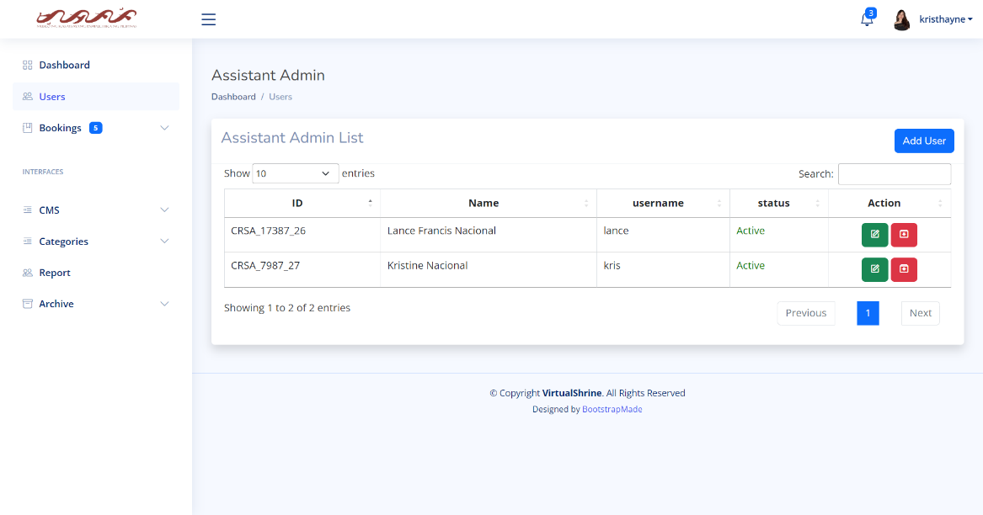Figure 37 shows the Assistant Admin Management panel, which is a tool used to manage assistant admin accounts.

**Figure 37. VirtualShrine Assistant Admin Management Panel**

Only the Super Admin (Museum Curator) can access this panel to add, edit, and archive users, and grant/revoke access for assistants. It also provides an overview of assistant admin accounts.

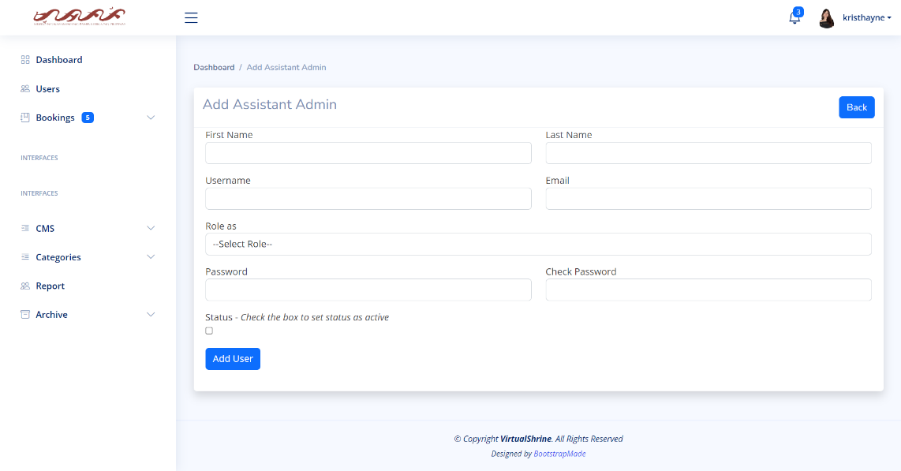Figure 38 shows the Add Assistant Admin form, which allows a user to add an assistant administrator to the system.

**Figure 38. Add Assistant Admin form**

This form can only be accessed by the super admin. The form contains fields for entering the user's name, username, email address, and password. The form also allows the Super Admin to select the appropriate roles and privileges for the new user. Once the necessary information is entered, the user can submit the form to complete the process.

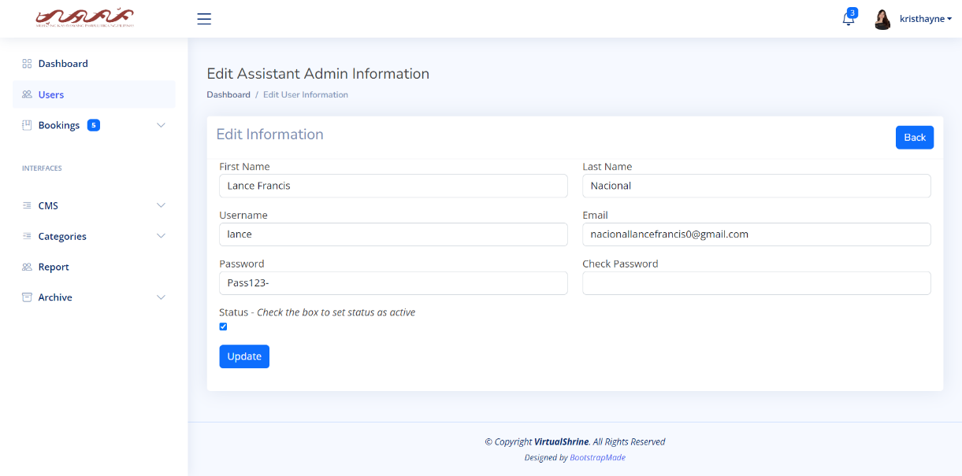 Figure 39 displays the Edit Assistant Admin Information form.

**Figure 39. Edit Assistant Admin Information form**

This form is used to update the details of an assistant administrator, such as their name, username, email address, and password. It also allows the Super Admin to change the administrator's active status. The form provides a convenient way for Super Admin to manage the assistant administrators.

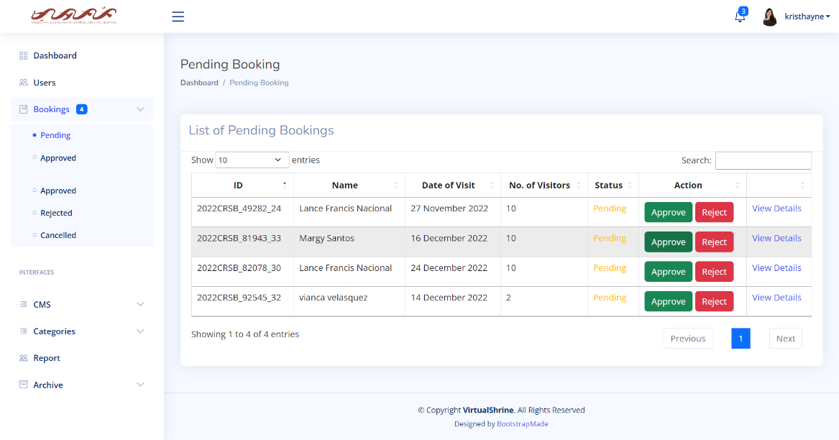Figure 40 illustrates the Pending Booking panel, which allows users to view a list of bookings that have not yet been processed.

**Figure 40. Pending Booking panel**

This panel provides a summary of each booking, including the visitor’s name, the number of visitors, and the desired dates of stay. Additionally, the panel allows users to approve or reject these bookings, thereby enabling them to manage their bookings more efficiently.

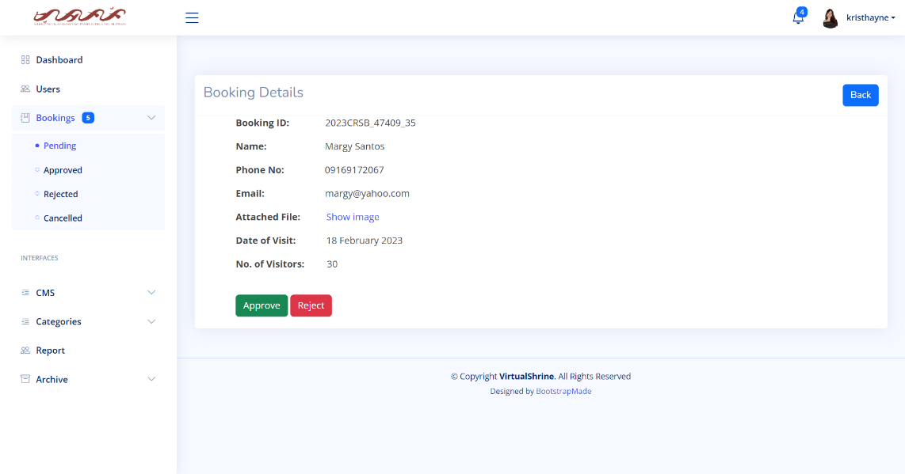 Figure 41 shows the Booking Details page, containing all the information that the visitor submitted during the booking process.

**Figure 41. Booking Details**

This page shows visitors' booking ID, name, contact info, date of visit and number of visitors. Admins can view attached ID to confirm identity and easily approve or reject booking.

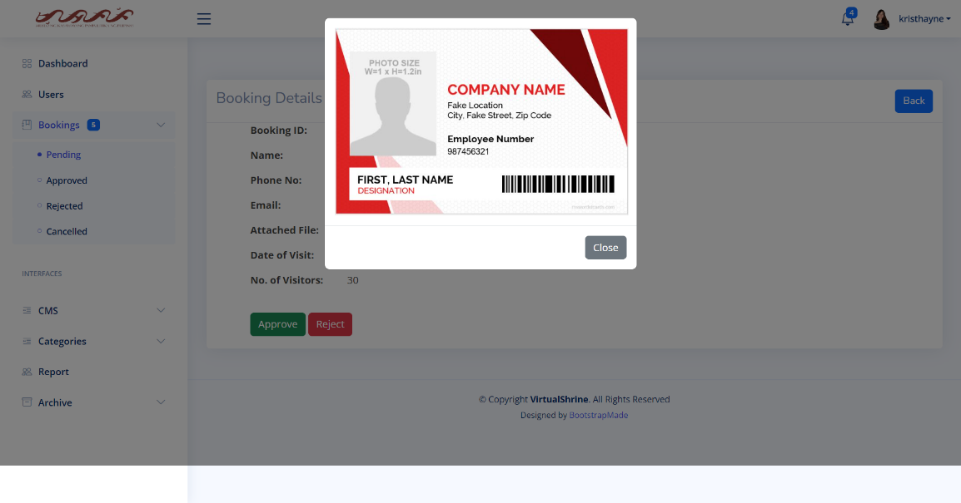Figure 42 shows the Attached File preview that the admin can utilize to verify the identity of a visitor.

**Figure 42. Attached File preview**

The preview reveals the visitor's ID, which the admin can use to confirm that the booking details are accurate. Additionally, the Attached File preview allows the admin to quickly access the necessary information to process the booking.

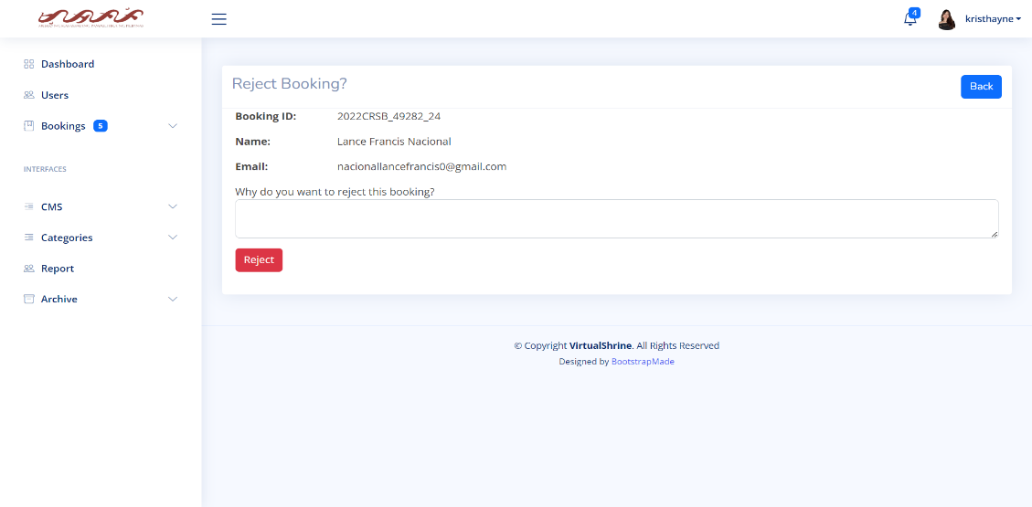Figure 43 displays the Reject Booking form, which is a feature that allows museum administrators to reject a booking made by a visitor.

**Figure 43. Reject Booking form**

The page displays primary visitor and a text box for the admin to input the reason for rejection. Clicking the "Reject" button finalizes the process. This feature is key to the museum's booking system, allowing administrators to respond quickly and efficiently while ensuring capacity is not exceeded. An email notification also provides an easy way for visitors to understand why their booking request was denied.

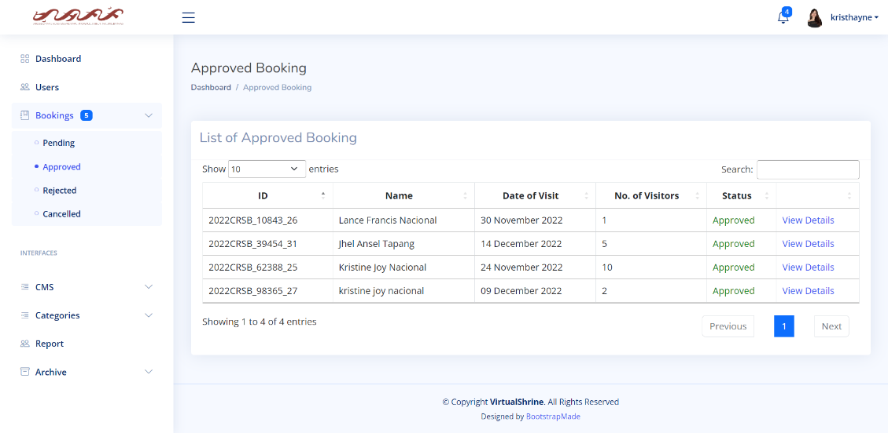Figure 44 displays the Approved Booking Panel, which allows admins to view and manage a list of all the bookings that have already been approved.

**Figure 44. Approved Booking Panel**

This feature is designed to help admins quickly and easily confirm visitors' bookings once they have arrived at the museum. The Approved Bookings Panel also allows admins to access useful information about the bookings, such as the number of people, the date of the booking, and the contact information of the visitor.

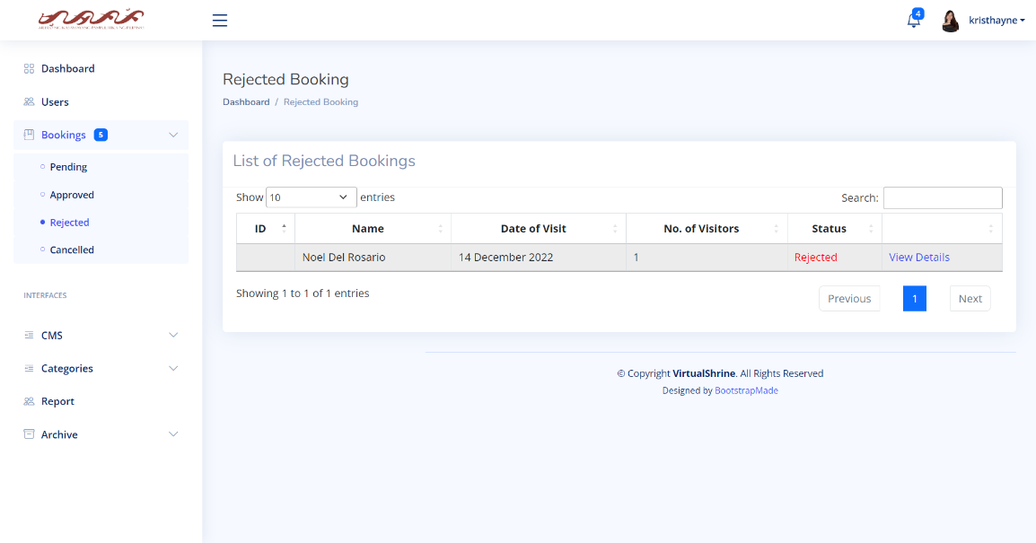Figure 45 displays the Rejected Booking panel, which allows admins to view and manage a list of all the bookings that have already been rejected.

**Figure 45. Rejected Booking Panel**

This panel provides the user with an overview of all the rejected bookings, including details such as the booking ID, and name of visitor. This panel is an essential tool for admins to ensure all bookings are handled efficiently.

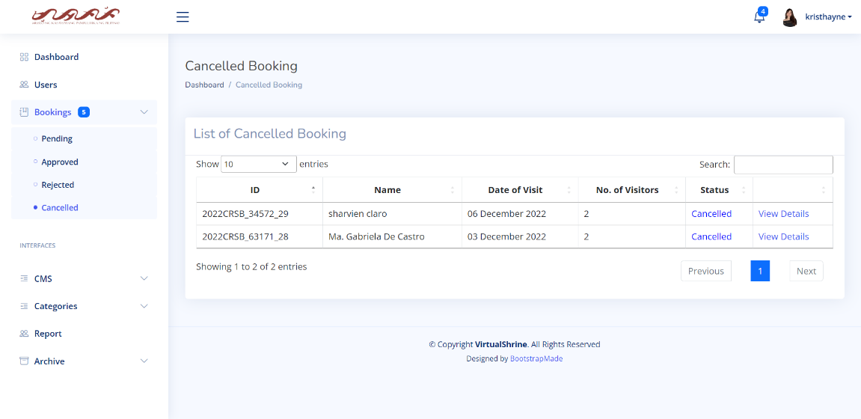Figure 46 displays the Cancelled Booking panel, which allows admins to view the bookings that have been cancelled by visitors.

**Figure 46. Cancelled Booking Panel**

This panel can help analyze visitor cancellation trends and make necessary changes to improve the booking experience.

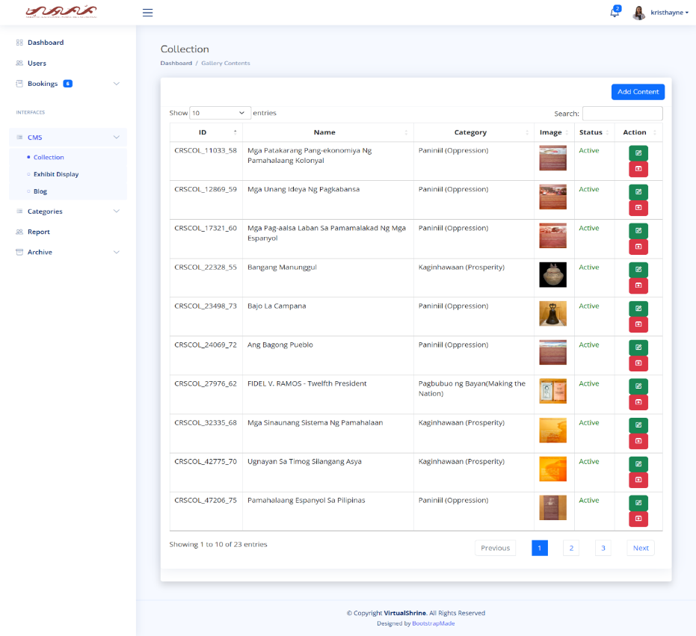Figure 47 illustrates the CMS - Collection panel of the website, providing admins with an overview of all the components in the website gallery.

**Figure 47. CMS - Collection Panel**

This panel includes a variety of gallery contents, allowing users to easily browse and find the items they are looking for. Additionally, this panel also allows admins to add new contents, and edit existing contents. Only the super admin can archive contents. Additionally, this panel also includes an advanced search option, allowing admins to quickly search for items. Furthermore, the panel also includes sorting and filtering tools which help users organize the contents and make it easier to navigate.

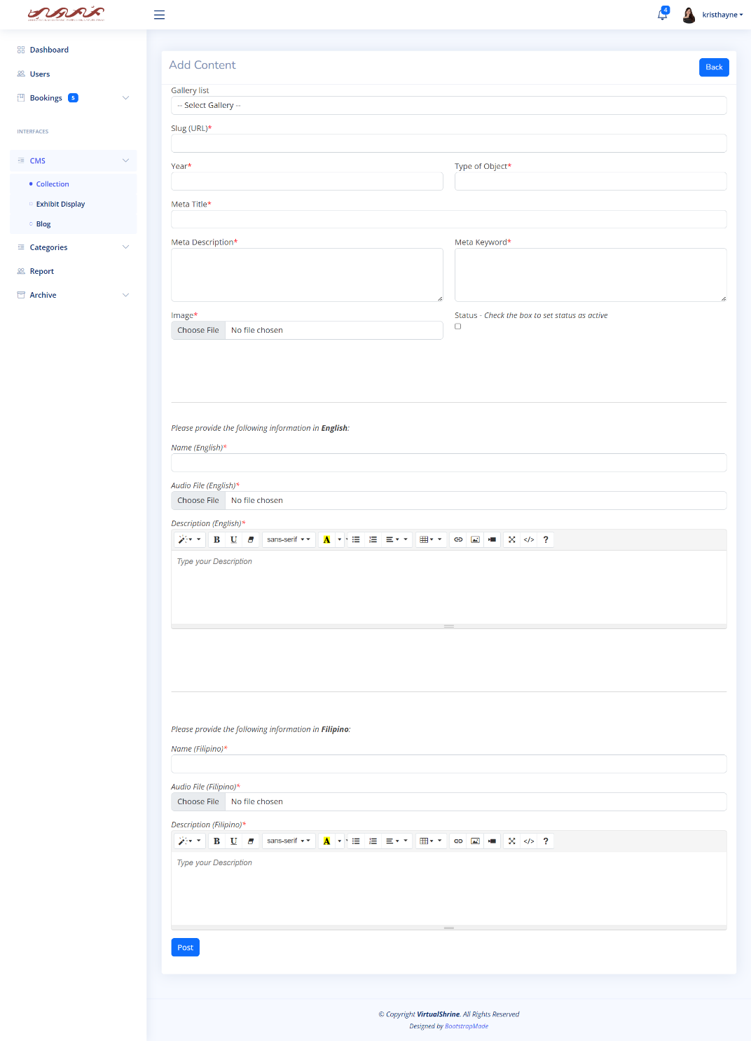 Figure 48 displays the Add Content form, this form will allow admins to upload new contents to the VirtualShrine website.

**Figure 48. Add Content Form**

This form provides admins with a variety of options for uploading content, such as text, images, and audio. Additionally, admins can enter title, description, and tags for the content. This form also allows admins to select the content type and visibility, as well as assign the content to a particular category. Once the necessary information is entered, admins can click the ‘Post’ button to upload the content to the website.

Figure 49 displays the Edit Content form which allows the admins to make changes to existing content in the VirtualShrine website.

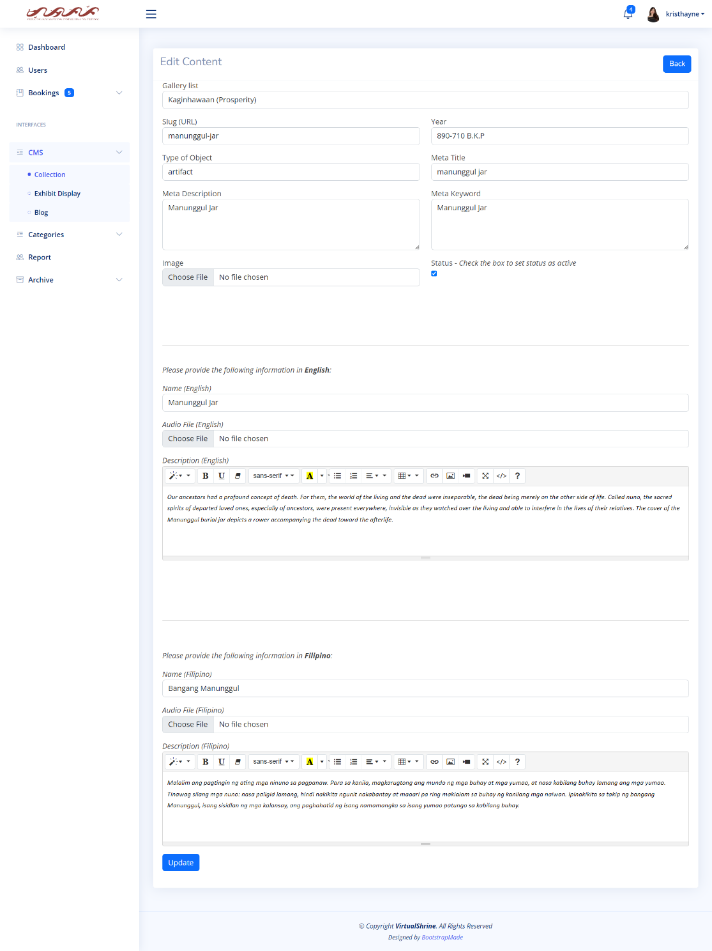

**Figure 49. Edit Content form**

This form provides the user with a range of options including the ability to modify existing content by deleting, adding, or editing text, images, and audio files. Other options such as setting the content's visibility can also be found in the Edit Content form. This form is an essential tool for the admins in managing and maintaining content on the VirtualShrine website.

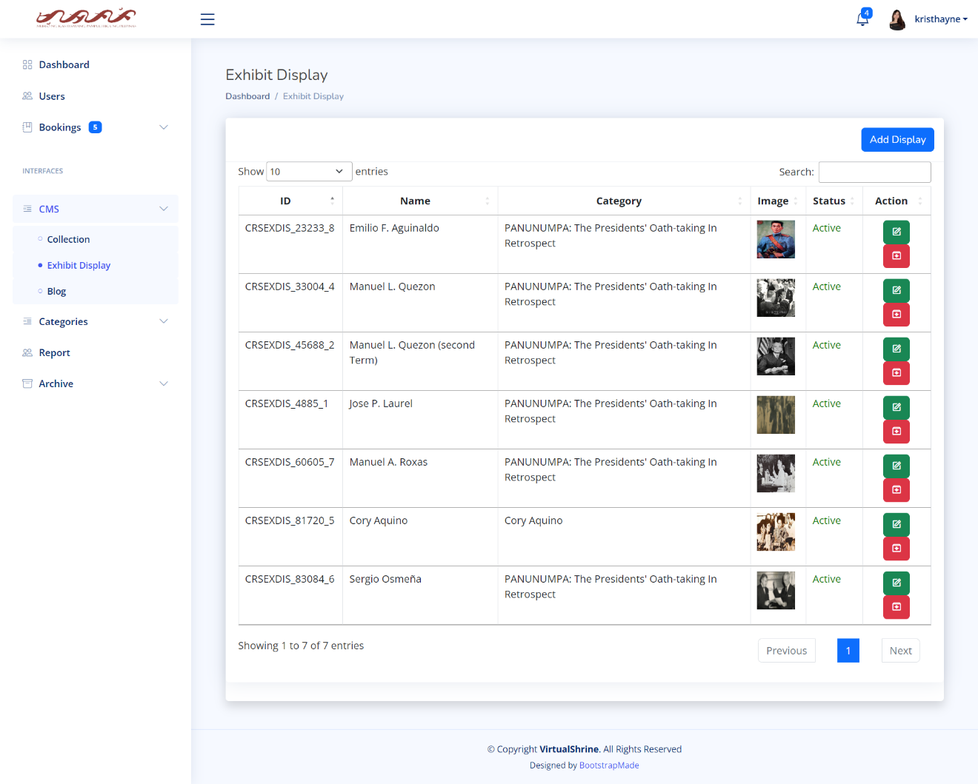 Figure 50 displays the CMS - Exhibit Display panel, which is a feature under the content management system (CMS) menu that allows administrators to view and manage all their Exhibit Displays in the VirtualShrine website.

**Figure 50. CMS - Exhibit Display panel**

This panel provides an overview of all of the Exhibit Displays created, including their titles, descriptions, and dates of creation. Additionally, admins can also see which displays are currently active or inactive, as well as any other relevant data associated with the displays. This feature of the CMS is useful for quickly and easily managing and monitoring the status of all displays in the exhibit.

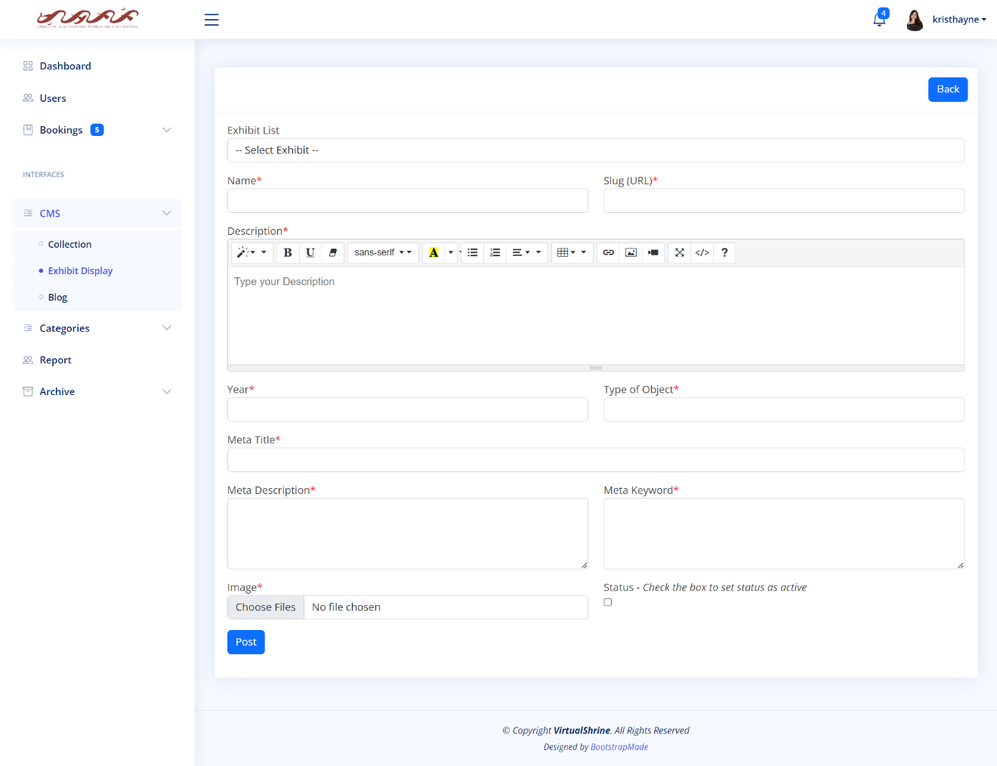Figure 51 displays the Add Exhibit Display form, which enables admins to create new exhibit displays for the VirtualShrine website.

**Figure 51. Add Exhibit Display form**

This form allows admins to easily create and manage new exhibit displays. Through the form, admins can select an active exhibit from the dropdown list to assign the display to a specific exhibit, and provide a Name, Description, and Image for the display. Once all the details are filled in, admins can click the 'Post' button to save the new exhibit display. This will add it to the chosen existing list of active exhibits, providing visitors with more information and visuals about the display.

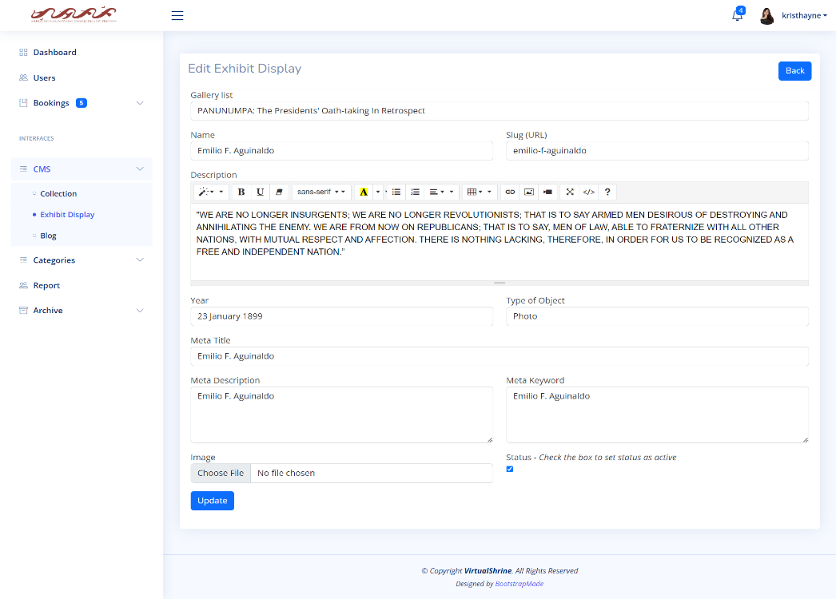Figure 52 displays the Edit Exhibit Display form which allows the admins to modify the existing Exhibit Display.

**Figure 52. Edit Exhibit Display**

Using this form, admins can make changes to the existing display, such as changing the name, description, and images associated with the Exhibit. Administrators also can change where the display is in the exhibit list, as well as change the status visibility of the display. With this form, admins have full control over the Exhibit Display, allowing them to customize it to meet their specific needs.

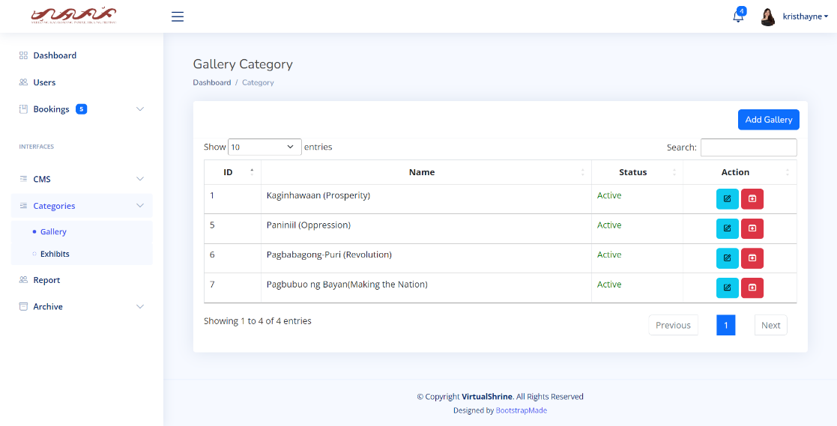 Figure 53 displays the Gallery Category panel, which enables administrators to view and manage the various Gallery Categories.

**Figure 53. Gallery Category**

This panel provides the ability to add, edit, and archive categories, as well as view a list of all categories and their associated images. Admins can also select images to assign to each category, allowing visitors to easily browse the galleries by category.

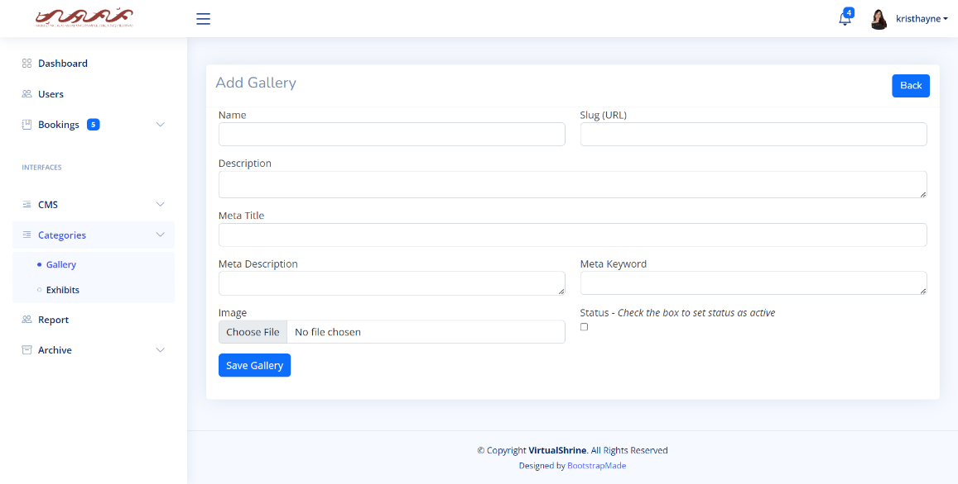Figure 54 displays the Add Gallery Category form which allows the admin to add a new Gallery Category into the VirtualShrine website.

**Figure 54. Add Gallery Category**

This form contains fields for the category name, and description. After entering the required information, the admin can click the Save Gallery button to add the new category. The newly added category will then be visible on the Gallery page (Figure 23), allowing users to view the category and its contents.

Figure 55 displays the Edit Gallery Category form, which allows the admins to edit an existing Gallery Category.

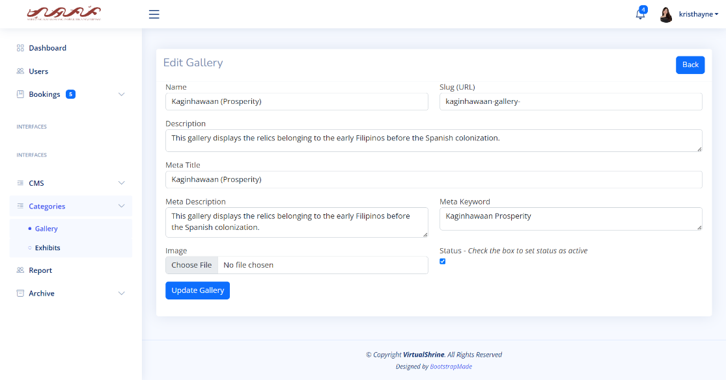

**Figure 55. Edit Gallery Category form**

Admins can use this form to change category name, description, active status, and change or remove images. This form is essential for organizing and managing gallery categories.

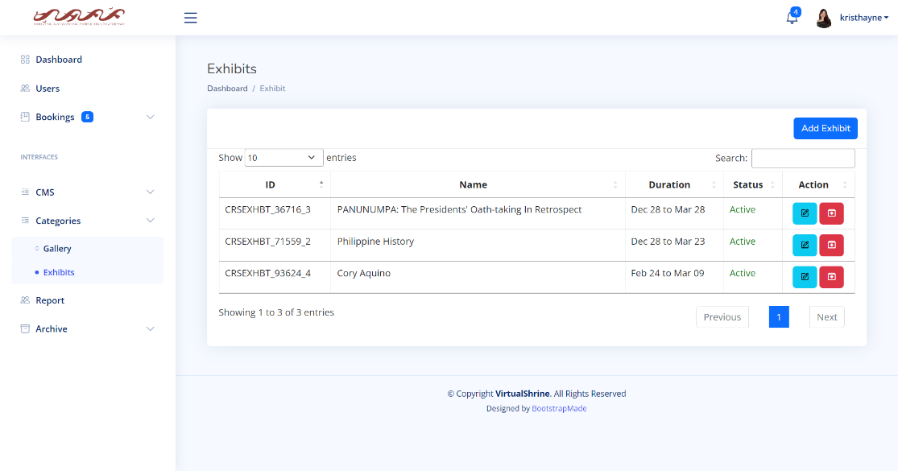Figure 56 displays the Exhibits panel, which enables administrators to view and manage the various Exhibits.

**Figure 56. Exhibits Panel**

This panel provides a variety of options, such as creating a new Exhibit, editing an existing Exhibit, and archiving an Exhibit. Additionally, the Exhibits panel allows administrators to view a list of all Exhibits, view the details of each Exhibit, and enable or disable a particular Exhibit.

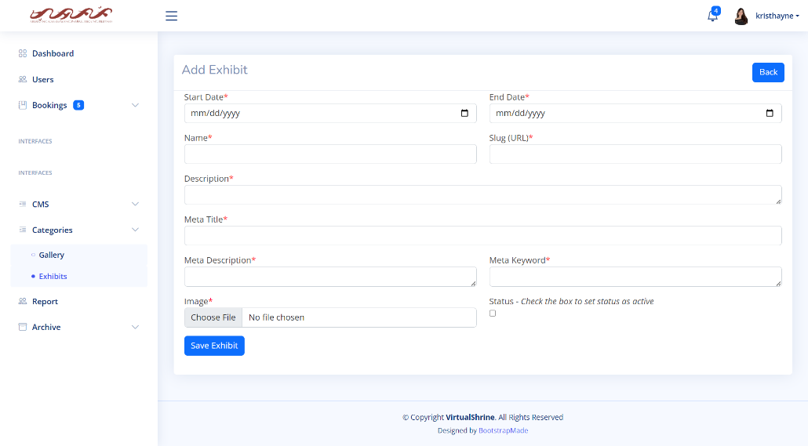 Figure 57 displays the Add Exhibit form, which allows the admins to create a new exhibit for the VirtualShrine Website.

**Figure 57. Add Exhibit form**

This form is used to input all the information concerning the new exhibit, including the exhibit’s start and end date, name, and description, along with the associated images. Once all the required details have been filled in and the form is submitted, the new exhibit will be added to the system and can be viewed by all users.

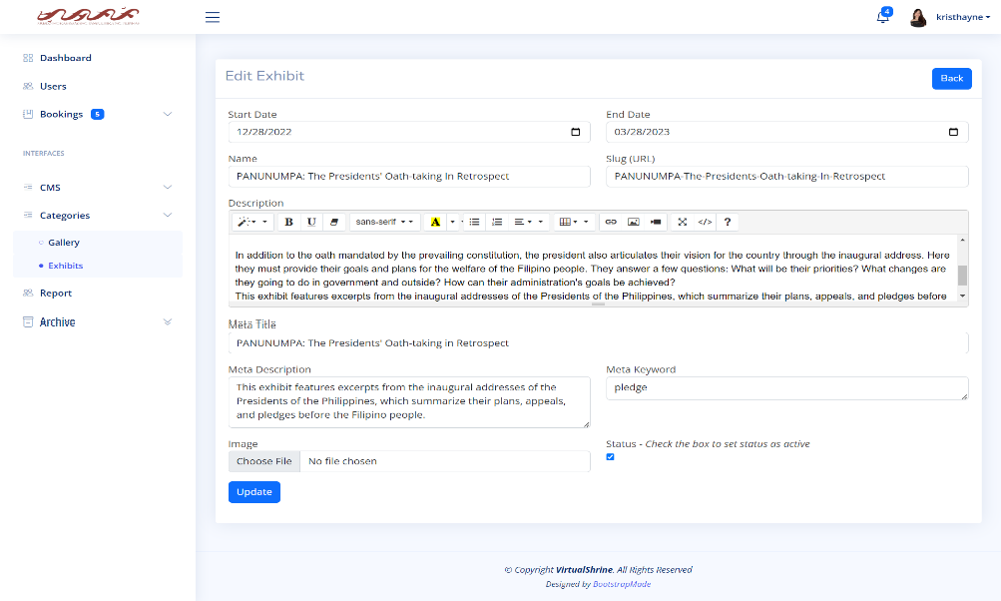Figure 58 displays the Edit Exhibit form, which allows admins to modify existing exhibits.

**Figure 58. Edit Exhibit Form**

This form is used to edit existing exhibit information such as the start and end date, exhibit name and description, and associated images. Additionally, admins can add new images, delete existing ones, or rearrange the order of the images. Once all the necessary changes have been made and the form is submitted, the exhibit will be updated within the system and the changes will be visible to all users.

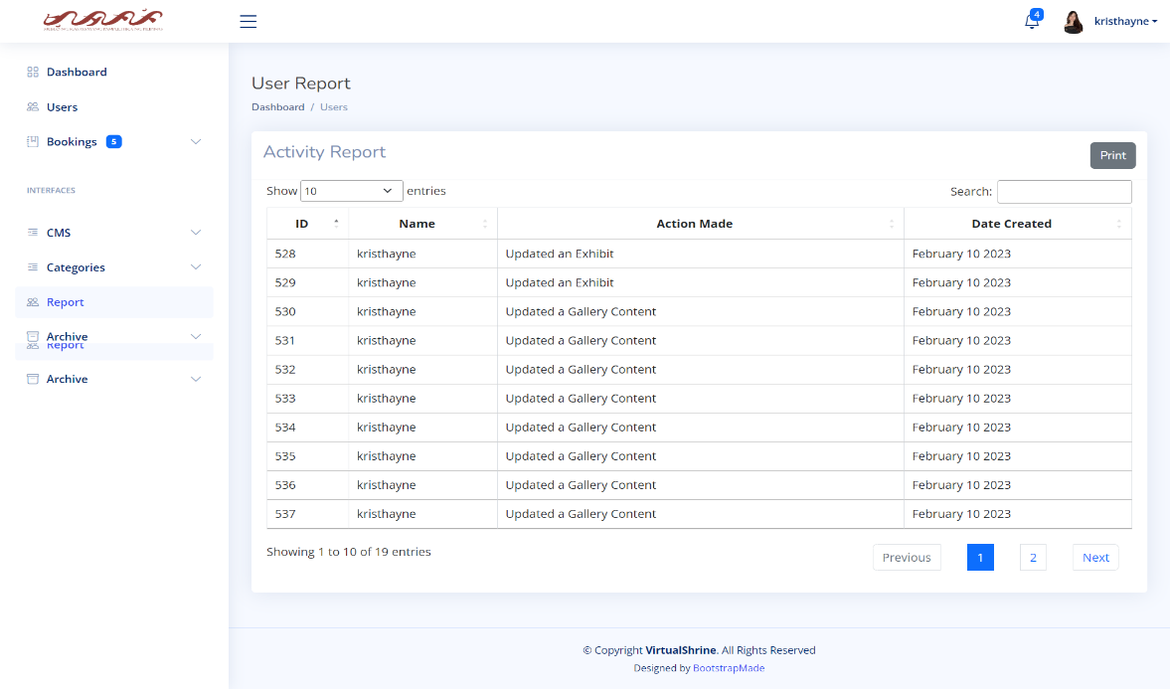Figure 59 displays the User Report panel, which the super admin can use to track the activity of all assistant admins within their organization.

**Figure 59. User Report panel**

This panel gives the super admin a comprehensive view of assistant admin activities, allowing for easy search and viewing. They can view activities such as modifying website content, approving, or declining museum visitor bookings, and changing assistant admin accounts.

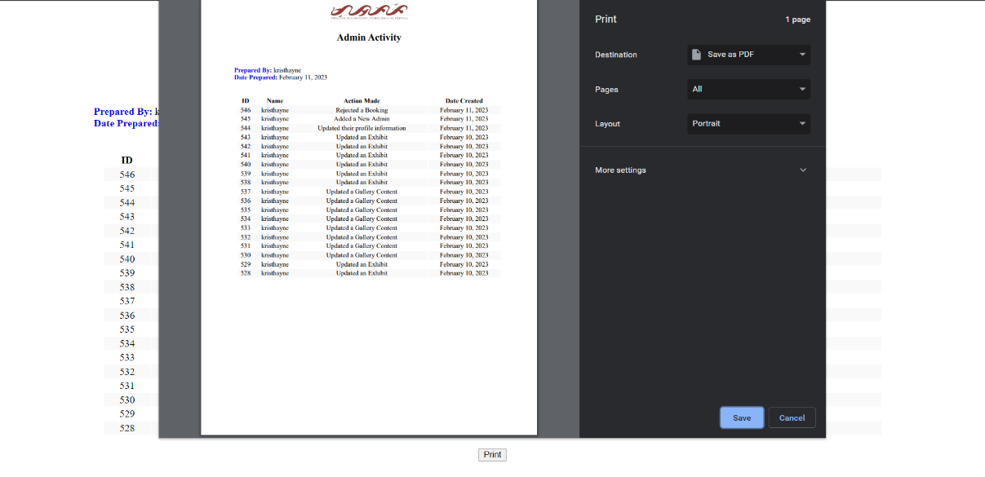Figure 60 displays the Print User Report.

**Figure 60. Print User Report**

The super admin can export the report results as a PDF, providing flexibility and convenience when needing to view the report results.

# **CHAPTER IV**

**RESULTS AND DISCUSSION**

The main purpose of this chapter is to provide the presentation, analysis and interpretation of data that has been categorized in accordance with the sequence of questions enumerated in the first chapter. All of the data collected from the evaluators were presented in tabular form with corresponding discussion and explanation of the findings obtained.

**Part I. Development of VirtualShrine: An interactive museum website for Casa Real Shrine**

Over time, museums continue to be forgotten by people, so some of them do not know about the importance of history. One of them is the Casa Real Shrine of Malolos. Because of the continuous advancement of modern technology, some of what can be seen in the museum can also be seen on the internet, the proponents have looked for a way so they introduced the “Virtual Shrine” a website that people can use to see what’s inside of the Casa Real Shrine and can book for their visit via online booking.

* 1. **Online Booking Reservation**

**Booking Consent Form**

Figure 61 displays the Booking Consent Form page. This page contains a statement regarding the collection of the visitor’s booking information.

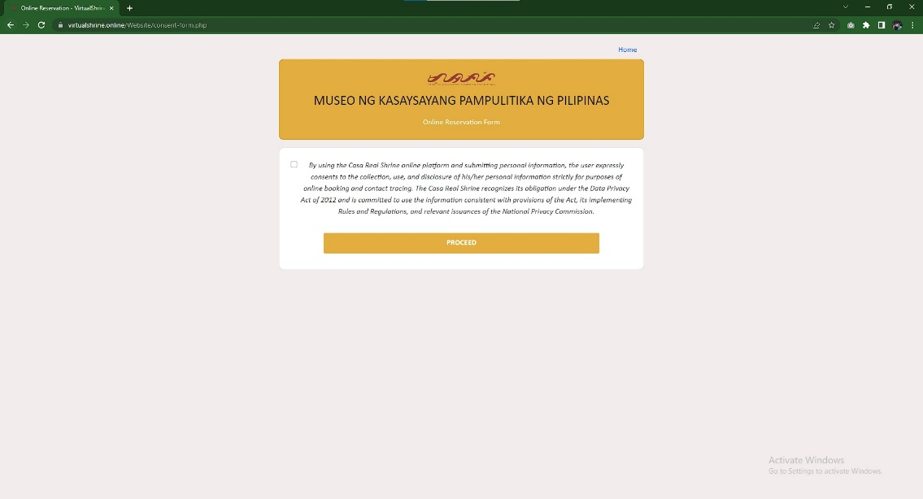

**Figure 61.** **Booking Consent Form**

This page is required because the visitor will have to provide their personal information. By checking the consent for checkbox, the visitor consents the collection of their information.

**Booking Form**

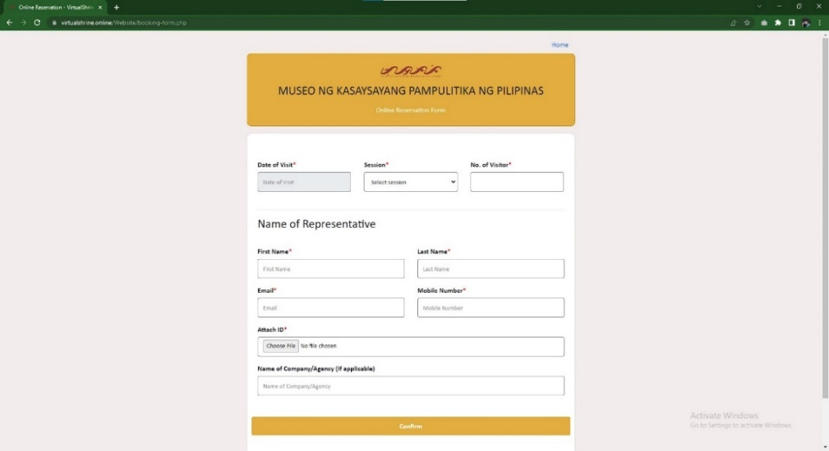 Figure 62 displays the Booking form which allows visitors to make a reservation for a museum visit. The form requires the visitor to provide necessary information for the booking process.

**Figure 62.** **Booking Form**

This form is a necessary part of the process to ensure that the visitor's reservation is valid and allows the museum management to keep track of the number of visitors they have at any given time. The information gathered from this form is essential for the business to manage their guest flow and ensure everyone has an enjoyable experience.

**Booking Submitted Confirmation Page**

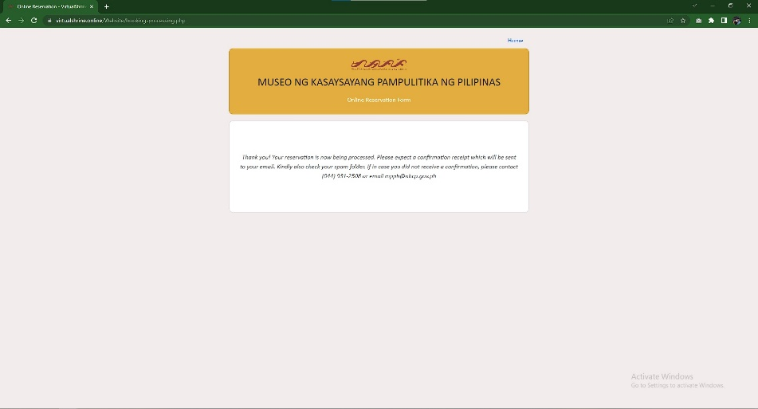Figure 63 displays the booking confirmation page.

**Figure 63.** **Booking Submitted Confirmation Page**

This page is displayed when the visitor’s booking is submitted successfully and is being reviewed by the administrator if all the details that the visitor provided are valid.

* 1. **Virtual Museum Tour**

**Access to the Virtual Tour Page**

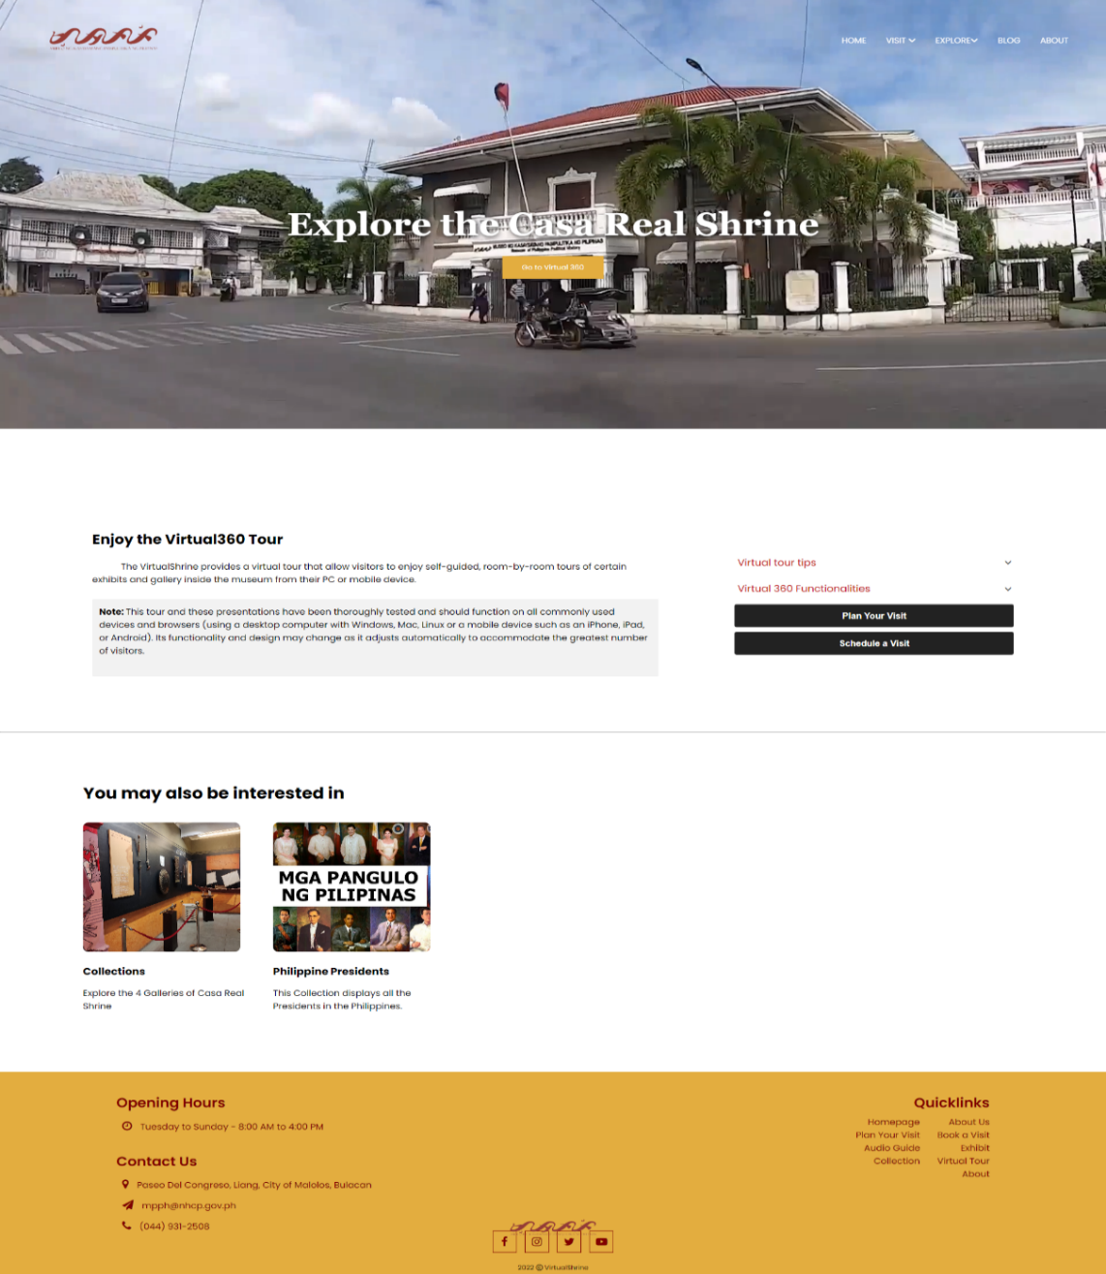Figure 64 displays the access page to the website's Virtual Tour feature. The website allows visitors to explore the museum virtually through a 360-degree viewing experience, enabling them to get an immersive, interactive experience of the museum from the comfort of their own home.

**Figure 64. Access to the Virtual Tour Page**

Figure 62 shows the page users must access before exploring the virtual tour, which is displayed in subsequent figures. By providing this feature, the website allows visitors to get a better understanding of the museum's layout and features before deciding if they would like to visit in person.

**Casa Real Shrine Virtual 360**

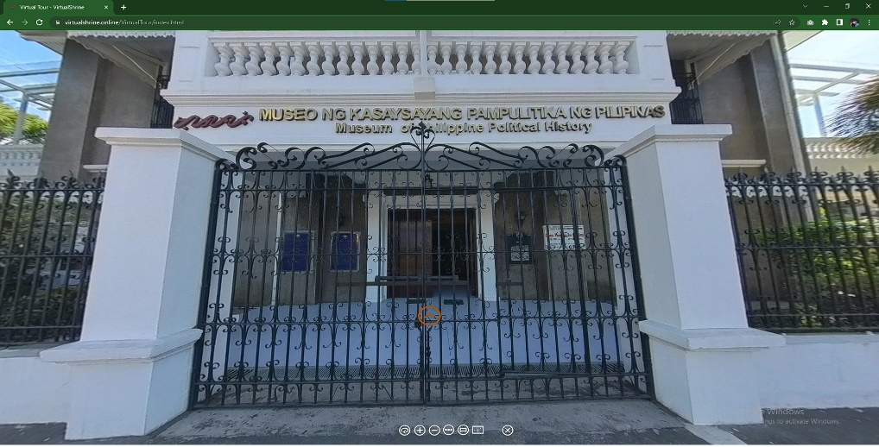Figure 65 displays the landing page when the user opens the virtual tour.

**Figure 65.** **Casa Real Shrine Virtual 360**

The yellow Door icon is the hotspot for the user to access inside the museum. At the bottom part of, the screen displays the controller for the virtual tour. This helps the user to familiarize themselves with the virtual 360 and navigate it easily.

**Casa Real Shrine Lobby Virtual 360**

Figure 66 displays the first room of the museum after entering the building. The Visitor can swipe from left and right to view the surroundings of the room and to interact with other hotspots they can use for other information of the museum.

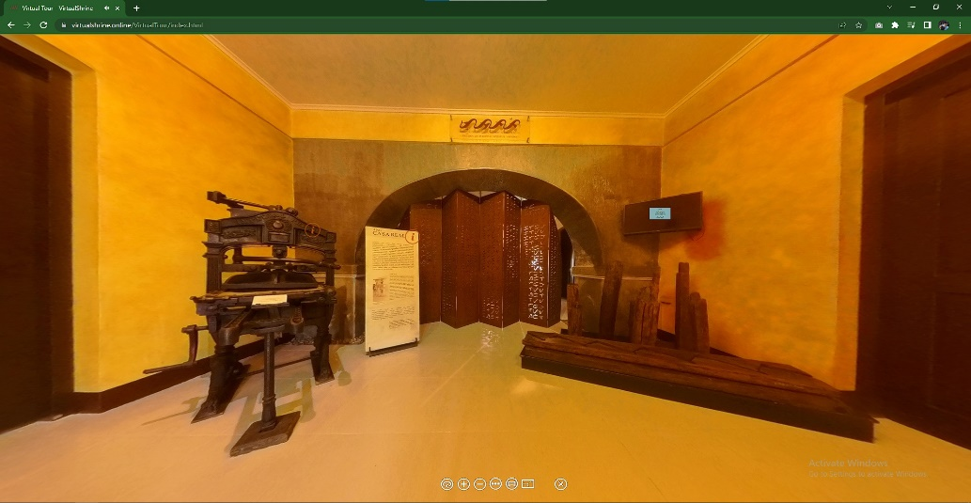

**Figure 66.** **Casa Real Shrine Lobby Virtual 360**

The hotspot where the visitor can use to interact with the display in the museum. If the visitor presses the hotspot, the system will display a pop-up with the definition of the display.

* 1. **Gallery Collections**

**Galleries Page**

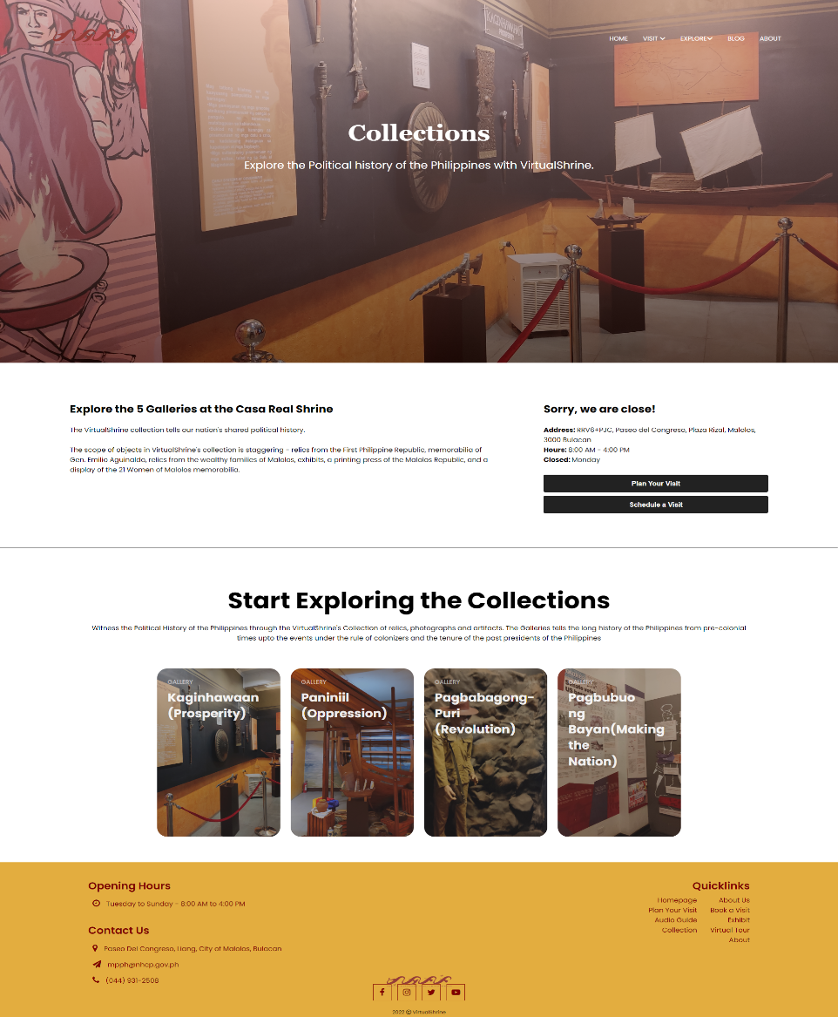Figure 67 displays the galleries page of the VirtualShrine Website. Each card corresponds to a different gallery collection page, including Kaginhawaan (Prosperity), Paniniil (Oppression), Pagbabagong-puri (Revolution), and Pagbuo ng bayan (Making the Nation).

**Figure 67. Galleries Page**

It is designed to be user-friendly, allowing visitors to easily navigate through the different galleries. The page is divided into four sections, each containing an image hyperlink that leads to a collection page. Each collection page contains detailed descriptions of the items in that gallery, as well as images and videos to further illustrate the content. Additionally, the page includes an interactive map of the museum, allowing visitors to explore the different galleries in an immersive and engaging manner.

**Galleries Collections**

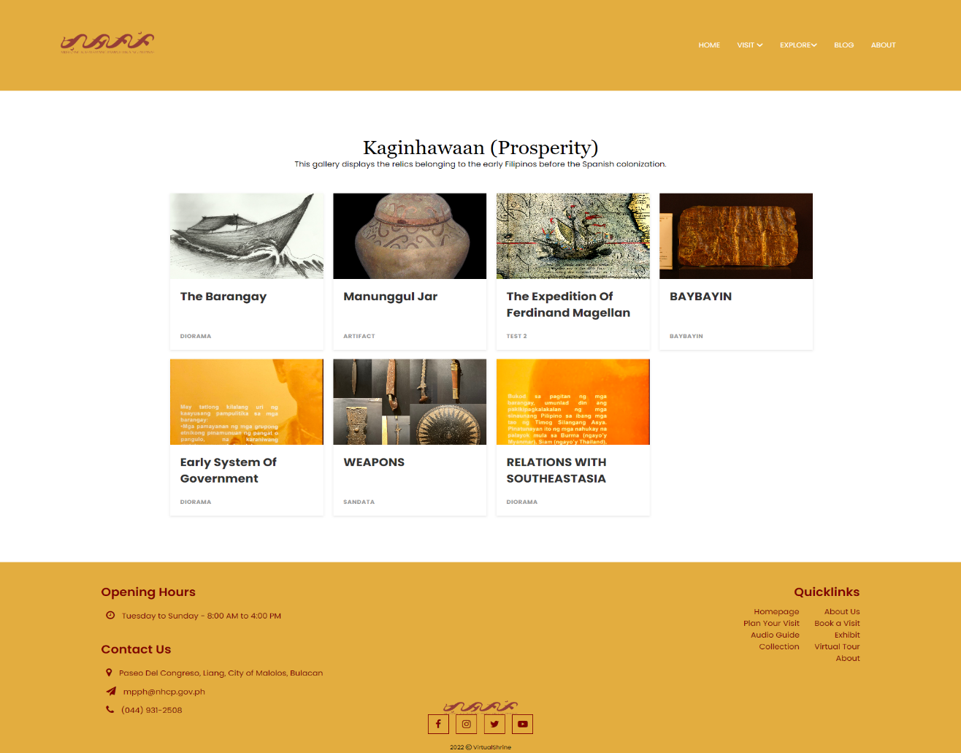Figure 68 displays the gallery Collections page, which provides visitors with an overview of the various displays or artifacts found inside the gallery.

**Figure 68.** **Galleries Collections**

It is designed to provide viewers with an overview of the various displays and collections available within the gallery. The page features a grid-style layout with each collection represented by a thumbnail image. The Gallery Collections page is designed to give users an overview of the collections and displays offered within the gallery, and to provide easy access to further information.

**Display Description**

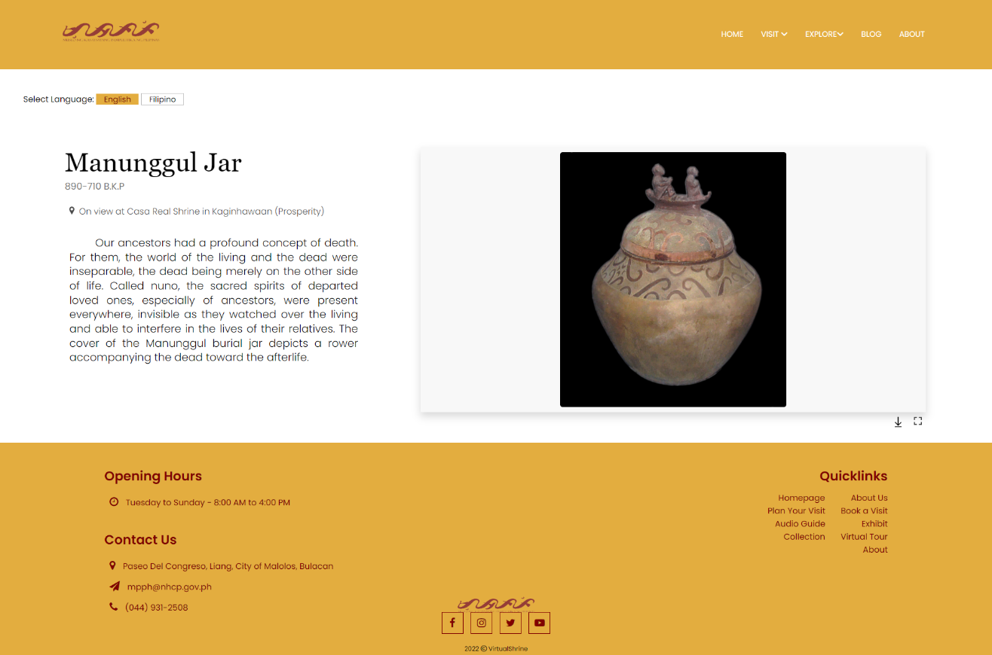Figure 69 is a website page that displays information about a particular artifact. Visitors can view the picture and description of the artifact, as well as download the image.

**Figure 69.** **Display Description**

This page is designed to provide visitors with an easy way to access information about the artifact and to conveniently obtain a copy of it. Additionally, the page also provides visitors with the option to choose the language for the description. This interactive website page allows visitors to gain a better understanding of the artifact and its history. The page is designed to be user-friendly and intuitive, with an easy-to-navigate layout. The page includes a clear picture of the artifact and a concise description that is informative and engaging.

**1.4 User Assisting Features**

**Plan Your Visit Page**

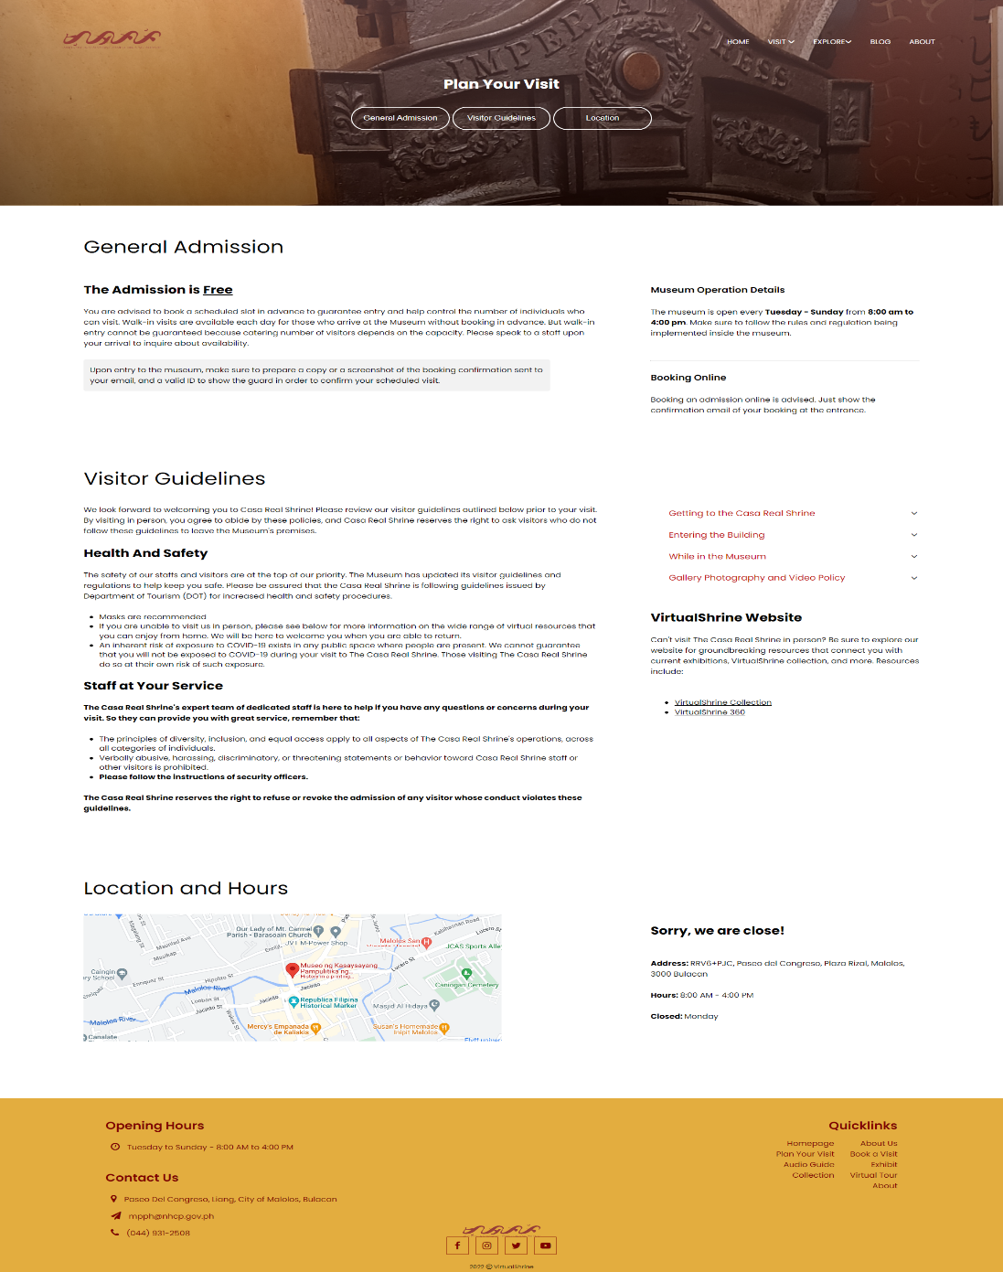Figure 70 displays the general information regarding the operation of Casa Real Shrine such as the operation time and day, and Health and Safety Guidelines that is being implemented in the museum.

**Figure 70.** **Plan Your Visit Page**

The website page is designed to make visitors aware of the protocols and restrictions in place to ensure their safety during their visit. It is organized in a clear and straightforward manner, allowing visitors to quickly find the information they need.

**Audio Guide**

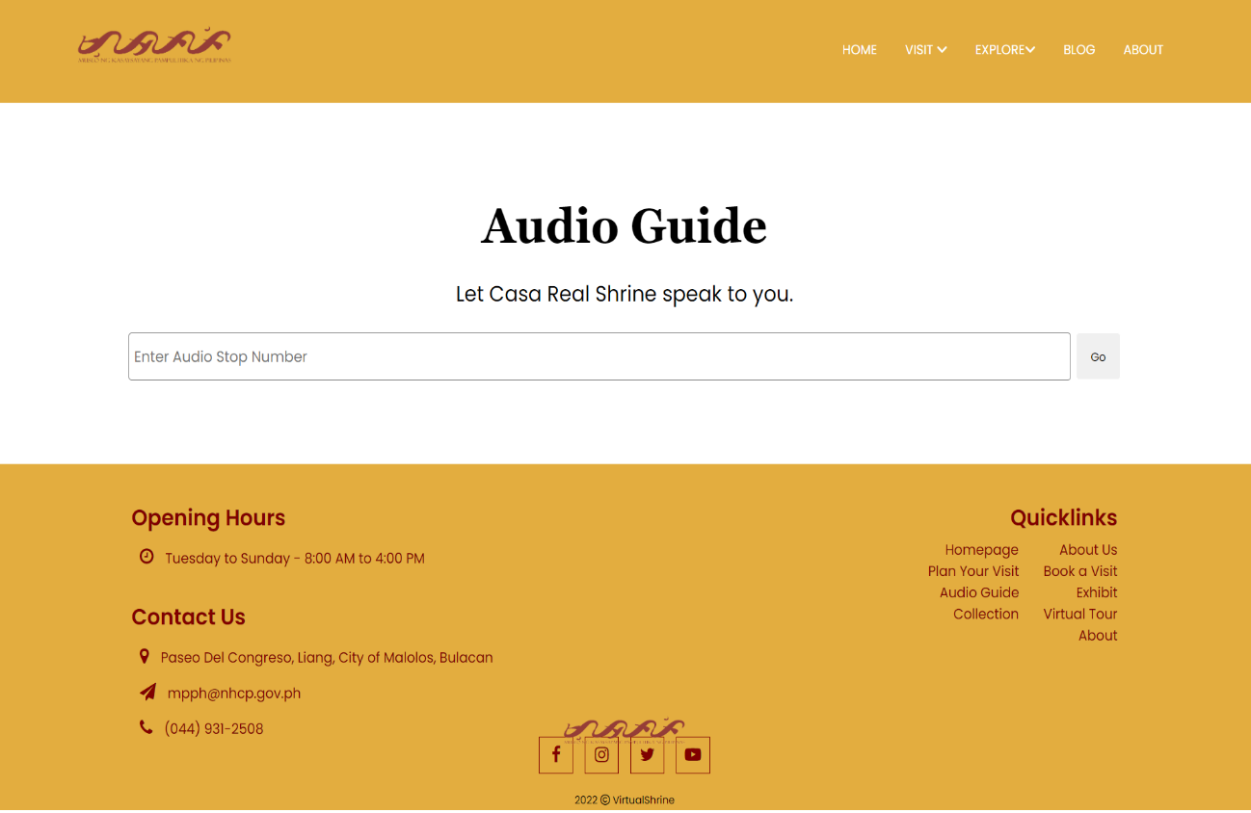 The audio guide page on Figure 71 is a page that allows users to gain access to audio guides for each display.

**Figure 71.** **Audio Guide**

The page is designed with a textbox where the user can input the audio stop number. The audio guide page is a useful resource for visitors to learn more about the different displays without having to read text, since they can hear all the relevant information in an audio format. The page is designed in a simple and straightforward manner, with a textbox as the focus, so that visitors can gain access to the audio guides quickly and easily.

**Part II. To design and develop a Management System**

In order to better manage the website content and allow admins to upload and modify the contents seen on the website, a Management System was developed.

**2.1 Manage User Admins**

**User Management**

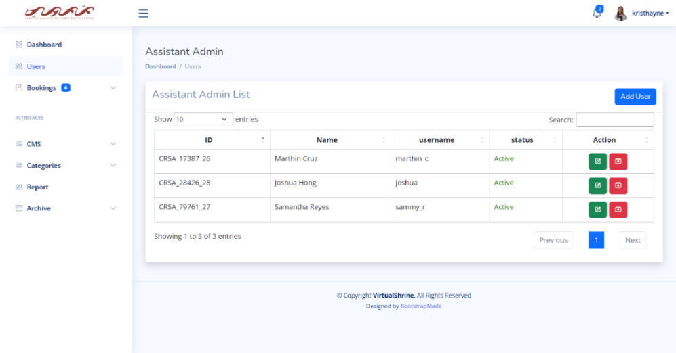 Figure 72 shows the user management panel. This is where the super admin can be able to view all the assistant admins.

**Figure 72.** **User Management**

The panel is designed to provide a clear and concise overview of the users. It displays a table containing their ID, Name, Username and Status, as well as two action buttons, edit and archive, to allow the super admin to update the user's information and remove them if necessary. Additionally, the page is designed with an intuitive interface, allowing the super admin to easily navigate through the user information and make any necessary changes.

**Edit User Information**

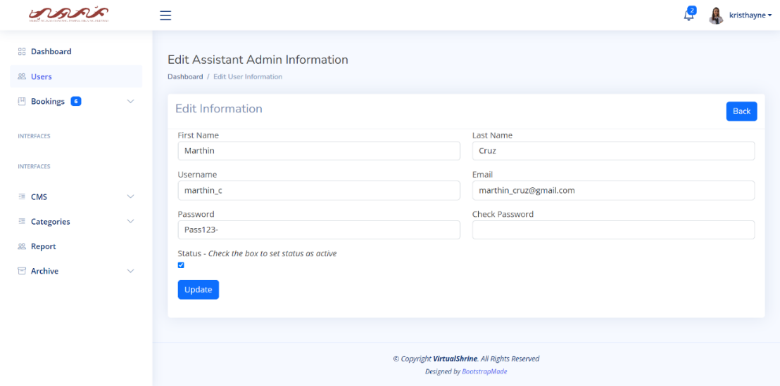Figure 73 displays the Edit User Information form, which is a page designed so that the Super Admin can make desired modifications or changes to the user information.

**Figure 73.** **Edit** **User Information**

The page is designed with a simple and user-friendly interface, making it easy and accessible for the Super Admin to make any necessary changes to the user information. This page is essential for the Super Admin as it allows them to make any changes quickly and easily, they need to the user information.

**Add New User**

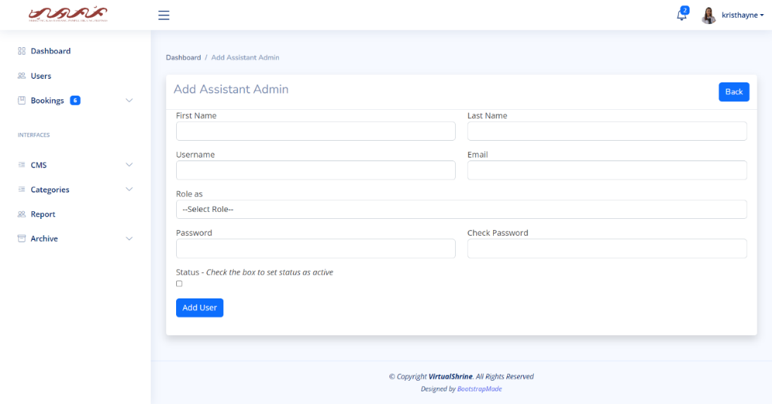Figure 74 displays the Add User Information form, a web page designed for Super Admins to add the details of any new admins on the system.

**Figure 74.** **Add New User**

This page is designed with a simple yet effective layout. By providing a simple and straightforward design, this page allows Super Admins to add any new admins quickly and easily to the system.

**2.2 Accept and Reject Visitor Booking**

**View all Pending Booking**

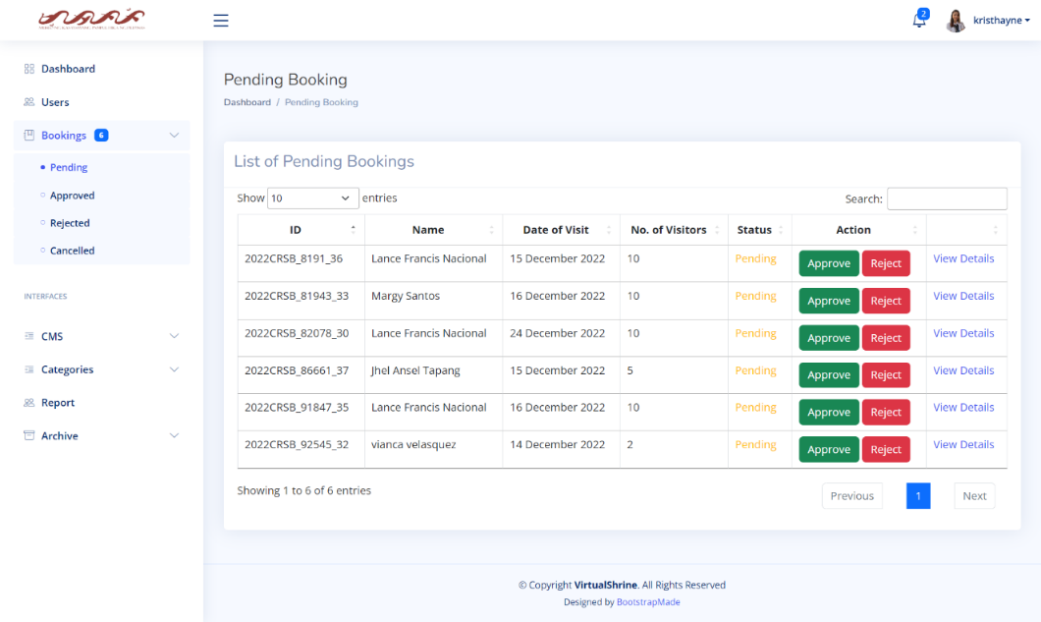In Figure 75, a table displays the pending bookings, including the Booking ID, Name of Visitor, Date of Visit, Number of Visitors, and status of the booking.

**Figure 75.** **View all Pending Booking**

The purpose of this page is to provide the admin with an overview of the pending bookings, including their details. To view additional information, the admin can click “View Details”. The website page is designed with an organized layout, making it easy for the admin to quickly review the bookings without having to look through multiple pages. The table is structured and clearly displays all the necessary information, making it simple to identify the bookings that need to be processed.

**View More booking details**

Figure 76 displays the page where the complete booking details is displayed. This page allows the admin to view and manage the bookings that have been requested by visitors.

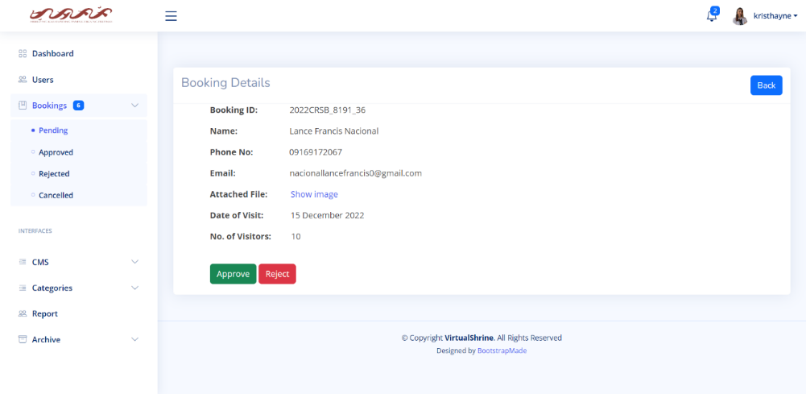

**Figure 76.** **View More booking details**

It displays the Booking ID, Name, Phone Number, Email, Attached File, Date of Visit, and Number of Visitors, as well as allowing the admin to perform an action such as approving or rejecting the booking. The page is designed with an intuitive interface, allowing the admin to view the booking details and act, quickly and easily.

**Attached File preview**

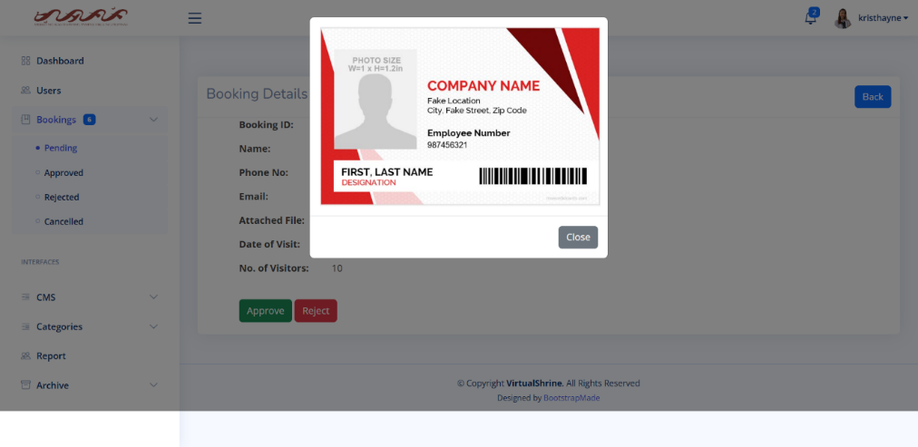Once the admin clicks the "show image" button, Figure 77 displays the page response. This feature is used to allow admins to verify the legitimacy of the attached ID.

**Figure 77. Attached File preview**

The preview reveals the visitor's ID, allowing the admin to quickly check the accuracy of the booking information. This feature is designed in a user-friendly way, providing administrators with a clear overview of the visitor's details in an organized format. This allows administrators to verify the identity of a visitor and process the booking easily.

**2.3 Upload Website Content**

This module is the CMS of the Management System. This allows admins to upload and modify website contents.

**2.3.1 Collections**

**Content Management System – Collections**

Figure 78. It is designed to provide website administrators with an overview of collections on the website, as well as the ability to manage them.

**Figure 78.** **Content Management System – Collections**

The panel is composed of a table which displays information about each collection, such as its title, ID, the associated gallery, a preview image, and its status. Additionally, there are action buttons at the end of each row that allow the administrator to edit or archive the collection. This panel is an important tool for website administration, as it allows admins to quickly view and manage collections on the website.

**Content Management System – Edit Collection Information**

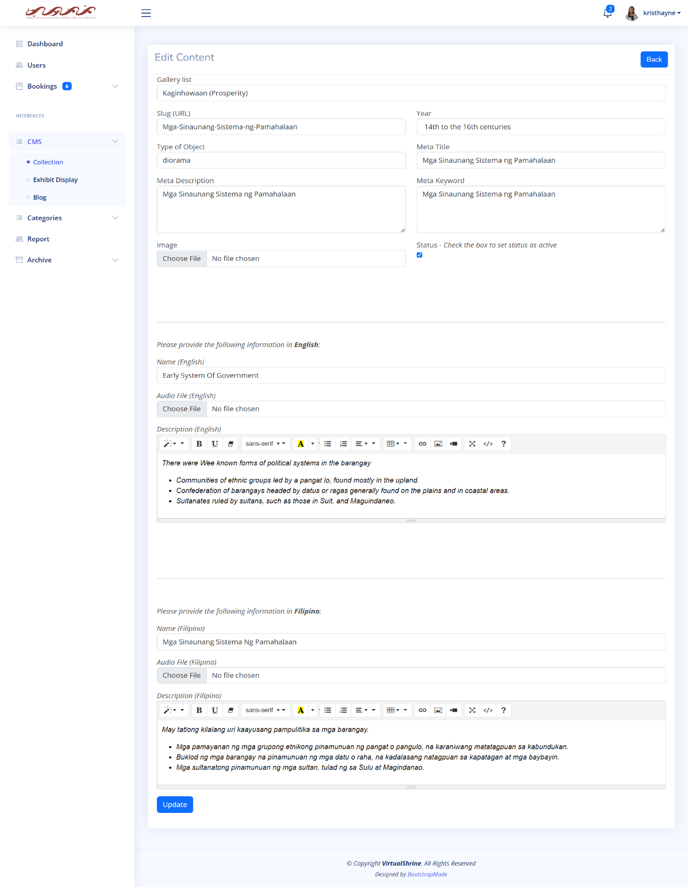As seen in Figure 79, the Edit Collection form allows website administrators to make changes to the display of collections on the website.

**Figure 79.** **Content Management System – Edit Collection Information**

It comprises range of input fields, including name, description, and a field for uploading an image. Additionally, admins can also manage the visibility of the collection display. The form is designed in a way that allows administrators to easily make changes to the collection display. It provides clear and concise labels for each field and includes helpful guidance to ensure that admins make the appropriate changes.

**Content Management System – Add new Collection**

In Figure 80, the Add new Collection form is shown. This is where the admin can add new collection that can displayed on its respective gallery category on the website.

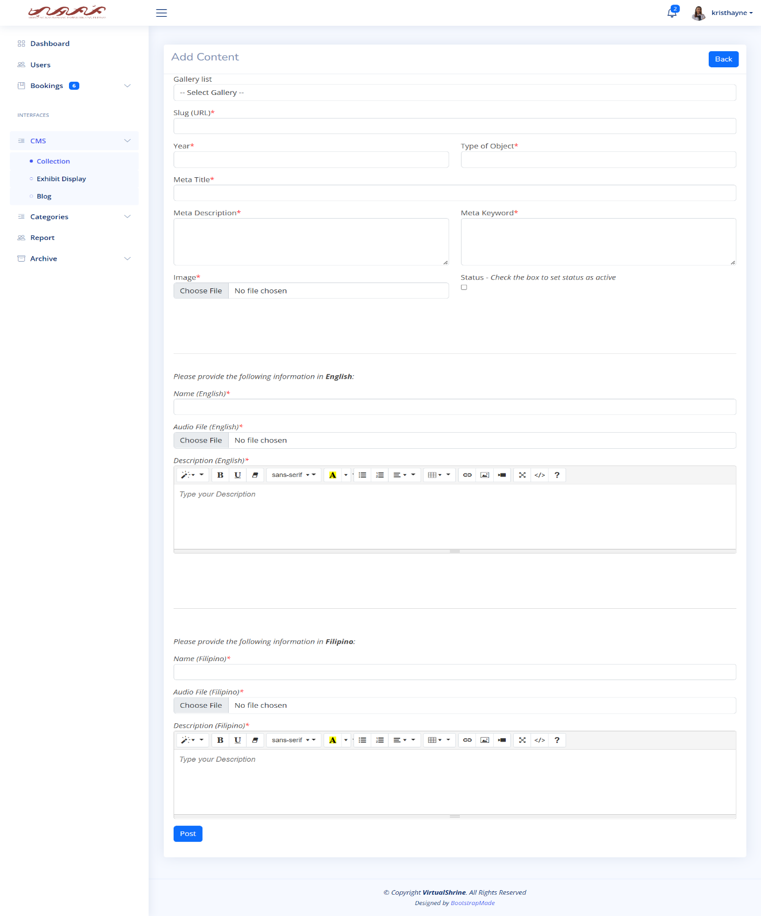

**Figure 80.** **Content Management System – Add new Collection**

Through this form, the admin can input the title and description of the collection, as well as the images to be featured in the gallery. This allows the admin to add new collections quickly and easily, making the website's gallery more dynamic and engaging.

**2.3.2 Exhibits**

**Content Management System – Exhibit Display**

Figure 81 displays the Exhibit Display Content Management System (CMS). This CMS provides a table that includes essential details about the Exhibit Display, such as its ID, Title or Name, the Exhibit it is associated with, a preview image, and its status.

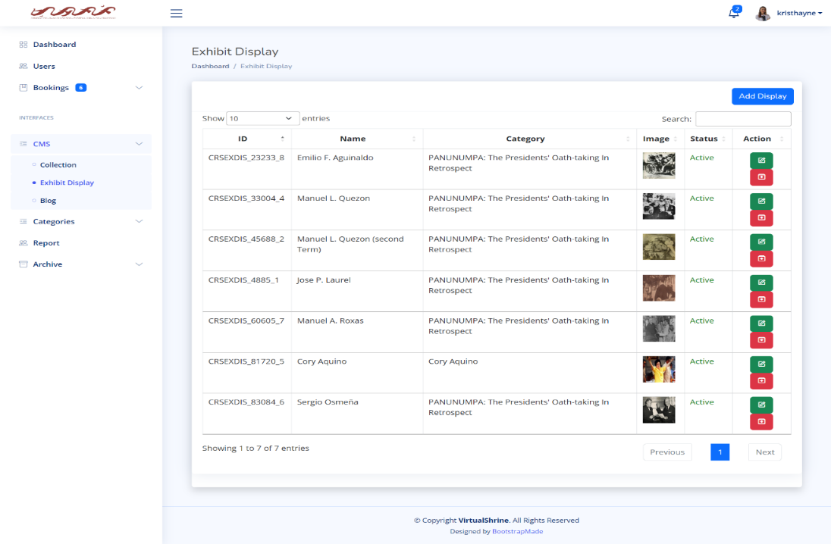

**Figure 81.** **Content Management System – Exhibit Display**

This panel provides action buttons for editing and archiving. The purpose of the Exhibit Display CMS is to allow administrators to easily access, edit, and manage all the Exhibits Displays. Through the CMS, users can quickly view the existing Exhibit Displays, add new ones, view, and modify existing ones, archive them, and more. This makes it easy to keep track of all the Exhibit Displays and ensure that they are updated and accurate.

**Content Management System – Add new Exhibit Display**

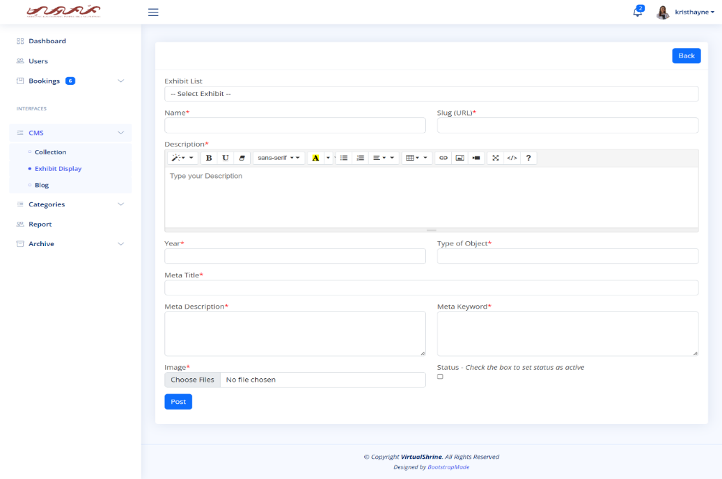In Figure 82, the Add new Exhibit Display form is shown. This is where the admin can add new Exhibit Display.

**Figure 82.** **Content Management System – Add new Exhibit Display**

The form includes fields for the name of the display, the type of display, and the description of the display. The purpose of the form is to provide a way for administrators to add new displays quickly and easily to an exhibit. This allows for more flexibility and customization of the exhibit, allowing for the creation of a truly unique and engaging experience.

**Content Management System – Edit Exhibit Display**

As seen in Figure 83, the Edit Exhibit display form designed to allow website administrators the capability to edit the Exhibit display information

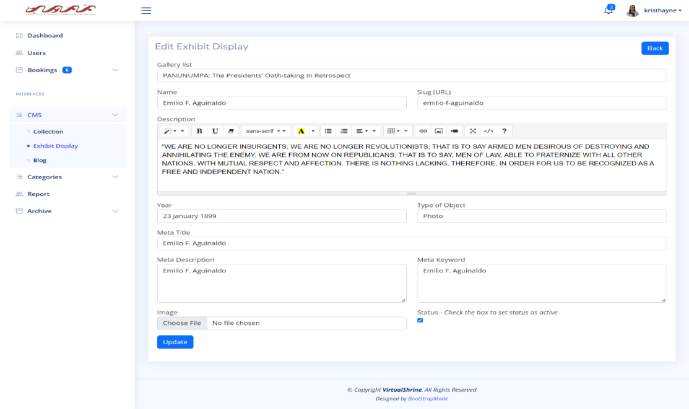

**Figure 83.** **Content Management System – Edit Exhibit Display**

This form allows admins to modify the content and format of the Exhibit display information to make it more attractive or easier to use for website viewers. The page also includes options for editing the Exhibit display title, description, and other related information. The page layout is user-friendly and intuitive, with clearly labeled inputs and buttons that allow admins to make changes quickly and easily. This form is an important tool for website administrators, as it allows them to keep the Exhibit display up-to-date and aesthetically pleasing.

**2.4 Generate and Print Admin Activity Record**

**Activity Report**

Figure 84 shows every activity like editing some of the website content or updating profile of the admin. It also includes the date when the data is changed.

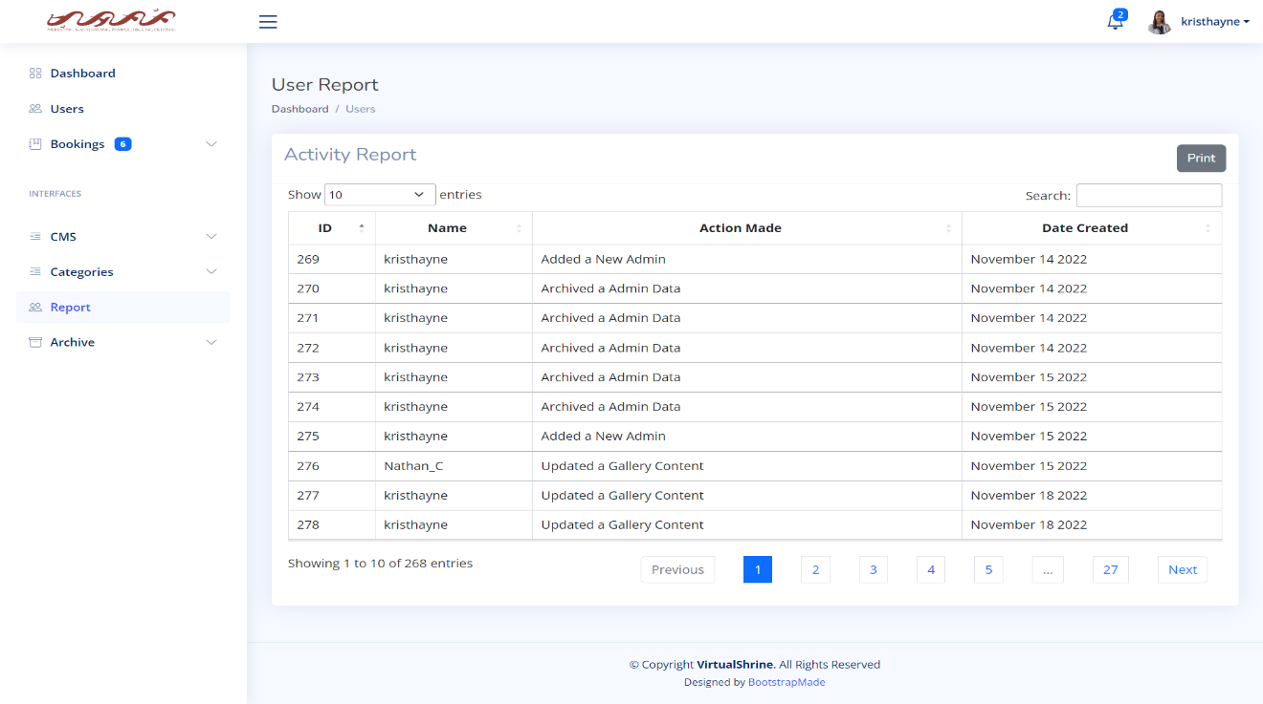

**Figure 84.** **Activity Report**

**Printing Report**

Figure 85 shows the printing report. This will help the admin to have a hard copy of the data when it needs to be submitted to the museum for the documentation.

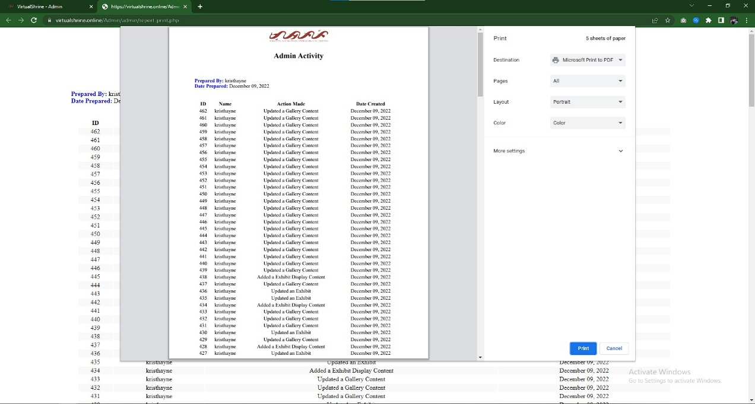

**Figure 85. Printing Report**

* 1. **Booking Confirmation through email after reservation**

**Email from the Administration**

Figure 86 displays the confirmation of booking reservation.

**Figure 86. Email from the Administration**

This confirmation email will automatically be sent to the email provided by the visitor during the booking process if the administrator approves their booking. The email includes the booking information, reminders, and the link for cancellation and rescheduling of booking.

**Part III. Software Quality Evaluation of the VirtualShrine: An Interactive Museum Website for Casa Real Shrine**

It is comprised of several tables that illustrate how well the VirtualShrine: An Interactive Museum Website performs. Table 4 shows the *Functional Suitability* criterion; Table 4 shows the *Performance Efficiency* criterion; Table 5 shows the *Usability* criterion; Table 6 shows the *Reliability* criterion; and Table 7 shows the *Portability* criterion. In addition, a table that presents the total number of respondents and a five-score Likert scale are also included. The developed application was assessed in terms of functional suitability, performance efficiency, usability, reliability, and portability using the ISO/IEC 25010:2011 or the Square - System and Software Quality Models.

Table 4 displays the Total Number of Respondents in this study, which includes twenty-five (25) individuals.

**Table 4**

**Total Number of Respondents**

|  |  |  |
| --- | --- | --- |
| **Evaluators** | **Frequency** | **Percentage (%)** |
| IT Professionals | 5 | 11% |
| CICT Faculty | 5 | 11% |
| Casa Real Shrine Museum Staff | 3 | 7% |
| Student | 12 | 27% |
| Local Tourist | 10 | 22% |
| Foreign Tourist | 10 | 22% |
| **TOTAL** | **45** | **100%** |

The respondents consist of five (5) IT Professionals who have a vast amount of experience working in the Information Technology field, five (5) Faculty Members from the College of Information and Communications Technology, twelve (12) students, ten (10) Local Tourists, ten (10) Foreign Tourists, and three (3) Casa Real Shrine Museum Staff. Collectively, these respondents are vital to this study as they provide insight into the topics being researched. The results they provide allow proponents to gain a better understanding of the study's objectives and draw meaningful conclusions.

Table 5 displays the 5-score Likert scale used to evaluate responses from 45 participants. The scale consists of five levels, namely 1 for Strongly Disagree, 2 for Disagree, 3 for Moderately Agree, 4 for Agree, and 5 for Strongly Agree.

**Table 5**

**5-Score Likert Scale**

|  |  |  |
| --- | --- | --- |
| **Scale** | **Range** | **Descriptive Interpretation** |
| 5 | 4.60-5.00 | Strongly Agree |
| 4 | 3.60-4.59 | Agree |
| 3 | 2.60-3.59 | Moderately Agree |
| 2 | 1.60-2.59 | Disagree |
| 1 | 0-1.59 | Strongly Disagree |

Each level is assigned a number and frequencies that indicate the degree of agreement or disagreement of the respondent. Furthermore, the computed mean of the responses is also presented. This scale is of great importance as it helps to accurately measure the opinion and attitude of the respondents and provides useful insights for decision-making.

Table 6 displays the Frequency Distribution and Descriptive Measures in the Evaluation of the Developed Website in terms of Functional Suitability.

**Table 6**

**Frequency Distribution and Descriptive Measures in the Evaluation of the Developed Website in terms of Functional Suitability**

|  |  |  |  |  |  |  |  |  |
| --- | --- | --- | --- | --- | --- | --- | --- | --- |
| ***No.*** | ***Characteristics*** | ***5*** | ***4*** | ***3*** | ***2*** | ***1*** | ***Mean*** | ***Descriptive Interpretation*** |
| 1 | ***Functional Completeness.*** The system functions according to its intended purpose. | **32** | **10** | **3** | **0** | **0** | **4.64** | Strongly Agree |
| 2 | ***Functional Correctness***. The system gives the exact output on each input per module. | **30** | **13** | **2** | **0** | **0** | **4.62** | Strongly Agree |
| 3 | ***Functional Appropriateness***. The system functions like any standard system entirely. | **32** | **10** | **3** | **0** | **0** | **4.64** | Strongly Agree |
|  | | **Weighted Mean** | | | | | **4.64** | **Strongly Agree** |

*4.60 - 5.00 Strongly Agree, 3.60 - 4.59 Agree, 2.60 - 3.59 Moderately Agree, 1.60 - 2.59 Disagree,0 - 1.59 Strongly Disagree*

Show Under the functional suitability sub characteristics, the functional completeness has a total mean of 4.64, interpreted as Strongly Agree, proved the developed website is capable to attain specified user objectives. Functional correctness has a total mean of 4.62, interpreted as Strongly Agree and still has a high acceptance rating from the respondents. And lastly, functional appropriateness has a total mean of 4.64, interpreted as Strongly Agree proved the developed website has an efficient and effective way of accomplishing all the specified tasks. Based on all the computed mean 4.64 is the final interpretation of the respondents it means that they are strongly agree that the website is with the functionality of the developed web portal.

Table 7 displays the Frequency Distribution and Descriptive Measures in the Evaluation of the Developed Website in terms of Performance Efficiency.

**Table 7**

**Frequency Distribution and Descriptive Measures in the Evaluation of the Developed Website in terms of Performance Efficiency**

|  |  |  |  |  |  |  |  |  |
| --- | --- | --- | --- | --- | --- | --- | --- | --- |
| ***No.*** | ***Characteristics*** | ***5*** | ***4*** | ***3*** | ***2*** | ***1*** | ***Mean*** | ***Descriptive Interpretation*** |
| 1 | ***Time-Behavior.*** The system's response and processing times, as well as its throughput rates, carry out its intended tasks and adhere to the specifications. | **34** | **7** | **3** | **1** | **0** | **4.64** | Strongly Agree |
| 2 | ***Resource Utilization.*** The amount and kind of resources used by the system meet the criteria. | **31** | **11** | **3** | **0** | **0** | **4.62** | Strongly Agree |
| 3 | ***Capacity.*** The system manages time efficiently and effectively. | **32** | **11** | **2** | **0** | **0** | **4.67** | Strongly Agree |
| 4 | ***System accuracy.*** The system accurately presents the output at the maximum level. | **33** | **9** | **3** | **0** | **0** | **4.67** | Strongly Agree |
|  | | **Weighted Mean** | | | | | **4.65** | **Strongly Agree** |

*4.60 - 5.00 Strongly Agree, 3.60 - 4.59 Agree, 2.60 - 3.59 Moderately Agree, 1.60 - 2.59 Disagree,0 - 1.59 Strongly Disagree*

The results indicate that the VirtualShrine website performed well in terms of its time behavior, resource utilization, capacity, and system accuracy. The respondents evaluated the website's performance efficiency highly, with a weighted mean of 4.65. This suggests that the website was able to meet the expected results in a short amount of time, while also using a small proportion of resources when in use. The data suggests that the VirtualShrine website is efficient in its performance, allowing users to effectively complete tasks with minimal effort.

Table 8 illustrates the items used to assess the compatibility of the newly developed website, VirtualShrine.

**Table 8**

**Frequency Distribution and Descriptive Measures in the Evaluation of the Developed Website in terms of Compatibility**

|  |  |  |  |  |  |  |  |  |
| --- | --- | --- | --- | --- | --- | --- | --- | --- |
| ***No.*** | ***Characteristics*** | ***5*** | ***4*** | ***3*** | ***2*** | ***1*** | ***Mean*** | ***Descriptive Interpretation*** |
| 1 | ***Co-Existence.*** The system can efficiently perform its required functions while sharing a familiar environment and resources with other systems, with no negative influence on any other method. | **34** | **9** | **1** | **1** | **0** | **4.69** | Strongly Agree |
| 2 | ***Interoperability.*** The system can exchange information and utilize data that has been exchanged between two or more platforms. | **30** | **12** | **3** | **0** | **0** | **4.6** | Agree |
| 3 | ***Flexibility.*** The system can be accessed on both phone and computer browsers. | **35** | **9** | **1** | **0** | **0** | **4.76** | Strongly Agree |
|  | | **Weighted Mean** | | | | | **4.69** | **Strongly Agree** |

*4.60 - 5.00 Strongly Agree, 3.60 - 4.59 Agree, 2.60 - 3.59 Moderately Agree, 1.60 - 2.59 Disagree,0 - 1.59 Strongly Disagree*

The categories of compatibility considered are Co-Existence, Interoperability, and Flexibility, each of which received a mean score of 4.96, representing a strong agreement with the idea that the website is compatible. This result indicates that Virtual Shrine has all the necessary features to make it compatible with other websites and user devices. Furthermore, this compatibility is critical in order for the website to successfully meet the needs of its users.

Table 9 displays the Frequency Distribution and Descriptive Measures in the Evaluation of the Developed Website in terms of Usability.

**Table 9**

**Frequency Distribution and Descriptive Measures in the Evaluation of the Developed Website in terms of Usability**

|  |  |  |  |  |  |  |  |  |
| --- | --- | --- | --- | --- | --- | --- | --- | --- |
| ***No.*** | ***Characteristics*** | ***5*** | ***4*** | ***3*** | ***2*** | ***1*** | ***Mean*** | ***Descriptive Interpretation*** |
| 1 | ***User friendly****. The design of the system is easy to understand and use.* | **32** | **10** | **3** | **0** | **0** | **4.64** | Strongly Agree |
| 2 | ***Acceptability Recognizability.*** *Users are able to determine whether the system is suitable for their requirements.* | **33** | **11** | **1** | **0** | **0** | **4.71** | Strongly Agree |
| 3 | ***System Utility.*** *The system can generate reports that can be viewed online (and can be download).* | **32** | **10** | **3** | **0** | **0** | **4.64** | Strongly Agree |
| 4 | ***Operability.*** *The system is simple to use, navigate.* | **38** | **7** | **0** | **0** | **0** | **4.84** | Strongly Agree |
|  | | **Weighted Mean** | | | | | **4.71** | **Strongly Agree** |

*4.60 - 5.00 Strongly Agree, 3.60 - 4.59 Agree, 2.60 - 3.59 Moderately Agree, 1.60 - 2.59 Disagree,0 - 1.59 Strongly Disagree*

This table shows the items used to determine the usability of the developed website which is categorized into the following: User-Friendly, Acceptability Recognizability, System Utility and Operability. The evaluation of the website's usability resulted in a total mean of 4.71, which is interpreted as 'Strongly Agree', indicating that the website Virtual Shrine has all the necessary features to provide an enjoyable user experience.

Table 10 displays the Frequency Distribution and Descriptive Measures in the Evaluation of the Developed Website in terms of Reliability.

**Table 10**

**Frequency Distribution and Descriptive Measures in the Evaluation of the Developed Website in terms of Reliability**

|  |  |  |  |  |  |  |  |  |
| --- | --- | --- | --- | --- | --- | --- | --- | --- |
| ***No.*** | ***Characteristics*** | ***5*** | ***4*** | ***3*** | ***2*** | ***1*** | ***Mean*** | ***Descriptive Interpretation*** |
| 1 | ***Maturity***. Under normal conditions, the system meets the requirements for reliability. | **33** | **10** | **2** | **0** | **0** | **4.69** | Strongly Agree |
| 2 | ***Availability.*** The system is operational and accessible when required for use. | **35** | **7** | **3** | **0** | **0** | **4.71** | Strongly Agree |
| 3 | ***Fault Tolerance.*** Despite the presence of hardware or software faults, the system or its components function as planned. | **30** | **14** | **1** | **0** | **0** | **4.64** | Strongly Agree |
| 4 | ***Recoverability.*** In an interruption or failure, the system can immediately recover the affected data and restore the system to its desired state. | **33** | **9** | **3** | **0** | **0** | **4.67** | Strongly Agree |
|  | | **Weighted Mean** | | | | | **4.68** | **Strongly Agree** |

*4.60 - 5.00 Strongly Agree, 3.60 - 4.59 Agree, 2.60 - 3.59 Moderately Agree, 1.60 - 2.59 Disagree,0 - 1.59 Strongly Disagree*

This table shows the items used to determining the reliability of the developed website by means of Maturity, Availability, Fault Tolerance, and Recoverability. The total mean of reliability that comes from the respondents is 4.68 which interpreted as Strongly Agree. This demonstrates that the created web portal is trustworthy when used normally and is accessible and fully functional when needed.

Table 11 displays the Frequency Distribution and Descriptive Measures in the Evaluation of the Developed Website in terms of Security.

**Table 11**

**Frequency Distribution and Descriptive Measures in the Evaluation of the Developed Website in terms of Security**

|  |  |  |  |  |  |  |  |  |
| --- | --- | --- | --- | --- | --- | --- | --- | --- |
| ***No.*** | ***Characteristics*** | ***5*** | ***4*** | ***3*** | ***2*** | ***1*** | ***Mean*** | ***Descriptive Interpretation*** |
| **1** | ***Confidentiality.*** The system guarantees that the data is only available to those granted access. | **38** | **6** | **1** | **0** | **0** | **4.82** | Strongly Agree |
| **2** | ***Accountability.*** The actions of an entity can be traced uniquely by the system to the entity. | **37** | **7** | **1** | **0** | **0** | **4.8** | Strongly Agree |
| **3** | **Integrity**. The system prevents unauthorized access to, or modification of data. | **33** | **11** | **1** | **0** | **0** | **4.71** | Strongly Agree |
|  | | **Weighted Mean** | | | | | **4.78** | **Strongly Agree** |

*4.60 - 5.00 Strongly Agree, 3.60 - 4.59 Agree, 2.60 - 3.59 Moderately Agree, 1.60 - 2.59 Disagree,0 - 1.59 Strongly Disagree*

This table shows the items used in determining the security of the developed website. Which is categorized by Confidentiality, Accountability, and Integrity. The Security have a total mean of 4.78 that comes from the respondents which interpreted as Strongly Agree. The system makes sure the data are secure, prohibits unauthorized users from accessing and changing the data, and saves auditable logs that demonstrate each activity was made.

Table 12 displays the Frequency Distribution and Descriptive Measures in the Evaluation of the Developed Website in terms of Maintainability.

**Table 12**

**Frequency Distribution and Descriptive Measures in the Evaluation of the Developed Website in terms of Maintainability**

|  |  |  |  |  |  |  |  |  |
| --- | --- | --- | --- | --- | --- | --- | --- | --- |
| ***No.*** | ***Characteristics*** | ***5*** | ***4*** | ***3*** | ***2*** | ***1*** | ***Mean*** | ***Descriptive Interpretation*** |
| **1** | ***Modularity.*** Because the system is made up of distinct parts, altering one has little to no impact on the others. | **39** | **6** | **0** | **0** | **0** | **4.87** | Strongly Agree |
| **2** | ***Modifiability***. The system allows updating different user records through level of security. | **35** | **9** | **1** | **0** | **0** | **4.76** | Strongly Agree |
| **3** | ***Testability***. It is clear that the application is effective and efficient. For the product, test criteria can be set, and tests can be run to see if the criteria have been met. | **35** | **9** | **1** | **0** | **0** | **4.76** | Strongly Agree |
| **4** | ***Analyzability.*** The system works well and efficiently. One can evaluate the effects of a planned modification to a system or product on one or more of its components. | **35** | **10** | **0** | **0** | **0** | **4.78** | Strongly Agree |
|  | | **Weighted Mean** | | | | | **4.79** | **Strongly Agree** |

*4.60 - 5.00 Strongly Agree, 3.60 - 4.59 Agree, 2.60 - 3.59 Moderately Agree, 1.60 - 2.59 Disagree,0 - 1.59 Strongly Disagree*

This table shows the items used in determining the maintainability of the developed system, which is categorized by Modularity, Modifiability, Testability, and Analyzability. The total computed mean for the maintainability is 4.79 which interpreted as Strongly Agree. It demonstrates the system's adaptability to various hardware, software, and other operational or usage scenarios. Mobile devices like smartphones, tablets, and PCs can all access the designed system online.

Table 13 displays the Frequency Distribution and Descriptive Measures in the Evaluation of the Developed Website in terms of Portability.

**Table 13**

**Frequency Distribution and Descriptive Measures in the Evaluation of the Developed Website in terms of Portability**

|  |  |  |  |  |  |  |  |  |
| --- | --- | --- | --- | --- | --- | --- | --- | --- |
| ***No.*** | ***Characteristics*** | ***5*** | ***4*** | ***3*** | ***2*** | ***1*** | ***Mean*** | ***Descriptive Interpretation*** |
| **1** | ***Adaptability.*** The system can effectively and efficiently be adapted for different evolving hardware, software, or other operational or usage environments. | **38** | **7** | **0** | **0** | **0** | **4.84** | Strongly Agree |
|  | | **Weighted Mean** | | | | | **4.84** | **Strongly Agree** |

*4.60 - 5.00 Strongly Agree, 3.60 - 4.59 Agree, 2.60 - 3.59 Moderately Agree, 1.60 - 2.59 Disagree,0 - 1.59 Strongly Disagree*

This table shows the item used in determining the portability of the developed system, which is categorized by Adaptability. Out of 45 respondents 38 is strongly agree and 7 is agree for the adaptability of the website. The portability has a total mean of 4.84 which interpreted as Strongly Agree. This means that the respondents strongly agree with portability of the website Virtual Shrine.

## Table 14 discusses the Summary Table for the Level of Acceptability of the Developed System.

**Table 14**

**Summary Table for the Level of Acceptability of the Developed System**

|  |  |  |
| --- | --- | --- |
| **Software Criteria** | **Computed Mean** | **Descriptive Interpretation** |
| **1. Functional Suitability** | **4.64** | **Strongly Agree** |
| **2. Performance Efficiency** | **4.65** | **Strongly Agree** |
| **3. Compatibility** | **4.69** | **Strongly Agree** |
| **4. Usability** | **4.71** | **Strongly Agree** |
| **5. Reliability** | **4.68** | **Strongly Agree** |
| **6. Security** | **4.78** | **Strongly Agree** |
| **7. Maintainability** | **4.79** | **Strongly Agree** |
| **8. Portability** | **4.84** | **Strongly Agree** |
| **Overall Mean** | **4.72** | **Strongly Agree** |

## The results of the evaluation showed that the software scored highly across all criteria. Functional Suitability registered a computed mean of 4.64 with a descriptive interpretation as “Strongly Agree”, Performance Efficiency on the other hand acquired 4.65 which is also interpreted as “Strongly Agree”, Compatibility registered a computed mean of 4.69 with a descriptive interpretation as “Strongly Agree”, Usability registered a computed mean 4.71 with a descriptive interpretation as “Strongly Agree”, Reliability registered a computed mean 4.68 with a descriptive interpretation as “Strongly Agree”, Security registered a computed mean 4.78 with a descriptive interpretation as “Strongly Agree” and Maintainability registered a computed mean 4.79 with a descriptive interpretation as “Strongly Agree”. Portability acquired the highest mean of 4.84 with a descriptive interpretation as “Strongly Agree”. Overall, the software was deemed to be of high quality and suitable for the intended use.

# **CHAPTER V**

**SUMMARY OF FINDINGS, CONCLUSION AND RECOMMENDATIONS**

This chapter presents the summary of findings that the researchers have analyzed, the conclusion based on the results obtained, interpreted data based on the previous chapter, and recommendations.

**Summary of Findings**

The world today lives in an era where Internet has become a vital part of everyone’s lives. Websites has become popular to organizations because it is effective in acting as a launchpad that would help them grow and expand their audience. Museum Organizations have also started to use websites to spread information to a greater audience online. However, some museums like the Casa Real Shrine still doesn’t have a website, so the proponents conceptualized a website for Casa Real Shrine. The purpose of this study is to develop an interactive museum website for Casa Real Shrine that will allow them to reach more audience and share information and knowledge regarding the Political history of the Philippines by providing interactive features like audio guide, collections, and virtual 360 tour of the museum galleries.

The researchers used the Agile development model for a more flexible workflow. This approach provides an opportunity for the researchers to make improvements and respond to changes constantly during production. The developed Website has (7) features: Homepage; Online Booking; Visitor Guide; Gallery; Audio Guide; Virtual Tour; and About Page. The Homepage will serve as the landing page whenever a visitor access the website. The Online Booking feature allows visitors to book a visit reservation online. Visitor Guide page displays information the visitor needs to know regarding the museum operations, and rules and regulations. The Gallery Page displays all the existing gallery inside the museum, and at the same time, gives visitors access to view the displays inside the gallery. The Audio Guide provides enhance visitor experience. The Virtual Tour has a 360 degree tour of the museum galleries. And lastly, the about page displays the information and the history of Casa Real Shrine.

The ISO/IEC 25010:2011 was used to evaluate the developed website in terms of functionality, performance, usability, reliability, and portability. In total, 36 individuals responded to the assessment survey, including 5 faculty members, 12 BulSu students, 5 IT professionals, 10 local visitors/tourists of Casa Real Shrine, 10 foreign visitors/tourists of Casa Real Shrine, and 4 Casa Real Shrine Museum staff. The results indicated that the developed mobile application had a weighted mean of 4.72, which was classified as "Highly Acceptable".

The primary goal of this study was to create a website that provides enhanced user experience, interactivity, and comprehensive knowledge to the online museum visitor. The following objectives were considered in the research:

1. **To develop a website that can perform functionalities such as:**
   1. **Online Booking reservation.** The developed website provides a booking feature which allows visitors to easily plan their visit in advance. They can select the date and time of their visit, as well as enter any other relevant information that may be needed. This feature makes it convenient for visitors to plan and book their visits without having to contact the organization directly.
   2. **Virtual Museum tour.** The developed website includes a feature that allows visitors to virtually tour a museum. Through the use of 360-degree technology, viewers can look around and explore the museum as if they were there in person. This feature provides an interactive and immersive experience that allows visitors to explore the museum in full detail.
   3. **Gallery Collections.** The developed website includes a Gallery Collection where it allows visitors to explore the library of images and provides definitions to help them understand the images. Additionally, the website provides the option for visitors to choose between English and Filipino as their language.
   4. **User assisting features.**
      1. **Plan Your Visit.** The developed website provides visitors with instructions and guidelines that they should follow while visiting the museum. This information helps visitors plan their museum trip and make sure they have a safe and enjoyable experience.
      2. **Audio Guide.** The developed website provides visitors with a way to listen to audio recordings that tell stories related to the exhibits they can view while visiting a museum. This Audio Guide feature allows visitors to learn more about the exhibits they are seeing, without having to read information or talk to museum staff.
2. **To design and develop a Management System that can perform functionalities such as:**
   1. **Manage User Admins.** The developed system gives the Head administrator the ability to keep track of and control the data related to assistant administrators. This could include creating, modifying, and deleting user accounts, tracking user activity, and managing user privileges.
   2. **Accept and Reject Visitor Booking.** The developed system allows both the head administrator and assistant administrator to approve or deny any requests for bookings from visitors. This system allows for two layers of approval and allows the head administrator and assistant administrator to both have a say in the decisions that are made regarding bookings.
   3. **Upload Website Content.**
      1. **Collections.** The developed system provides the ability for two types of administrators - a "super admin" and an "assistant admin" - to add images, videos, and other forms of media to a gallery collection.
      2. **Exhibits.** The developed website allows two different types of administrators - a super administrator and an assistant administrator - to create a new schedule for an exhibit and upload the content related to the exhibit into the website.
      3. **Blog.** The developed website allows both the main administrator (super admin) and the secondary administrator (assistant admin) to upload and publish blog posts on the website.
   4. **Generate and Print Admin Activity Report.** The system has been created to provide administrators with a way to create and print out a report that details their activities. This report can be used to track the activities of an administrator and make sure they are carrying out their duties in an efficient and effective manner.
   5. **Booking confirmation through email after reservation.** The system has been developed to send an email to the user once the admin has reviewed and approved the visitor’s reservation request. The email will confirm the booking and provide additional information needed.

The proponents developed VirtualShrine: An interactive museum website for casa real shrine to provide a useful and reliable website with a pleasant and appealing user interface. The website met the needs of the users in terms of enhancing user experience, interactivity, and comprehensive knowledge regarding the information associated with Casa Real Shrine Museum.

**Conclusion**

The research conducted in this study led to the creation of a website which fulfilled all the stated and intended features. The website proved to be advantageous to all users, who can use it to discover the history of Philippine politics. It is expected that more individuals will be interested and intrigued by the history of the Casa Real Shrine as a result of the website.

**Recommendations**

The following suggestion were made given the study’s findings and conclusion and can be used by future information technology researchers who would conduct similar research:

1. An enhance VR control capabilities in virtual tours that could focus on improving the user experience and accessibility of VR technology. This could involve exploring new ways to interact with virtual environments, such as using voice commands or gesture recognition, as well as studying how to make VR technology more accessible to people with disabilities.
2. A Museum maps that could focus on exploring the use of augmented reality (AR) technology to enhance the visitor experience. This could involve developing AR museum maps that can be accessed through a smartphone or other device, allowing visitors to see virtual annotations and information about exhibits as they explore the museum.
3. QR codes for audio guides in museums could focus on studying the effectiveness of this technology as a tool for enhancing visitor engagement and understanding of museum exhibits. This could involve conducting user studies to evaluate the usefulness and ease of use of QR code-based audio guides, as well as examining how different design elements and features impact visitor behavior and engagement.
4. Calendar integration for museum closures could focus on studying the effectiveness of different notification systems and strategies for informing researchers and other stakeholders about unexpected closures. This could involve conducting user studies to evaluate the effectiveness of different notification methods, such as email, text message, or push notification, as well as examining the impact of different timing and frequency of notifications on researcher behavior and satisfaction.

**REFERENCES**

1. **Journals**

Chen, T. L., Lai, W. C., & Yu, T. K. (2021, January 11). Participating in Online Museum Communities: An Empirical Study of Taiwan’s Undergraduate Students. Frontiers in Psychology, *Volume*11, https//10.3389/fpsyg.2020.565075, ISSN=1664-1078, Retrieved May 11, 2022, from https://www.frontiersin.org/articles/10.3389/fpsyg.2020.565075/full

Chong, C., & Smith, D. (2017). Interactive Learning Units on museum websites. Journal of Museum Education, 42(2), 169–178. https://doi.org/10.1080/10598650.2017.1301626

Custers, M. (2019). Agile development: Benefits and challenges. IEEE Software, 36(2), 74-79.

Garcia, A. (2019). The recent state of online booking. Scandinavian Traveler. Retrieved from https://scandinaviantraveler.com

Gulati, S., & Sharma, R. (2018). Agile software development: Benefits and challenges. International Journal of Production Research, 56(15), 4681-4698.

Li J., Nie J-W, Ye J. (2022) Evaluation of virtual tour in an online museum: Exhibition of Architecture of the Forbidden City: <https://journals.plos.org/plosone/article?id=10.1371/journal.pone.0261607#sec005>

Lin, M., Chen, H., & Liu, K. (2017). A Study of the Effects of Digital Learning on Learning Motivation and Learning Outcome. *Eurasia journal of mathematics, science and technology education, 13*, 3553-3564.

Madriaga, J. G., Virto, N. R., & Blaso, F. (2017, August). *The influence of museums’ websites on users’ intentions*. Retrieved from ResearchGate:https://www.researchgate.net/publication/318701715_The_influence_of_museums'_websites_on_users'_intentions

Kabassi, K. (2017). Evaluating websites of museums: State of the art. Journal of Cultural Heritage, Volume 24 - Pages 184-196.

Schweibenz, Werner. (2019). The virtual museum: an overview of its origins, concepts, and terminology. 4.

Tambahani, G., Wenas, M., & Somya, R. (2016). Perancangan Online Virtual Gallery Dengan Memanfaatkan Teknologi HTML5. AITI, 13(1), 15-30. Retrieved from <https://ejournal.uksw.edu/aiti/article/view/1260>

Walsh, D., Hall, M. H., Clough, P., & Foster, J. (2020). Characterizing online museum users: a study of the National Museums. International Journal on Digital Libraries, 21:75–87.

Z. Liu, M. Wang, S. Qi and C. Yang (2019), Study on the Anti-Theft Technology of Museum Cultural Relics Based on Internet of Things: <https://ieeexplore.ieee.org/document/8788595>

1. **Electronic References**

Albadawi, Bushra Izzat (2021) “The Virtual Museum VM as a Tool for Learning Science in Informal Environment”: <https://dspace.alquds.edu/items/67d230e5-8864-4e74-b8a7-e157c33b1f24/full>

Aldrich, E., Bessette, K., Mueller, P., & Prakash, M. (2016). Evaluating Digital Learning Resources for International Students at the British Museum (Doctoral dissertation, WORCESTER POLYTECHNIC INSTITUTE).

Allen, L. B., & Crawley, K. J. (2013, November 25). *Challenging Beliefs, Practices, and Content: How Museum Educators Change*. Retrieved from Wiley Online Library:https://onlinelibrary.wiley.com/doi/10.1002/sce.21093

Balanchine, S. (2018, September 29). *Museum Marketing Challenges and Solutions in Digital Transformation Era*. Retrieved from Cetrix:https://www.cetrixcloudservices.com/blog/museum-marketing-challenges-and-solutions-in-digital-transformation-era

Billock, J. (2020, September 16). *How Will Covid-19 Change the Way Museums Are Built?* Retrieved from Smithsonian:https://www.smithsonianmag.com/travel/how-will-covid-19-change-way-future-museums-are-built-180975022/

Butler, J. (2017, August 31). *Five takeaways on how museums are adapting to digital age demands*. Retrieved from Knight Foundation:<https://knightfoundation.org/articles/five-takeways-on-how-museums-are-adapting-to-digital-age-demands/>

C. Di Stefano and F. Battisti, "Caravaggio in Rome: A qoe-based proposal for a virtual gallery," *2017 3DTV Conference: The True Vision - Capture, Transmission and Display of 3D Video (3DTV-CON)*, 2017, pp. 1-4, doi: 10.1109/3DTV.2017.8280423.

Charr, M. (2020). *What makes a good museum website?* Retrieved from Museum Next:https://www.museumnext.com/article/what-makes-a-good-museum-website/

Chen, T. L., Lai, W. C., & Yu, T. K. (2021, January 11). Participating in Online Museum Communities: An Empirical Study of Taiwan’s Undergraduate Students. Frontiers in Psychology, Volume11, https//10.3389/fpsyg.2020.565075, ISSN=1664-1078, Retrieved May 11, 2022, from https://www.frontiersin.org/articles/10.3389/fpsyg.2020.565075/full

Cristóbal, E. F., Ramón, J. C., Daries, N., & Serra, A. C. (2021, August 20). Museums in the Digital Age: An Analysis of Online Communication and the Use of E-Commerce. Retrieved from Digital Library: <https://dl.acm.org/doi/abs/10.1145/3464977>

Fernandez, S. L., Crespo, N. T., & Fernández, R. H. (2022, January). Driving traffic to the museum: The role of the digital communication tools. *Volume*174, https://doi.org/10.1016/j.techfore.2021.121273. Retrieved from Science Direct: https://www.sciencedirect.com/science/article/abs/pii/S0040162521007071#!

*History of Flight Booking: CRSs, GDS Distribution, Travel Agencies, and Online Reservations*. (2019, April 12). Retrieved from altexsoft: https://www.altexsoft.com/blog/travel/history-of-flight-booking-crss-gds-distribution-travel-agencies-and-online-reservations/

Khan, A., Abbas, S., Abbas, T., Ali, K., & Zainab, Z. (2021). Benefits of agile methodology in software development. International Journal of Computer Science and Mobile Computing, 10(1), 53-62.

Laura A. Maye, Dominique Bouchard, Gabriela Avram, and Luigina Ciolfi. 2017. r In Proceedings of the 2017 Conference on Designing Interactive Systems (DIS '17). Association for Computing Machinery, New York, NY, USA, 221–232. <https://doi.org/10.1145/3064663.3064753>

[Raimo, N.](https://www.emerald.com/insight/search?q=Nicola%20Raimo), [De Turi, I.](https://www.emerald.com/insight/search?q=Ivano%20De%20Turi), [Ricciardelli, A.](https://www.emerald.com/insight/search?q=Alessandra%20Ricciardelli) and [Vitolla, F.](https://www.emerald.com/insight/search?q=Filippo%20Vitolla) (2021), "Digitalization in the cultural industry: evidence from Italian museums", [International Journal of Entrepreneurial Behavior & Research](https://www.emerald.com/insight/publication/issn/1355-2554), Vol. ahead-of-print No. ahead-of-print. <https://doi.org/10.1108/IJEBR-01-2021-0082>

Ruiz, O. O. (2020, June 2). *The 10 “must-have” features of an online booking system*. Retrievedfrombookingkit:https://bookingkit.com/blog/10-must-features-online-booking-system/

Steeves, K. (2020, October 1). *What Exactly Is an Online Booking System?* Retrieved fromcheckfront:https://www.checkfront.com/blog/what-is-an-online-booking-system#:~:text=An%20online%20booking%20system%20is,operation%2C%20all%20in%20one%20place.

**Appendix A**

*Letter of Request for Capstone Adviser*

 Bulacan State University

**COLLEGE OF INFORMATION & COMMUNICATIONS**

**TECHNOLOGY**

City of Malolos 3000, Bulacan

Tel. No. (044) 796-0147/(044)791-7386

<http://www.bulsu.edu.ph/>

**MRS. MA. RUBY ANGELA CRISOSTOMO** March 31, 2022

CICT Faculty Member

Bulacan State University

Dear Mrs. Crisostomo:

Greetings!

We, the undersigned, are third year students of Bulacan State University pursuing a degree, Bachelor of Science in Information Technology and currently taking Capstone I subject.

We are writing to humbly request your service and expertise to serve as an adviser for our Capstone project. We believe that your knowledge and insights will be valuable and will greatly enrich our work.

Hoping & praying that you will consider our request. Thank you very much & God bless!

**Respectfully yours,**

The Researchers

**Claro, Sharvien Paul M.**

**Gabutina, Carlo Elijah R.**

**Mauricio, Angelo D.**

**Nacional, Kristine Joy S.**

**Navarro, Rovi Keith Y.**

**Tapang, Jhel Ansel D.**

**Noted by:**

**Dr. Mayleen Dorcas B. Castro**

Capstone Coordinator

**Conforme:**

**Mrs. Ma. Ruby Angela Crisostomo**

CICT, Faculty

**Appendix B**

*Letter of Request for Capstone Panel Member*

Bulacan State University

**COLLEGE OF INFORMATION & COMMUNICATIONS**

**TECHNOLOGY**

City of Malolos 3000, Bulacan

Tel. No. (044) 796-0147/(044)791-7386

<http://www.bulsu.edu.ph/>



**MS. LILIBETH ANTONIO**  April 4, 2022

CICT Faculty Member

Bulacan State University

Dear Ms. Antonio:

Greetings!

We, the undersigned, are third year students of Bulacan State University pursuing a degree, Bachelor of Science in Information Technology and currently taking Capstone I subject.

We are writing to humbly request your service and expertise to serve as one of our panel members for our Capstone project Title Oral Presentation. We believe that your knowledge and insights will be valuable and will greatly enrich our work.

Hoping & praying that you will consider our request. Thank you very much & God bless!

**Respectfully yours,**

The Researchers

**Claro, Sharvien Paul**

**Gabutina, Carlo Elijah**

**Mauricio, Angelo**

**Nacional, Kristine Joy**

**Navarro, Rovi Keith**

**Tapang, Jhel Ansel**

**Noted by:**



**Dr. Mayleen Dorcas B. Castro**

Capstone Coordinator

**Conforme:**

**Ms. Lilibeth Antonio**

CICT, Faculty

Bulacan State University

**COLLEGE OF INFORMATION & COMMUNICATIONS**

**TECHNOLOGY**

City of Malolos 3000, Bulacan

Tel. No. (044) 796-0147/(044)791-7386

<http://www.bulsu.edu.ph/>



**ENGR. TERESITA MANGAHAS**  April 4, 2022

CICT Faculty Member

Bulacan State University

Dear Engr. Mangahas:

Greetings!

We, the undersigned, are third year students of Bulacan State University pursuing a degree, Bachelor of Science in Information Technology and currently taking Capstone I subject.

We are writing to humbly request your service and expertise to serve as one of our panel members for our Capstone project Title Oral Presentation. We believe that your knowledge and insights will be valuable and will greatly enrich our work.

Hoping & praying that you will consider our request. Thank you very much & God bless!

**Respectfully yours,**

The Researchers

**Claro, Sharvien Paul**

**Gabutina, Carlo Elijah**

**Mauricio, Angelo**

**Nacional, Kristine Joy**

**Navarro, Rovi Keith**

**Tapang, Jhel Ansel**

**Noted by:**



**Dr. Mayleen Dorcas B. Castro**

Capstone Coordinator



**Conforme:**

**Engr. Teresita Mangahas**

CICT, Faculty

Bulacan State University

**COLLEGE OF INFORMATION & COMMUNICATIONS**

**TECHNOLOGY**

City of Malolos 3000, Bulacan

Tel. No. (044) 796-0147/(044)791-7386

<http://www.bulsu.edu.ph/>



**MS. LYKA SAN PEDRO** April 4, 2022

CICT Faculty Member

Bulacan State University

Dear Ms. San Pedro:

Greetings!

We, the undersigned, are third year students of Bulacan State University pursuing a degree, Bachelor of Science in Information Technology and currently taking Capstone I subject.

We are writing to humbly request your service and expertise to serve as one of our panel members for our Capstone project Title Oral Presentation. We believe that your knowledge and insights will be valuable and will greatly enrich our work.

Hoping & praying that you will consider our request. Thank you very much & God bless!

**Respectfully yours,**

The Researchers

**Claro, Sharvien Paul**

**Gabutina, Carlo Elijah**

**Mauricio, Angelo**

**Nacional, Kristine Joy**

**Navarro, Rovi Keith**

**Tapang, Jhel Ansel**

**Noted by:**



**Dr. Mayleen Dorcas B. Castro**

Capstone Coordinator



**Conforme:**

**Ms. Lyka San Pedro**

CICT, Faculty

**Appendix C**

*Letter of Invitation for Proposal Presentation*



**BULACAN STATE UNIVERSITY**

**College of Information and Communications Technology**

**Guinhawa, City of Malolos, Bulacan**

<http://www.bulsu.edu.ph/>

May 19, 2022

MS. MA. RUBY ANGELA J. CRISOSTOMO

Faculty Member, CICT

BuLSU

Dear Ms. Crisostomo,

Greetings!

This is to inform you of the schedule for the Capstone Project Proposal Oral Presentation for the BS Information Technology Third Year Students that will be conducted on **June 2, 2022** via the MS Teams Meet platform.

In line with this, I’d like to notify you of the group which you are concerned with:

**Capstone Title :** VirtualShrine: An Interactive Museum Website for Casa Real Shrine

**Researchers :** Claro, Sharvien Paul M., Gabutina, Carlo Elijah R., Mauricio, Angelo D., Nacional, Kristine Joy S., Navarro, Rovi Keith Y., Tapang, Jhel Ansel D.

**Time :** 10:00 – 11:00 AM

**Invitation :** ( ✓ ) As Adviser ( ) As Critic/Member

( ) As Panel Chairman () As Client

It is expected that you come on time and be present during the whole duration of the presentation. Hoping for your usual support and cooperation in this endeavor!

Thank you,



**MAYLEEN DORCAS B. CASTRO, DIT**

Capstone Project Coordinator

**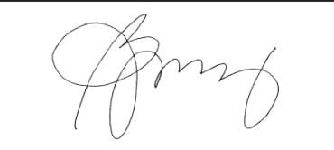*Conforme:***

______________________________



**BULACAN STATE UNIVERSITY**

**College of Information and Communications Technology**

**Guinhawa, City of Malolos, Bulacan**

<http://www.bulsu.edu.ph/>

May 19, 2022

MS. LILIBETH ANTONIO

Faculty Member, CICT

BuLSU

Dear Ms. Antonio,

Greetings!

This is to inform you of the schedule for the Capstone Project Proposal Oral Presentation for the BS Information Technology Third Year Students that will be conducted on **June 2, 2022,** via the MS Teams Meet platform.

In line with this, I’d like to notify you of the group which you are concerned with:

**Capstone Title :** VirtualShrine: An Interactive Museum Website for Casa Real Shrine

**Researchers :** Claro, Sharvien Paul M., Gabutina, Carlo Elijah R., Mauricio, Angelo D., Nacional, Kristine Joy S., Navarro, Rovi Keith Y., Tapang, Jhel Ansel D.

**Time :** 10:00 – 11:00 AM

**Invitation :** ( ) As Adviser ( ) As Critic/Member

( ✓ ) As Panel Chairman () As Client

It is expected that you come on time and be present during the whole duration of the presentation. Hoping for your usual support and cooperation in this endeavor!

Thank you,



**MAYLEEN DORCAS B. CASTRO, DIT**

Capstone Project Coordinator

***Conforme:***



______________________________





**BULACAN STATE UNIVERSITY**

**College of Information and Communications Technology**

**Guinhawa, City of Malolos, Bulacan**

<http://www.bulsu.edu.ph/>

May 19, 2022

ENGR. TERESITA MANGAHAS

Faculty Member, CICT

BuLSU

Dear Engr. Mangahas,

Greetings!

This is to inform you of the schedule for the Capstone Project Proposal Oral Presentation for the BS Information Technology Third Year Students that will be conducted on **June 2, 2022** via the MS Teams Meet platform.

In line with this, I’d like to notify you of the group which you are concerned with:

**Capstone Title :** VirtualShrine: An Interactive Museum Website for Casa Real Shrine

**Researchers :** Claro, Sharvien Paul M., Gabutina, Carlo Elijah R., Mauricio, Angelo D., Nacional, Kristine Joy S., Navarro, Rovi Keith Y., Tapang, Jhel Ansel D.

**Time :** 10:00 – 11:00 AM

**Invitation :** ( ) As Adviser (✓) As Critic/Member

( ) As Panel Chairman () As Client

It is expected that you come on time and be present during the whole duration of the presentation. Hoping for your usual support and cooperation in this endeavor!

Thank you,



**MAYLEEN DORCAS B. CASTRO, DIT**

Capstone Project Coordinator

***Conforme:***

______________________________



**BULACAN STATE UNIVERSITY**

**College of Information and Communications Technology**

**Guinhawa, City of Malolos, Bulacan**

<http://www.bulsu.edu.ph/>

May 19, 2022

MS. LYKA SAN PEDRO

Faculty Member, CICT

BuLSU

Dear Ms. San Pedro,

Greetings!

This is to inform you of the schedule for the Capstone Project Proposal Oral Presentation for the BS Information Technology Third Year Students that will be conducted on **June 2, 2022** via the MS Teams Meet platform.

In line with this, I’d like to notify you of the group which you are concerned with:

**Capstone Title :** VirtualShrine: An Interactive Museum Website for Casa Real Shrine

**Researchers :** Claro, Sharvien Paul M., Gabutina, Carlo Elijah R., Mauricio, Angelo D., Nacional, Kristine Joy S., Navarro, Rovi Keith Y., Tapang, Jhel Ansel D.

**Time :** 10:00 – 11:00 AM

**Invitation :** ( ) As Adviser (✓) As Critic/Member

( ) As Panel Chairman () As Client

It is expected that you come on time and be present during the whole duration of the presentation. Hoping for your usual support and cooperation in this endeavor!

Thank you,



**MAYLEEN DORCAS B. CASTRO, DIT**

Capstone Project Coordinator

***Conforme:***

______________________________

**Appendix D**

*Letter for Client*

Republic of the Philippines



**Bulacan State University**

##### City of Malolos, Bulacan

##### Tel (044) 919 7800 local 1101/1102

##### 

**COLLEGE OF INFORMATION AND COMMUNICATIONS TECHNOLOGY**

May 16, 2022

**MRS. MA. ANTONIA T. JIMENEZ**

Museum Curator

Casa Real Shrine

Dear Mrs. Jimenez:

Greetings!

We are 3rd-year college students from Bulacan State University taking up the course of Bachelor of Science in Information Technology. We've decided to design a website for our capstone project a VirtualShrine: An Interactive Museum website for Casa Real Shrine that will be utilized to virtualize Casa Real Shrine. As for that, we are asking for your permission to be our client on this project.

           The concept of our proposed system is to deliver more knowledge to the online museum user by improving users’ experience, interactivity, and comprehensive knowledge. This proposed project website could also serve as promotion for the Casa Real Shrine of Malolos to a vast audience online.

This system can help you on:

* Promote the Casa Real Shrine on a wider audience online.
* Online Booking Admission
* User Assisting features
* Virtual Museum tours

Students will use the information provided above for educational purposes only. We are hoping for your kind consideration and favorable response. Thank you, and God bless!

**Respectfully yours,**

**The Researchers**

**Claro, Sharvien Paul M.**

**Gabutina, Carlo Elijah R.**

**Mauricio, Angelo D.**

**Navarro, Rovi Keith Y.**

**Tapang, Jhel Ansel D.**

**Nacional, Kristine Joy S.**

Project Leader

BSIT 3M – Group 2

**Noted by:**

**Dr. Mayleen Dorcas Castro**

Capstone Coordinator

**Conforme:**

**Mrs. Ma. Antonia T. Jimenez**

Museum Curator

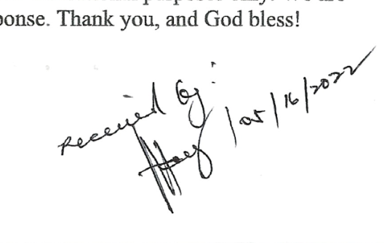

Republic of the Philippines



**Bulacan State University**

##### City of Malolos, Bulacan

##### Tel (044) 919 7800 local 1101/1102

##### 

**COLLEGE OF INFORMATION AND COMMUNICATIONS TECHNOLOGY**

July 7, 2022

**MRS. MA. ANTONIA T. JIMENEZ**

Museum Curator

Casa Real Shrine

Dear Mrs. Jimenez:

Greetings!

This letter is in regard to requesting for Data collection such as images, description, and 360-degree view of the artifacts displayed in your museum. We are 3rd-year college students from Bulacan State University taking up the course of Bachelor of Science in Information Technology conducting a study entitled “VirtualShrine: an interactive website for Casa Real Shrine”.

As part of the study's development, we will photograph the artifacts on display at the museum and capture a 360-degree view of each gallery. We would also want to request a description of the artifacts that are on display.

The intention of our work is to use those data as contents for the interactive museum website for Casa Real Shrine and be able to share the collected data to the museum website visitors.

We will be very grateful to you for your help. We can assure you that your privacy will not be affected.

If you have any further queries, you can reach us at virtualshrine.developers@gmail.com

**Respectfully yours,**

**The Researchers**

**Claro, Sharvien Paul M.**

**Gabutina, Carlo Elijah R.**

**Mauricio, Angelo D.**

**Navarro, Rovi Keith Y.**

**Tapang, Jhel Ansel D.**

**Nacional, Kristine Joy S.**

Project Leader

BSIT 3M – Group 2

**Noted by:**

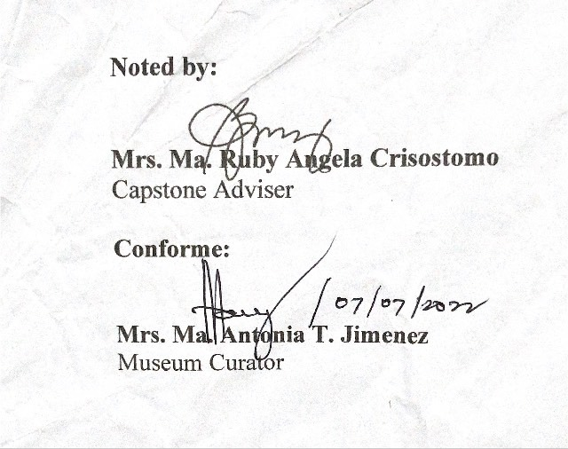

**Mrs. Ma. Ruby Angela Crisostomo**

Capstone Adviser

**Conforme:**

**Mrs. Ma. Antonia T. Jimenez**

Museum Curator

**Appendix E**

*Letter for Invitation for Final Capstone Defense*

Republic of the Philippines



BULACAN STATE UNIVERSITY

**College of Information and Communications Technology**

City of Malolos, Bulacan

December 11, 2022

**MS. MA. RUBY ANGELA J. CRISOSTOMO**

CICT, Faculty

Dear Ms. Crisostomo,

Greetings!

This is to inform you of the Capstone Project Final and Oral Presentation for BS Information Technology Fourth Year Students will be on **December 14, 2022,** at the ILCA Office, Ground Floor of Federizo Hall.

In line with this, I’d like to notify you of the schedule which you are concerned with:

VirtualShrine: An Interactive Museum Website for Casa Real Shrine

Capstone Title :

Claro, Sharvien Paul M., Gabutina, Carlo Elijah R., Mauricio, Angelo D., Mergal, Jhan Mar D., Nacional, Kristine Joy S., Navarro, Rovi Keith Y., Tapang, Jhel Ansel D.

Proponents/ :

Researchers

Time : **10:00 – 11:00 am**

Invitation : ( **✓**) As Adviser () As Panel Chairman () As Member

It is expected that you will come on time and be present during the whole duration of the presentation.

Thank you,



**MAYLEEN DORCAS B. CASTRO, DIT**

Capstone Project Coordinator

Noted by:

**DIGNA S. EVALE, DIT KENO C. PIAD, DIT**

Head, BSIT Program College Dean



Conforme:

**Ms. Ma. Ruby Angela J. Crisostomo**

CICT, Faculty

Republic of the Philippines



BULACAN STATE UNIVERSITY

**College of Information and Communications Technology**

City of Malolos, Bulacan

December 11, 2022

**MS. LILIBETH G. ANTONIO**

CICT, Faculty

Dear Ms. Antonio,

Greetings!

This is to inform you of the Capstone Project Final and Oral Presentation for BS Information Technology Fourth Year Students will be on **December 14, 2022,** at the ILCA Office, Ground Floor of Federizo Hall.

In line with this, I’d like to notify you of the schedule which you are concerned with:

VirtualShrine: An Interactive Museum Website for Casa Real Shrine

Capstone Title :

Claro, Sharvien Paul M., Gabutina, Carlo Elijah R.**,** Mauricio, Angelo D.**,** Mergal, Jhan Mar D.**,** Nacional, Kristine Joy S.**,** Navarro, Rovi Keith Y.**,** Tapang, Jhel Ansel D.

Proponents/ :

Researchers

Time : **10:00 – 11:00 am**

Invitation : ( ) As Adviser (**✓**) As Panel Chairman () As Member

It is expected that you will come on time and be present during the whole duration of the presentation.

Thank you,



**MAYLEEN DORCAS B. CASTRO, DIT**

Capstone Project Coordinator

Noted by:

**DIGNA S. EVALE, DIT KENO C. PIAD, DIT**

Head, BSIT Program College Dean

Conforme:

**MS. Lilibeth G. Antonio**

CICT, Faculty

Republic of the Philippines



BULACAN STATE UNIVERSITY

**College of Information and Communications Technology**

City of Malolos, Bulacan

December 11, 2022

**ENGR. TERESITA S. MANGAHAS**

CICT, Faculty

Dear Engr. Mangahas,

Greetings!

This is to inform you of the Capstone Project Final and Oral Presentation for BS Information Technology Fourth Year Students will be on **December 14, 2022,** at the ILCA Office, Ground Floor of Federizo Hall.

In line with this, I’d like to notify you of the schedule which you are concerned with:

VirtualShrine: An Interactive Museum Website for Casa Real Shrine

Capstone Title :

Claro, Sharvien Paul M., Gabutina, Carlo Elijah R.**,** Mauricio, Angelo D.**,** Mergal, Jhan Mar D.**,** Nacional, Kristine Joy S.**,** Navarro, Rovi Keith Y.**,** Tapang, Jhel Ansel D.

Proponents/ :

Researchers

Time : **10:00 – 11:00 am**

Invitation : ( ) As Adviser () As Panel Chairman (**✓**) As Member

It is expected that you will come on time and be present during the whole duration of the presentation.

Thank you,



**MAYLEEN DORCAS B. CASTRO, DIT**

Capstone Project Coordinator

Noted by:

**DIGNA S. EVALE, DIT KENO C. PIAD, DIT**

Head, BSIT Program College Dean



Conforme:

**Engr. Teresita S. Mangahas**

CICT, Faculty

Republic of the Philippines



BULACAN STATE UNIVERSITY

**College of Information and Communications Technology**

City of Malolos, Bulacan

December 11, 2022

**MS. LYKA D.L SAN PEDRO**

CICT, Faculty

Dear Ms. San Pedro,

Greetings!

This is to inform you of the Capstone Project Final and Oral Presentation for BS Information Technology Fourth Year Students will be on **December 14, 2022,** at the ILCA Office, Ground Floor of Federizo Hall.

In line with this, I’d like to notify you of the schedule which you are concerned with:

VirtualShrine: An Interactive Museum Website for Casa Real Shrine

Capstone Title :

Claro, Sharvien Paul M., Gabutina, Carlo Elijah R., Mauricio, Angelo D., Mergal, Jhan Mar D., Nacional, Kristine Joy S., Navarro, Rovi Keith Y., Tapang, Jhel Ansel D.

Proponents/ :

Researchers

Time : **10:00 – 11:00 am**

Invitation : ( ) As Adviser () As Panel Chairman (**✓**) As Member

It is expected that you will come on time and be present during the whole duration of the presentation.

Thank you,



**MAYLEEN DORCAS B. CASTRO, DIT**

Capstone Project Coordinator

Noted by:

**DIGNA S. EVALE, DIT KENO C. PIAD, DIT**

Head, BSIT Program College Dean



Conforme:

**Ms. Lyka D.L San Pedro**

CICT, Faculty

**Appendix F**

*PANEL REPORT*

**Appendix G**

*Evaluation Criteria for Software*

Republic of the Philippines

BULACAN STATE UNIVERSITY

**College of Information and Communications Technology**

City of Malolos, Bulacan

*(Adapted from Product Software Quality – ISO/IEC 25010)*

1. **Evaluator’s Profile**

**Name: ___________________________ Date: _______________**Course/Occupation/Position:________________________________________

1. **Software Evaluation**

**Instruction:**

Good day! We are 4th-Year BSIT Major in Web Development students from Bulacan State University - Main Campus, conducting capstone project entitled **"VIRTUALSHRINE: An Interactive Museum Website for Casa Real Shrine"**.

In this regard, please evaluate the developed application by using the given scale below and placing a checkmark (√) under its corresponding numeric rating.

|  |  |  |
| --- | --- | --- |
| **Scale** | **Range** | **Descriptive Interpretation** |
| 5 | 4.60 - 5.00 | Excellent |
| 4 | 3.60 - 4.59 | Very Good |
| 3 | 2.60 - 3.59 | Satisfactory |
| 2 | 1.60 - 2.59 | Fair |
| 1 | 0 - 1.59 | Poor |

|  |  |  |  |  |  |
| --- | --- | --- | --- | --- | --- |
| **Indicator** | **5** | **4** | **3** | **2** | **1** |
| 1. **Function and Stability** |  |  |  |  |  |
| 1. The system functions according to its intended purpose. |  |  |  |  |  |
| 1. The system gives the exact output on each input per module. |  |  |  |  |  |
| 1. The system functions like any standard system entirely |  |  |  |  |  |
| 1. The system functions to different user with different restrict ions. |  |  |  |  |  |
| 1. The system interacts to different inputs and features entirely. |  |  |  |  |  |
| 1. **Performance and Efficiency** |  |  |  |  |  |
| 1. The system meets the user’s expectation and objectives. |  |  |  |  |  |
| 1. The system can be used to its maximum limit from the design capacity. |  |  |  |  |  |
| 1. The system can respond to multiple interaction from the user. |  |  |  |  |  |
| 1. The system manages time efficiently and effectively. |  |  |  |  |  |
| 1. The system accurately presents the output at the maximum level. |  |  |  |  |  |
| 1. **Compatibility** |  |  |  |  |  |
| 1. Co-Existence. The system can efficiently perform its required functions while sharing a familiar environment and resources with other systems, with no negative influence on any other method. |  |  |  |  |  |
| 1. Interoperability. The system can exchange information and utilize data that has been exchanged between two or more platforms. |  |  |  |  |  |
| 1. The system can be accessed on both phone and computer browsers. |  |  |  |  |  |
| 1. **Usability** |  |  |  |  |  |
| 1. User friendly. The design of the system is easy to understand and use. |  |  |  |  |  |
| 1. Acceptability Recognizability. Users are able to determine whether the system is suitable for their requirements. |  |  |  |  |  |
| 1. System Utility. The system can generate reports that can be viewed online (and can be download). |  |  |  |  |  |
| 1. Operability. The system is simple to use, navigate. |  |  |  |  |  |
| 1. **Reliability** |  |  |  |  |  |
| 1. Maturity. Under normal conditions, the system meets the requirements for reliability. |  |  |  |  |  |
| 1. Availability. The system is operational and accessible when required for use. |  |  |  |  |  |
| 1. Fault Tolerance. Despite the presence of hardware or software faults, the system or its components function as planned. |  |  |  |  |  |
| 1. Recoverability. In an interruption or failure, the system can immediately recover the affected data and restore the system to its desired state. |  |  |  |  |  |
| 1. **Security** |  |  |  |  |  |
| 1. Confidentiality. The system guarantees that the data is only available to those granted access. |  |  |  |  |  |
| 1. Confidentiality. The system guarantees that the data is only available to those granted access. |  |  |  |  |  |
| 1. Accountability. The actions of an entity can be traced uniquely by the system to the entity. |  |  |  |  |  |
| 1. **Maintainability** |  |  |  |  |  |
| 1. The system’s information and interfaces can be updated through administrator account. |  |  |  |  |  |
| 1. The system allows updating different user records through level of security. |  |  |  |  |  |
| 1. The system username and password can be modified online. |  |  |  |  |  |
| 1. The system’s hierarchy of authority especially administrator and super administrator can monitor different user’s account online. |  |  |  |  |  |
| 1. **Portability** |  |  |  |  |  |
| 1. Adaptability. The system can effectively and efficiently be adapted for different evolving hardware, software, or other operational or usage environments. |  |  |  |  |  |

**Comments/Suggestions:** ____________________________________________________________________________________________________________________________________________________________________________________________________________________________________________________________________________________________________________________________________________________________________________________________________________________________________

**Appendix H**

*Relevant Source Code*

CLIENT SIDE - homepage.php

<!DOCTYPE html>

<html>

<meta name="viewport" content="with=device-width, initial-scale=1.0">

<head>

<title>Homepage - VirtualShrine</title>

<link rel="stylesheet" href="assets/css/homepage.css">

<link rel="preconnect" href="https://fonts.googleapis.com">

<link rel="icon" type="image/png" href="assets/img/crs-logo.png">

<link rel="preconnect" href="https://fonts.gstatic.com" crossorigin>

<link rel="stylesheet" href="https://cdnjs.cloudflare.com/ajax/libs/font-awesome/6.2.0/css/all.min.css">

<link rel="stylesheet" href="https://stackpath.bootstrapcdn.com/font-awesome/4.7.0/css/font-awesome.css">

<script src="https://cdnjs.cloudflare.com/ajax/libs/jquery/3.6.1/jquery.min.js" charset="utf-8"></script>

<link href="https://fonts.googleapis.com/css2?family=Poppins:wght@100;200;300;400;600;700&display=swap" rel="stylesheet">

</head>

<body>

<!-- push -->

<section class="header">

<nav>

<a href="homepage.php"><image class="logo" src="assets/img/crs-logo-white.png" alt="Casa Real Shrine logo"></image></a>

<div class="nav-links" id="mySidebar">

<i class="fa fa-times" onclick="closeNav()"></i>

<ul>

<li class="menu-item"><a href="homepage.php">HOME</a></li>

<li class="menu-item">

<a href="#">VISIT <i class="fas fa-angle-down"></i></a>

<ul class="sub-menu">

<li class="sub-item"><a href="plan_visit.php">Plan Your Visit</a></li>

<li class="sub-item"><a href="consent-form.php">Book a Visit</a></li>

<li class="sub-item"><a href="audio-guide.php">Audio Guide</a></li>

<li class="sub-item"><a href="exhibits.php">Exhibits</a></li>

</ul>

</li>

<li class="menu-item">

<a href="#">EXPLORE<i class="fas fa-angle-down"></i></a>

<ul class="sub-menu">

<li class="sub-item"><a href="gallery.php">Collections</a></li>

<li class="sub-item"><a href="virtual-tour.php">Virtual Tour</a></li>

</ul>

</li>

<li class="menu-item"><a href="blog.php">BLOG</a></li>

<li class="menu-item"><a href="about-crs.php">ABOUT</a></li>

</ul>

</div>

<div id="main"></div>

<i class="fa fa-bars" onclick="openNav()"></i>

</div>

</nav>

<!-- [END] NAVIGATION -->

<!-- [START] HEADER -->

<div class="text-box">

<h1>WELCOME TO THE VIRTUALSHRINE</h1>

<p>Free Entry - Operation time : 8:00AM - 4:00PM</p>

<a class="book-btn" href="consent-form.php">Book a Visit Now</a>

</div>

<!-- [END] OF HEADER -->

</section>

<!-- [START] STARTING PAGE -->

<section class="content-split">

<h1>ABOUT CASA REAL SHRINE</h1>

<div class="content-wrap">

<div class="content-split-side rich-text">

<div class="carousel">

<div class="carousel-inner">

<div class="carousel-item">

<img src="Images/about/history-of-casa-real-shrine.jpg" alt="">

</div>

<div class="carousel-item">

<img src="Images/about/women-of-malolos.jpg" alt="">

</div>

<div class="carousel-item">

<img src="Images/about/crs-printing-press.jpg" alt="">

</div>

<div class="carousel-item">

<img src="Images/about/thumb2.jpg" alt="">

</div>

</div>

<div class="carousel-controls">

<span class="prev"></span>

<span class="next"></span>

</div>

<div class="carousel-indicators"></div>

</div>

</div>

<div class="content-split-main rich-text">

<p class="about-desc">Located at Paseo del Congreso, Plaza Rizal Malolos Bulacan, Casa Real Shrine served as the

National Museum and the National Printing Press during the First Philippine Republic. It

is a government museum consisting of relics from the First Philippine Republic.

Memorabilia's of Gen. Emilio Aguinaldo are also found here. First class families of Malolos,

their furnitures, old books, stamps, paper money and coin are also displayed in the Shrine.</p>

<p class="about-desc-2">Casa Real is also one of Malolos oldest structure. The building contains

exhibits, printing press of the Malolos Republic and a display of the 21 Women of Malolos

memorabilia. Also presented here are the photographs of the 100 Filipino women. Each of them has

distinct characteristics in their fields.</p>

<a href="about-crs.php"><button class="button-31" role="button">Learn More</button></a>

</div>

</div>

</section>

<!-- [END] STARTING PAGE -->

<!-- [START] HOMEPAGE CONTENTS -->

<section class="home-content">

<h1>Explore Our Galleries</h1>

<p>Tour the 5 galleries of Casa Real Shrine</p>

<div class="row">

<a href="GalleryInfo.php">

<div class="gallery-col">

<img src="Images/homepage-gallery/ginhawa.jpg" alt="kaginhawaan">

<div class="layer">

<h3>KAGINHAWAAN</h3>

</div>

</div>

</a>

<a href="GalleryInfo.php">

<div class="gallery-col">

<img src="Images/homepage-gallery/paniil.jpg" alt="kaginhawaan">

<div class="layer">

<h3>PANINIIL</h3>

</div>

</div>

</a>

<a href="GalleryInfo.php">

<div class="gallery-col">

<img src="Images/homepage-gallery/bago-puri.jpg" alt="kaginhawaan">

<div class="layer">

<h3>PAGBABAGONG-PURI</h3>

</div>

</div>

</a>

<a href="GalleryInfo.php">

<div class="gallery-col">

<img src="Images/homepage-gallery/buo.jpg" alt="kaginhawaan">

<div class="layer">

<h3>PAGBUBUO NG BAYAN</h3>

</div>

</div>

</a>

</div>

</section>

<!-- [END] OF HOMEPAGE CONTENTS -->

<!-- [START] VIRTUALSHRINE NEXT TO YOU -->

<section class="vs-features">

<h1>VIRTUALSHRINE NEXT TO YOU</h1>

<p>Explore our virtual tours and experience the Casa Real wherever you are</p>

<div class="row">

<div class="features-col">

<a href="audio-guide.php">

<div id="container">

<img id="image" src="Images/homepage-features/image1.jpg" alt="">

</div>

</a>

<div class="card-title">

<h3>Audio Guide</h3>

<p>Explore Casa Real with an Audio Guide</p>

</div>

</div>

<div class="features-col">

<a href="virtual-tour.php">

<div id="container">

<img id="image" src="Images/homepage-features/image2.JPG" alt="">

</div>

</a>

<div class="card-title">

<h3>Virtual 360</h3>

<p>Check out the virtual 360 tour of the Casa Real Shrine</p>

</div>

</div>

<div class="features-col">

<a href="gallery.php">

<div id="container">

<img id="image" src="Images/homepage-features/image3.jpg" alt="">

</div>

</a>

<div class="card-title">

<h3>Collections</h3>

<p>Learn the political history of the Phillipines by visiting the collections of Casa Real Shrine</p>

</div>

</div></div>

</div>

</section>

<!-- [END] OF VIRTUALSHRINE NEXT TO YOU-->

<!-- [START] FOOTER -->

<section id="footer">

<div class="title-text">

<!-- <h1>Visit Casa Real Today</h1> -->

</div>

<div class="footer-row">

<div class="footer-left">

<div>

<h1>Opening Hours</h1>

<p><i class="fa fa-clock-o"></i> Tuesday to Sunday - 8:00 AM to 4:00 PM</p>

</div>

<br>

<div>

<h1>Contact Us</h1>

<p><i class="fa fa-map-marker"></i> Paseo Del Congreso, Liang, City of Malolos, Bulacan</p>

<p><i class="fa fa-paper-plane"></i> mpph@nhcp.gov.ph</p>

<p><i class="fa fa-phone"></i> (044) 931-2508</p>

</div>

</div>

<div class="footer-right">

<div>

<h1>Quicklinks</h1>

<div class="quicklinks">

<span style="margin-right:50px;"><a href="homepage.php">Homepage</a></span><a href="crs-about.php">About Us</a><br>

<span style="margin-right:30px;"><a href="plan_visit.php">Plan Your Visit</a></span><a href="consent-form.php">Book a Visit</a><br>

<span style="margin-right:70px;"><a href="audio-guide.php">Audio Guide</a></span><a href="exhibits.php">Exhibit</a><br>

<span style="margin-right:30px;"><a href="gallery.php">Collection</a></span><a href="virtual-tour.php">Virtual Tour</a><br>

<span><a href="">About</a></span>

</div>

</div>

</div>

</div>

<div class="social-links">

<img src="Images/Logo.png" class="footer-img">

<a href="https://www.facebook.com/CasaRealMalolos"><i class="fa fa-facebook"></i></a>

<a href="https://www.instagram.com/nhcpofficial/"><i class="fa fa-instagram"></i></a>

<a href="https://twitter.com/NHCPOfficial"><i class="fa fa-twitter"></i></a>

<a href="https://www.youtube.com/@NHCPOfficial"><i class="fa fa-youtube-play"></i></a>

<p>2022 <i class="fa-regular fa-copyright"></i> VirtualShrine</p>

</div>

</section>

<!-- [END] FOOTER -->

<!-- JAVASCRIPT FOR TOGGLE MENU -->

<script>

/* Set the width of the sidebar to 250px and the left margin of the page content to 250px */

function openNav() {

document.getElementById("mySidebar").style.width = "250px";

}

/* Set the width of the sidebar to 0 and the left margin of the page content to 0 */

function closeNav() {

document.getElementById("mySidebar").style.width = "0";

}

</script>

<script src="assets/js/swiper-script.js"></script>

</body>

</html>

ADMIN SIDE – login.php

<?php

session_start();

?>

<html>

<head>

<title>Login - VirtualShrine</title>

<meta name="MobileOptimized" content="width">

<meta name="HandheldFriendly" content="true">

<meta name="viewport" content="width=device-width, minimum-scale=1.0, maximum-scale=1.0, user-scalable=no">

<link rel="icon" type="image/png" href="image/VirtualShrineLogo.png">

<link rel="stylesheet" href="assets/css/login-style.css">

<link rel="stylesheet" href="https://cdnjs.cloudflare.com/ajax/libs/font-awesome/6.2.0/css/all.min.css">

<script src="https://cdnjs.cloudflare.com/ajax/libs/jquery/3.6.1/jquery.min.js" charset="utf-8"></script>

</head>

<div class="py5">

<div class="container">

<div class="row justify-content-center">

<div class="col-md-5">

<div class="card">

<div class="card-header">

<img src="image/VirtualShrineLogo.png">

<div class="center">

<div class="center-header">

<h1>Login</h1>

</div>

<hr>

<div class="center-body">

<?php include('message.php')?>

<form action="logincode.php" method="post">

<div class="txt_field">

<input type="username" required name="username">

<label>Username</label>

</div>

<div class="txt_field">

<input type="password" required name="password">

<span></span>

<label>Password</label>

</div>

<input type="submit" name="login_btn" class="btn btn-primary" value="Login"></input>

<div class="MainAdmin_link"></div>

</form>

</div>

</div>

</div>

</div>

</div>

</div>

</div>

</div>

<!-- Modal

<div class="modal fade" id="no-slot" tabindex="-1" role="dialog" aria-labelledby="exampleModalLabel" aria-hidden="true">

<div class="modal-dialog" role="document">

<div class="modal-content">

<div class="modal-body" id="loading-msg">

</div>

<div class="modal-footer">

<button type="button" class="btn btn-secondary" data-dismiss="modal">Ok</button>

</div>

</div>

</div>

</div>

<script src="assets/js/main.js?v1"></script>

<script src="assets/js/parsely.min.js"></script>

<script src="assets/js/popper.min.js"></script>

<script src="assets/js/bootstrap.min.js"></script> -->

<script src="https://cdn.jsdelivr.net/npm/bootstrap@5.1.3/dist/js/bootstrap.bundle.min.js"></script>

</body>

</html>

Virtual Tours – index.html

<!DOCTYPE html>

<html>

<head>

<meta http-equiv="Content-Type" content="text/html;charset=UTF-8" />

<meta http-equiv="X-UA-Compatible" content="IE=edge" />

<title>Virtual Tour - VirtualShrine</title>

<link rel="icon" type="image/png" href="img/crs-logo.png">

<meta name="viewport" content="width=device-width, initial-scale=1.0, minimum-scale=1.0, maximum-scale=1.0" />

<meta name="apple-mobile-web-app-capable" content="yes" />

<meta name="apple-mobile-web-app-status-bar-style" content="black" />

<meta name="mobile-web-app-capable" content="yes" />

<style type="text/css" title="Default">

/* fullscreen */

html {

height:100%;

}

body {

height:100%;

margin: 0px;

overflow:hidden; /* disable scrollbars */

-webkit-tap-highlight-color: rgba(0, 0, 0, 0); /* remove highlight on tab for iOS/Android */

}

/* fix for scroll bars on webkit & >=Mac OS X Lion */

::-webkit-scrollbar {

background-color: rgba(0,0,0,0.5);

width: 0.75em;

}

::-webkit-scrollbar-thumb {

background-color: rgba(255,255,255,0.5);

}

</style>

</head>

<body>

<!-- - - - - - - 8<- - - - - - cut here - - - - - 8<- - - - - - - -->

<script type="text/javascript" src="pano2vr_player.js">

</script>

<script type="text/javascript" src="skin.js">

</script>

<div id="container" style="width:100%;height:100%;overflow:hidden;">

<br>Loading...<br><br>

</div>

<script type="text/javascript">

// create the panorama player with the container

pano=new pano2vrPlayer("container");

// add the skin object

skin=new pano2vrSkin(pano);

// load the configuration

window.addEventListener("load", function() {

pano.readConfigUrlAsync("pano.xml");

});

if (window.navigator.userAgent.match(/Safari/i)) {

// fix for white borders, rotation on iPhone

function iosHfix(e) {

window.scrollTo(0, 1);

var container=document.getElementById("container");

var oh=container.offsetHeight;

document.documentElement.style.setProperty('height', '100vh');

if (oh!=container.offsetHeight) {

container.style.setProperty('height',"100%");

} else {

container.style.setProperty('height',window.innerHeight+"px");

}

window.scrollTo(0, 0);

pano.setViewerSize(container.offsetWidth, container.offsetHeight);

};

setTimeout(iosHfix,0);

setTimeout(iosHfix,100);

window.addEventListener("resize", function() {

setTimeout(iosHfix,0);

// hide toolbar on iPad happens with a delay

setTimeout(iosHfix,500);

setTimeout(iosHfix,1000);

setTimeout(iosHfix,2000);

});

}

</script>

<noscript>

<p><b>Please enable Javascript!</b></p>

</noscript>

<!-- - - - - - - 8<- - - - - - cut here - - - - - 8<- - - - - - - -->

</body>

</html>

**Appendix I**

*PLAGIARISM CERTIFICATION*

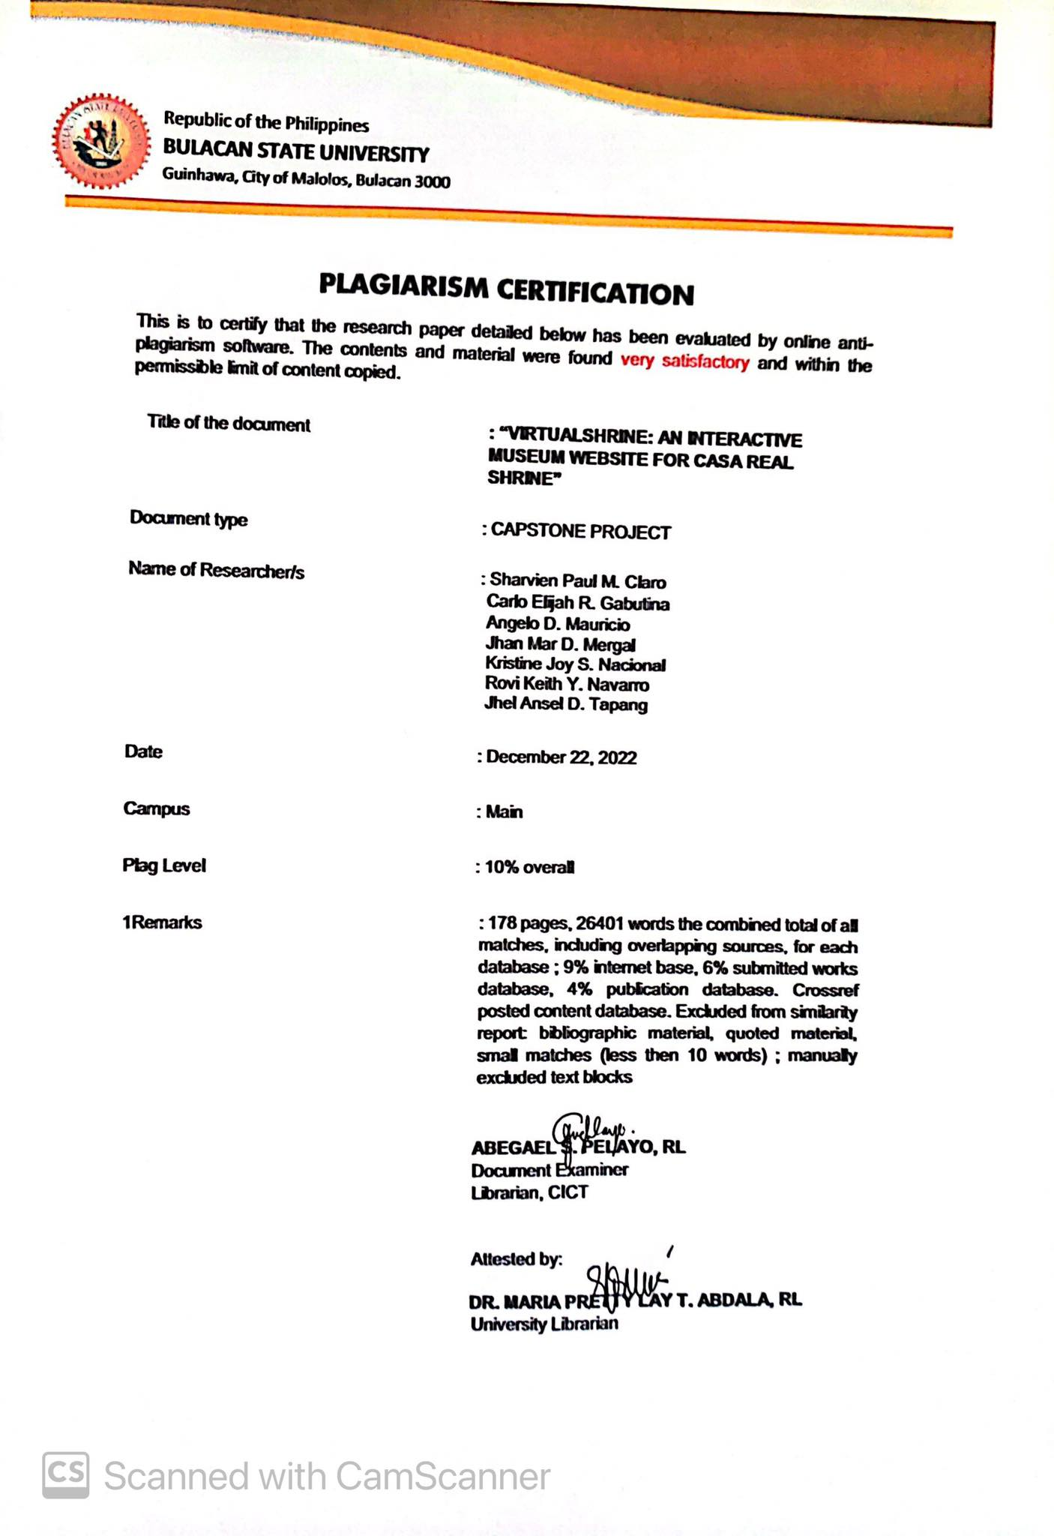

**Appendix J**

*PLAGIARISM CERTIFICATION*

*(IMRAD)*

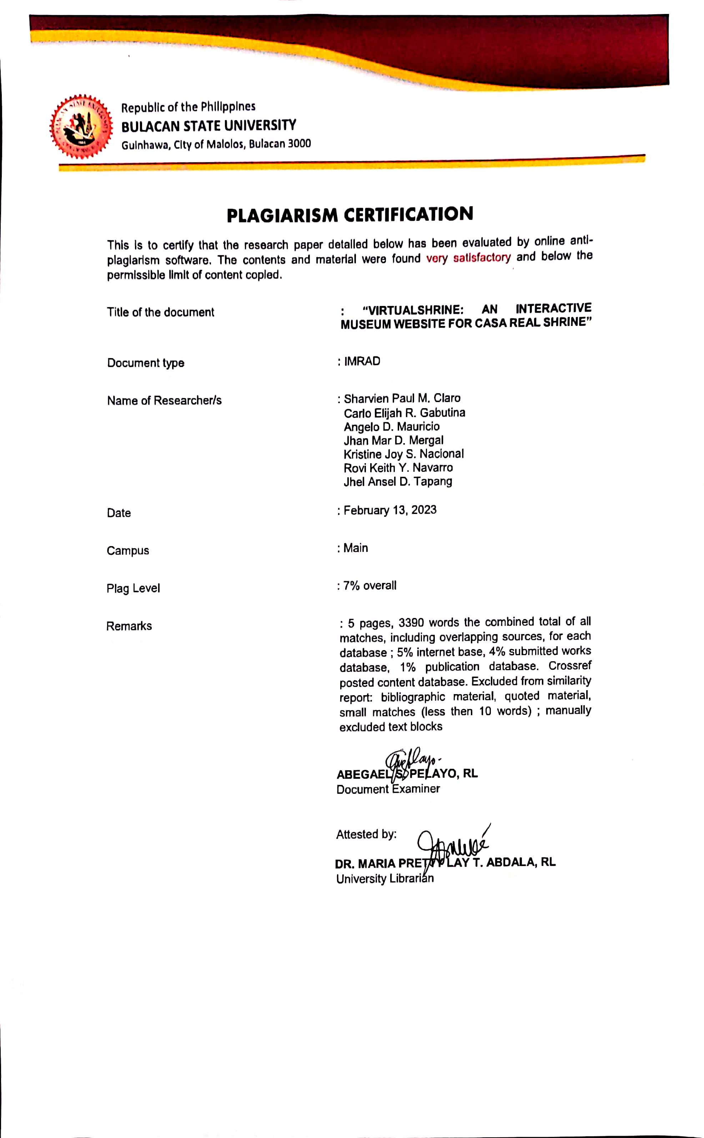

**Appendix K**

*IMRAD CERTIFICATION*

*(ADVISER)*



**CERTIFICATION**

This is to certify that the IMRAD format for the Capstone/Thesis Project of Claro, Sharvien Paul M., Gabutina, Carlo Elijah R., Mauricio, Angelo D., Mergal, Jhan Mar D., Nacional, Kristine Joy S., Navarro, Rovi Keith Y., and Tapang, Jhel Ansel D. with the title VirtualShrine: An Interactive Museum Website For Casa Real Shrine was already checked by the undersigned that it adheres to all the requirements set for a Research Journal.

Given this 22nd of December, in the year 2022.

MA. RUBY ANGELA J. CRISOSTOMO, MSIT

Capstone/Thesis Project Adviser

**Appendix L**

*IMRAD PAPER*

**VirtualShrine: An Interactive Museum Website for Casa Real Shrine**

**Claro, Sharvien Paul M.**

Bulacan State University  
Balagtas, Bulacan, Philippines

09062698915

sharvienpaul.claro.m@bulsu.edu.ph

**Mergal, Jhan Mar D.**

Bulacan State University  
Meycauayan City, Bulacan, Philippines

09152070169

jhanmar.mergal.d@bulsu.edu.ph

**Gabutina, Carlo Elijah R.**

Bulacan State University  
Marilao, Bulacan, Philippines

09092065191

carloelijah.gabutina.r@bulsu.edu.ph

**Nacional, Kristine Joy S.**

Bulacan State University  
Valenzuela City, Philippines

09361685997

kristinejoy.nacional.s@bulsu.edu.ph

**Tapang, Jhel Ansel D.**

Bulacan State University  
Malolos, Bulacan, Philippines

09125216212

jhelansel.tapang.d@bulsu.edu.ph

**Mauricio, Angelo D.**

Bulacan State University  
Meycauayan City, Bulacan, Philippines

09756759366

angelo.mauricio.d@bulsu.edu.ph

**Navarro, Rovi Keith Y.**

Bulacan State University  
Macabebe, Pampanga, Philippines

09612947453

rovikeith.navarro.y@bulsu.edu.ph

**ABSTRACT**

This study aimed to describe the daily operations and encountered problems of the NHCP Museo ng Kasaysayang Pampulitika ng Pilipinas, Casa Real, and to develop a website and web-based admin information and content management system of cases. The study employed a quantitative approach and utilized the Agile Software Development methodology to develop the system. To evaluate the acceptability of the developed website, the researchers consulted IT professionals, an IT instructor from Bulacan State University, and the end-users of the system such as the museum staff, students, local and foreign tourists. The study was evaluated using the ISO/IEC 25010 software quality evaluation criteria, with the responses of the respondents indicating a strong agreement with the system. The researchers concluded that the developed website is usable, functional, user-friendly, reliable, and secure. Recommendations for improvement included enhancing VR control capabilities in virtual tours, exploring the use of augmented reality (AR) technology through museum maps, studying the effectiveness of QR codes for audio guides in museums, and studying the effectiveness of different notification systems for calendar integration for museum closures.

**CCS Concepts**

• **Software and its engineering ➝ Software creation and management ➝ Designing software ➝ Software design engineering**

**Keywords**

Museum; Website; Booking System; Virtual Tours; Content Management System; Virtual Reality

# **INTRODUCTION**

# **Project Context**

The internet's global expansion over the years has impacted human activities through digital media, museums are evolving to adapt to the change and encourage young netizens to access and use museum materials [1]. However, capturing and maintaining the attention of visitors is an absolute challenge in today's world, where information can be found online. Along with the digital revolution, visitor expectations have shifted somewhere along the way, and museums are striving to meet the difficulties posed by this new wave of digital expectations from their visitors [2].

In order to adapt with the changes in technology, museums need a visually appealing, informative, and entertaining website to attract visitors. According to Butler J. [3], digital communications has created an opportunity for many museums around the world to create connections, communities, and relationships. It gives museums new avenues to share information about their exhibits and collections with a vast number of audiences and at the same time, allows them to understand visitor experience. To create a website that accurately depicts what makes a museum unique is to implement an engaging and interactive feature into the website [4]. An interactive website is one that allows users to engage with and communicate with the website's content. It takes a unique and entertaining approach that is sure to catch the interest of its users.

It is apparent that museum websites play a significant role in information dissemination. According to a growing body of literature: Increased online and off-line museum visits is an effective strategy to boost visitors' interest and satisfaction and encourages online website visitors to visit the actual museum [5]. According to Madriaga, Virto, & Blaso [6], the websites of museums were originally intended to provide basic information such as hours of operation, location, and costs. But because of the evolution of digital media, websites now provide a variety of interactive capabilities, like virtual galleries as well as a variety of materials to help visitors navigate better.

Most museums around the world offer the opportunity to purchase or book tickets online because of the threat of Covid-19 virus, museums and galleries are required to have a booking system to limit the visitors visiting the museum at the same time. This way, the spread of virus within the museum could be prevented. [7]

The implementation of the Casa Real Interactive Website benefits both the Casa Real management and the visitors. Through the Casa Real interactive website, Visitors who want to visit the museum could inquire and book for admission online, the website could serve as the visitors’ digital itinerary and virtual tour guide as they venture into the museum making their visit hassle free. During the testing phase, feedback from end users was gathered and used to identify recurring issues while also further improving the development of the website. Following the observation of these issues at Casa Real Shrine, the proponents would like to design and develop an Interactive Website for Casa Real Shrine.

# **Purpose and Description of the Project**

The study aims to propose a web base system and bring the Casa Real Shrine to the virtual world as a virtual museum. The study also aims to utilize technology to freely walk and virtually visit the museum of Casa Real Shrine. Proposing a virtual museum is the main concern of the proponents to develop an interactive museum that is user friendly, interactive and provides additional information through the web for Casa Real Shrine is the main concern of this study.

# **Objectives of the Study**

The primary goal of this study is to create an Interactive Museum Website called “VirtualShrine” for Casa Real Shrine. The aim is to enhance the experience of online museum visitors and provide them with a more comprehensive knowledge of the Shrine.

The study has specific objectives, such as developing functionalities like online booking reservations, virtual museum tours, gallery collections, and user assisting features like planning a visit and audio guides. In addition, the study aims to design and develop a Management System that can manage user admins, accept and reject visitor bookings, upload website content like collections, exhibits, and blogs, generate and print admin activity reports, and send booking confirmations through email. Finally, the study has evaluated the proposed system's acceptability using the software quality standard ISO 25010 instrument with eight criteria, including functionality suitability, performance efficiency, compatibility, usability, reliability, security, maintainability, and portability.

# **Scope and Limitation of the Study**

The main concern of this study is to design and develop “VirtualShrine: An Interactive Museum Website for Casa Real Shrine”. This study helps improve the current situation and promote the benefits of using an Interactive Website to improve museum operations. The main advantage is its accessibility at any time since it is web-based.  As a part of the limitation of the study, the study only addressed the improvement of Casa Real Shrine in integrating a web based interactive museum website. Other areas or matters affecting the structure and maintenance of the museum are not part of our research study.

The study was utilized using a beta test to observe its purpose, potential changes, and any hazards towards the user. By this method the proponents were able to come up with information that is vital to the research that could help improve the development of the system and have great results once the final output is done.

# **LITERATURE REVIEW**

# **The utilization of Interactive Website to Museums**

New technologies are changing the way businesses communicate and interact with customers, and the tourist sector, and museums are no exception. As a result, the usage of digital communication tools has become widespread, considerably broadening the horizons of communication [8] and at the same time, it has provided alternative visitor interactions and many advantages [9].  The main focus of this study is to design and develop a website that could improve the visitor experience. The proponents discovered that there is no existing website for Casa Real Shrine that could efficiently highlight the museum's uniqueness and services to its target audience.

Proponents have attempted to understand and improve several aspects of audience online and offline experiences over the last two decades, including identifying factors that motivate individuals to visit museums, elements of the visit that influence their overall satisfaction, what is retained following their visit, ways to improve online visitors' website experiences, and understanding how all these combines to encourage visits to museum websites [10]. Through web-based interfaces, museums are improving access to their collections and enabling enhanced user experiences [11]. However, Kabassi [9] stated that for a website to attract more people to the museum, it must be useful and functional. It is indeed important to make sure that the website would appeal to the visitors therefore, the proponents designed the website according to the rules of web design, at the same time, the proponents has considered the importance of the functionality of the applied design.

# **Online Booking Admission**

According to Garcia (2019), when the first Electronic Online Booking was created in 1995 by SAS for their airline the way of selling tickets was much faster and avoided the problem that the ticket was being sold out. In the year 2019, the Online Booking had some minor enhancement like having an online payment, fast processing, and even paying online with cryptocurrencies that you can also book online with just a few taps using your mobile phone. The Online booking system is one of the features that helps Casa Real Virtual Museum visitors when they visit Casa Real Shrine. There are many features to consider in creating an online booking system. Some examples of this are: (a) Online booking in real time may help the customer to see the available dates or if that date is fully booked. (b) Various Currencies and Language features might be considered one of the needs in an online booking system because if a customer is from another country, they can still use the system as it supports different languages and accepts other currencies in payment. (c) Intelligent Calendar/Diary, this feature provides the user with a summary of all bookings. This help avoid unnecessary work. (d) Booking management via Smartphones and Tablets is much more convenient instead of using PCs. These features can help customers access the system easily using their smartphones. [13]

The proponents believe that incorporating an online booking admission system into the proposed website help both visitors and the client. The online booking system allows a systemized visitor admission as opposed to the current manual booking system in the Casa Real Shrine, where visitors will only be able to schedule or book for a visit once they arrive at the onsite museum.

# **Virtual Gallery**

The researcher Tambahani, G. S., Wenas, M. B., & Somya, R. [14] created an Online Virtual Gallery using the most recent technology, HTML5, to store files such as drawings, paintings, sketches, films, games, etc. As a result of this research, a virtual container was produced that could allow the program to hold exhibition files effectively online. It is relevant to the study since it has the same features as the proposed website, such as storing files like museum collections, relics, and more. A virtual gallery is meaningless without its online visitors. The author Stefano, C. D., and Battisti F. [15] designed a framework that allows the user to visit a virtual museum in which all canvases painted by Caravaggio and conserved in Rome are displayed. The synergistic collaboration between Art History and ICT provided this project with a unique goal, combining the interests and demands of both disciplines to create a Digital Humanities project. One of the goals of proposing the Casa Real Shrine website is to engage people online using the proposed website, to showcase museum displays in a virtual gallery, and to encourage museum website visitors to visit the physical museum.

# **Virtual Tour Guide**

Famous museums are now providing these services online with the prediction that more people will visit with more personalized and engaging new or old visitors. The focus of the study is to create a virtual Casa Real Shrine with virtual tours to completely immerse the visitors in a whole new virtual world of Casa Real Shrine. According to the article about a common fear that apparently “remains the biggest fear” for people [16]. A troubling thought through people wanting to visit museums in the middle of a pandemic and are afraid to catch something, affecting the mental and actual well-being of the person. The ideal solution is the virtual museum with a more in-depth virtual tour for the visitors to resolve the conflict of the visitor. The main study is to tackle the common threat and issues of the visitors and give a proper solution with no compromises to the visitors' well-being by creating the virtual tour.

# **Digital Learning**

Learning via digital resources such as desktop computers, laptops, tablets, and smartphones is known as digital learning. The proposed website is designed to be responsive, thus, it can be accessed with the use of either desktop or mobile. The interactive opportunities provided by the devices, rather than the equipment themselves, are what make digital learning engaging. By allowing the learner to choose and control the flow of information through mouse-clicking or screen-tapping, certain digital tools engage the learner. In multimedia learning, these characteristics are referred to as interactivity [17]. Digital technology has played a large role in shaping the new learning opportunities because digital content is far more engaging, easier to update, and it is portable and cheaper. Digital learning has the ability to maximize information absorption and excel at building higher order critical thinking abilities [18]. One of the objectives of the proposed website is to be able to provide learning through the use of digital media.

# **METHODS AND DESIGN**

# **Research Design**

# The quantitative technique was used in the study to collect data from visitors of the Casa Real Shrine of Malolos. The proponents gathered statistics on visitor satisfaction comparing the present museum operations without the website and the museum operations after the website is implemented.

# The research and development element of the design involves (1) analyzing the existing museum operations, (2) innovating and developing a system based on the findings, and (3) testing the efficacy of the innovation. The approach includes a quantitative examination of the program/system, its components, as well as implementation and outcome data. Essentially, the procedure includes conducting comprehensive documentation analysis.

# **Project Development**

# The study used an agile method for research, it is based on based on iterative development, where requirements and solutions evolve through collaboration between self-organizing cross-functional teams. can help develop the features of the Casa Real Virtual Museum. According to Altameem E. (2015) [19], Agile is an important tool in software development because this methodology addresses the common project drawbacks including schedule predictability, scope creep and costs. The team members are also able to work effectively and accomplish the project tasks and increase motivation to the team that cause to increase in creativity and innovativeness thus delivering high-quality software.

# Initiation Phase

# In this study, Virtual Shrine focused on the virtualization of the museum for visitors reassuring the safety of the visitors without compromising any content and added content as well. Adding Online Booking Admission to the system added more security for data. Popular museums had done online 3D virtual tours around 1999, boosting the number of visitors both online, and in person, using the technology now as an advantage to the system. Through an online web-based system the visitors could take the tour anytime and with the Online Booking making it convenient for any visitors. Attentiveness to the system’s performance made sure the plans proceeded as intended in the project for a higher chance of success. Upon approval of the proposed system, VirtualShrine: An Interactive Museum Website for Casa Real Shrine used the feasibility study and support documentation to begin the planning phase.

# Planning Phase

# The Planning phase is a step before developing the software. This helped the proponents avoid problems during the early stage of developing the project that might have helped them for the future of the software. In creating the VirtualShrine website, the features of the software were important for the developers. That's why creating a plan was a must for the satisfaction of their audience. A good project plan should describe the project, break it down into tasks, estimate resources, develop a schedule, create a communication plan, and write a statement of work. For Casa Real Virtual Museum, the project goal is to reintroduce the importance of museums to new generations. The project tasks should be divided among the members, and resources such as 360 cameras and computers should be estimated. A schedule should be created to ensure the tasks are done on time, and a communication plan and statement of work should be established. Management at Casa Real Shrine should be consulted for requirements.

# Design Phase

# The System Design Phase is a crucial step in the software development process. It involved the conceptualization, specification, and validation of a system. During this phase, the proponents created a detailed design that met the requirements of the client and users. The proponents used Adobe XD as a prototyping software. Adobe XD is a powerful platform for creating interactive designs, prototypes, and wireframes. It is a great tool for creating high-fidelity designs that accurately represent the intended user experience. Adobe XD also allowed the proponents to easily share the designs with stakeholders, enabling changes and feedback quickly. This helped ensure that the final design met the requirements of all stakeholders.

# Development Phase

# The development phase of the Casa Real Shrine interactive museum website, VirtualShrine, required a significant amount of technical work. This included coding, programming, and database design. The coding involved writing code to create the website's structure and features. The programming involved creating the logic and backend systems that made the website run smoothly and securely. Finally, the database design involved creating a database to store the data and information associated with the website. In order to ensure that the website was secure and able to handle high traffic, security protocols were implemented and tested. Data encryption, authentication, and authorization were implemented to protect the website from malicious attacks. Additionally, the website was tested for performance and scalability in order to ensure that it could handle high volumes of traffic. Finally, the website was tested for usability, accessibility, and compatibility with various browsers and devices. This ensured that users could easily use and interact with the website from any device.

# Testing Phase

# The proponents performed beta test during the testing phase to ensure accuracy of code, desired functionality, and website compatibility. The Testing teams gathered and loaded test data into the testing environment. Testers found faults or errors during the process, and procedures were in place to ensure programmers addressed them quickly and documented changes/revisions. This decreased tester downtime and saved programmer time troubleshooting, while maintaining integrity of program documentation. The data collected during the beta testing process was also used to develop new strategies and improve the overall performance of the application.

# Project Evaluation

# The proponents conducted post-implementation evaluations at the end of the project to confirm that project objectives had been met and to evaluate project management actions. The proponents interviewed all people and staff members who had been actively involved in the operational usage of the product or document and addressed any issues that were discovered.

# Implementation Phase

# The implementation phase involved an approved website into production environments. In this stage, the primary tasks included the implementation schedule, training end users, and access to the website. In addition, Casa Real Shrine had input and verified data, configured, and tested system and security parameters, and conducted post-implementation reviews. Verifying the input data and security parameters for accuracy was an important element of the implementation process. Organizations frequently ran a new system alongside an old system until the new system's quality and reliability were verified. During the verification process, employees documented any programming, procedural, or configuration changes.

# **Research Instrument**

# The developed system was assessed using the ISO/IEC 25010:2011 were assessed to ascertain if the expected output was met. The respondents used a Likert scale based on the parameters from the ISO/IEC 25010 model to rate the generated system. To poll the respondents, the researchers used Google Forms and Surveys.

# **Data Gathering Procedure**

# The respondents of this study are five (5) IT Professionals that have proven extensive knowledge or working in the field of Information Technology, five (5) Faculty Members from the College of Information and Communications Technology, twelve (12) students, ten (10) Local Tourist, ten (10) Foreign Tourist and three (3) Casa Real Shrine Museum Staff.

# **Statistical Treatment**

# The evaluation procedure used a five-score scale which is 1 for Strongly Disagree, 2 for Disagree, 3 for Moderately Agree, 4 for Agree, and 5 for Strongly Agree. The five-score rating with its frequencies was collected from 45 respondents and the computed mean.

Table 1. 5-Score Likert Scale

|  |  |  |
| --- | --- | --- |
| Scale | Range | Descriptive Interpretation |
| 5.0 | 4.60 - 5.00 | Strongly Agree |
| 4.0 | 3.60 - 4.59 | Agree |
| 3.0 | 2.60 - 3.59 | Moderately Agree |
| 2.0 | 1.60 - 2.59 | Disagree |
| 1.0 | 0 - 1.59 | Strongly Disagree |

1. **RESULTS AND DISCUSSION**
   1. Design and Development of the Homepage for the VirtualShrine website

# Figure 1 shows the Homepage for the VirtualShrine website, which acts as the entry point for all visitors.



**Figure 1. VirtualShrine Homepage**

* 1. System Acceptability Using the Software Quality Evaluation Criteria from ISO/IEC 25010:2011

# The developed system was assessed in terms of functional suitability, performance efficiency, usability, reliability, and portability using the ISO/IEC 25010:2011.

**Functional Suitability**. The developed interactive museum website attains a high-positive value that can be interpreted as Strongly Agree. It means that the researchers accomplish the stated and implied functionalities in the application.

**Performance Efficiency**. The developed interactive museum website attains a high-positive value that can be interpreted as Strongly Agree. It means that the application can process and give accurate information in a short time and takes only a small proportion of resources.

**Compatibility.** The developed interactive museum website attains a high-positive value that can be interpreted as Strongly Agree. This shows that the website Virtual Shrine has complete features when it comes to compatibility.

**Usability**. The developed interactive museum website attains a high-positive value that can be interpreted as Strongly Agree. It means that the respondents agree that the functionalities serve their purpose and can be used by many in the future.

**Reliability**. The developed interactive museum website attains a high-positive value that can be interpreted as Strongly Agree. The application provides accurate information that has proved useful and available to use freely when the user needs its service.

**Security.**  The developed interactive museum website attains a high-positive value that can be interpreted as Strongly Agree. The system makes sure the data are secure, prohibits unauthorized users from accessing and changing the data, and saves auditable logs that demonstrate each activity was made.

**Maintainability**. The developed interactive museum website also attains a high-positive value that can be interpreted as Strongly Agree. It demonstrates the system's adaptability to various hardware, software, and other operational or usage scenarios. Mobile devices like smartphones, tablets, and PCs can all access the designed system online.

**Portability**. The developed interactive museum website also attains a high-positive value that can be interpreted as Strongly Agree. The application can adapt to different OS versions and can still have the same valuable information.

Overall, with a weighted mean of 4.72, the developed interactive museum website met the software quality standards and concluded as Highly Acceptable.

Table 2. Frequency Distribution and Descriptive Measures in the Evaluation of the Developed Interactive Museum Website using the ISO/IEC 25010:2011 or the Square - System and Software Quality Models

|  |  |  |
| --- | --- | --- |
| **Characteristic** | **Weighted Mean** | **Descriptive Interpretation** |
| Functional Suitability | 4.64 | Strongly Agree |
| Performance Efficiency | 4.65 | Strongly Agree |
| Compatibility | 4.69 | Strongly Agree |
| Usability | 4.71 | Strongly Agree |
| Reliability | 4.68 | Strongly Agree |
| Security | 4.78 | Strongly Agree |
| Maintainability | 4.79 | Strongly Agree |
| Portability | 4.84 | Strongly Agree |
| **Overall** | **4.72** | **Strongly Agree** |

# **CONCLUSIONS**

As a result of this study led to the creation of a website which fulfilled all the stated and intended features. The website proved to be advantageous to all users, who can use it to discover the history of Philippine politics. It is expected that more individuals will be interested and intrigued by the history of the Casa Real Shrine as a result of the website.

# **RECOMMENDATIONS**

Considering the findings and conclusion of the study, the following recommendations were drawn and can serve as a basis for future researchers who would want to develop a similar application:

1. Enhancing VR control capabilities in virtual tours that could focus on improving the user experience and accessibility of VR technology. This could involve exploring new ways to interact with virtual environments, such as using voice commands or gesture recognition, as well as studying how to make VR technology more accessible to people with disabilities.

2. Museum maps that could focus on exploring the use of augmented reality (AR) technology to enhance the visitor experience. This could involve developing AR museum maps that can be accessed through a smartphone or other device, allowing visitors to see virtual annotations and information about exhibits as they explore the museum.

3. QR codes for audio guides in museums could focus on studying the effectiveness of this technology as a tool for enhancing visitor engagement and understanding of museum exhibits. This could involve conducting user studies to evaluate the usefulness and ease of use of QR code-based audio guides, as well as examining how different design elements and features impact visitor behavior and engagement.

4. Calendar integration for museum closures could focus on studying the effectiveness of different notification systems and strategies for informing researchers and other stakeholders about unexpected closures. This could involve conducting user studies to evaluate the effectiveness of different notification methods, such as email, text message, or push notification, as well as examining the impact of different timing and frequency of notifications on researcher behavior and satisfaction.

# **ACKNOWLEDGEMENTS**

The proponents would like to express their sincere gratitude to all those who made this work possible. Special thanks go to their Capstone Adviser, Angela J. Crisostomo, for her guidance, arrangements and advice that enabled them to overcome the obstacles that threatened their progress. The proponents are also thankful to their Capstone Coordinator, Ma'am Mayleen Dorcas Castro, for her teachings and constant reminder of how to conduct their research in a professional and ethical manner. Appreciation is also extended to the staff of Museo ng Kasaysayang Pampulitika ng Pilipinas for entrusting the proponents with creative freedom in developing the website. Most of all, the proponents are grateful to their parents for their unwavering support and love. Finally, the proponents would like to thank the Lord for blessing them every day on their journey, providing them with strength in the face of adversity.

# **REFERENCES**

1. Chen, T. L., Lai, W. C., & Yu, T. K. (2021, January 11). Participating in Online Museum Communities: An Empirical Study of Taiwan’s Undergraduate Students. Frontiers in Psychology, Volume11, https//10.3389/fpsyg.2020.565075, ISSN=1664-1078, Retrieved May 11, 2022, from https://www.frontiersin.org/articles/10.3389/fpsyg.2020.565075/full
2. Balanchine, S. (2018, September 29). Museum Marketing Challenges and Solutions in Digital Transformation Era. Retrieved from Cetrix: https://www.cetrixcloudservices.com/blog/museum-marketing-challenges-and-solutions-in-digital-transformation-era
3. Butler, J. (2017, August 31). Five takeaways on how museums are adapting to digital age demands. Retrieved from Knight Foundation: https://knightfoundation.org/articles/five-takeways-on-how-museums-are-adapting-to-digital-age-demands/
4. Charr, M. (2020). What makes a good museum website? Retrieved from Museum Next: https://www.museumnext.com/article/what-makes-a-good-museum-website/
5. Allen, L. B., & Crawley, K. J. (2013, November 25). Challenging Beliefs, Practices, and Content: How Museum Educators Change. Retrieved from Wiley Online Library: https://onlinelibrary.wiley.com/doi/10.1002/sce.21093
6. Madriaga, J. G., Virto, N. R., & Blaso, F. (2017, August). The influence of museums’ websites on users’ intentions. Retrieved from ResearchGate: https://www.researchgate.net/publication/318701715_The_influence_of_museums'_websites_on_users'_intentions
7. Billock, J. (2020, September 16). How Will Covid-19 Change the Way Museums Are Built? Retrieved from Smithsonian: https://www.smithsonianmag.com/travel/how-will-covid-19-change-way-future-museums-are-built-180975022/
8. Fernandez, S. L., Crespo, N. T., & Fernández, R. H. (2022, January). Driving traffic to the museum: The role of the digital communication tools. Volume174, https://doi.org/10.1016/j.techfore.2021.121273. Retrieved from Science Direct: [https://www.sciencedirect.com/science/article/abs/pii/S0040162521007071#](https://www.sciencedirect.com/science/article/abs/pii/S0040162521007071)!
9. Kabassi, K. (2017). Evaluating websites of museums: State of the art. Journal of Cultural Heritage, Volume 24 - Pages 184-196.
10. Chen, T. L., Lai, W. C., & Yu, T. K. (2021, January 11). Participating in Online Museum Communities: An Empirical Study of Taiwan’s Undergraduate Students. Frontiers in Psychology, Volume11, https//10.3389/fpsyg.2020.565075, ISSN=1664-1078, Retrieved May 11, 2022, from https://www.frontiersin.org/articles/10.3389/fpsyg.2020.565075/full
11. Walsh, D., Hall, M. H., Clough, P., & Foster, J. (2020). Characterizing online museum users: a study of the National Museums. International Journal on Digital Libraries, 21:75–87.
12. Garcia, A. (2019). The recent state of online booking. Scandinavian Traveler. Retrieved from https://scandinaviantraveler.com
13. Ruiz, O. O. (2020, June 2). The 10 “must-have” features of an online booking system. Retrievedfrombookingkit:https://bookingkit.com/blog/10-must-features-online-booking-system/
14. Tambahani, G., Wenas, M., & Somya, R. (2016). Perancangan Online Virtual Gallery Dengan Memanfaatkan Teknologi HTML5. AITI, 13(1), 15-30. Retrieved from https://ejournal.uksw.edu/aiti/article/view/1260
15. C. Di Stefano and F. Battisti, "Caravaggio in Rome: A qoe-based proposal for a virtual gallery," 2017 3DTV Conference: The True Vision - Capture, Transmission and Display of 3D Video (3DTV-CON), 2017, pp. 1-4, doi: 10.1109/3DTV.2017.8280423.
16. Nanni A, Ulqinaku A. Mortality threats and technology effects on tourism. Ann Tour Res. 2021 Jan;86:102942. doi: 10.1016/j.annals.2020.102942. Epub 2020 May 3. PMID: 32367899; PMCID: PMC7196396.
17. Chong, C., & Smith, D. (2017). Interactive Learning Units on museum websites. Journal of Museum Education, 42(2), 169–178. https://doi.org/10.1080/10598650.2017.1301626
18. Aldrich, E., Bessette, K., Mueller, P., & Prakash, M. (2016). Evaluating Digital Learning Resources for International Students at the British Museum (Doctoral dissertation, WORCESTER POLYTECHNIC INSTITUTE).
19. Altameem, E. (n.d.). Impact of Agile Methodology on Software Development | Altameem | Computer and Information Science | CCSE. Impact of Agile Methodology on Software Development | Altameem | Computer and Information Science | CCSE. Retrieved December 20, 2022, from https://www.ccsenet.org/journal/index.php/cis/article/view/44383

**Appendix M**

*CURRICULUM VITAE*



**SHARVIEN PAUL**

**M. CLARO**

**D O C U M E N T E R**

S K I L L S

* Time Management
* Fast learner
* Flexibility
* Planning
* Microsoft Office (Excel, Word, PowerPoint)
* Basic Programming (C++ & Java)

E D U C A T I O N

Dr. Yanga’s College INC.

2017-2019

SECONDARY SCHOOL

Bulacan State University

2019-2023 (Anticipated Graduation)

BACHELOR OF SCIENCE IN INFORMATION TECHNOLOGY

C O N T A C T

 09062698915

 [sharvienpaul.claro.m@bulsu.edu.ph](mailto:sharvienpaul.claro.m@bulsu.edu.ph)

 Borol 2nd Balagtas Bulacan

T R A I N I N G S / S E M I N A R S

A T T E N D E D :

* StackLeague University Series: Bulacan State University Edition (2022)

P E R S O N A L

I N F O R M A T I O N

**Age:** 21 years’ old

**Birthday:** April 28, 2001

**Citizenship:** Filipino

**Civil Status**: Single

**Gender:** Male

**Languages (Speak):** Tagalog, and English

**Mother’s Name:** Niela Claro

**Father’s Name:** Simplicio Claro

E X P E R I E N C E

* Work Immersion

I Hereby to certificate that the above information is true and correct to the best of my knowledge and ability

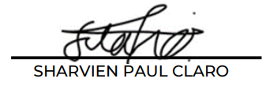

E D U C A T I O N

ACLC College of Meycauayan

2016-2018

SECONDARY SCHOOL

Bulacan State University

2019-2023 (Anticipated Graduation)

BACHELOR OF SCIENCE IN INFORMATION TECHNOLOGY

P E R S O N A L

I N F O R M A T I O N

**Age:** 22 years’ old

**Birthday:** May 11, 2000

**Citizenship:** Filipino

**Civil** **Status**: Single

**Gender:** Male

**Languages (Speak):** Tagalog, and English

**Mother’s Name:** Julie Ann Gabutina

**Father’s Name:** Frederick Gabutina

I Hereby to certificate that the above information is true and correct to the best of my knowledge and ability

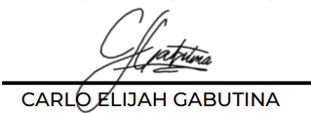

**CARLO ELIJAH**

**R. GABUTINA**

T R A I N I N G S / S E M I N A R S

A T T E N D E D :

* StackLeague University Series: Bulacan State University Edition (2022)

E X P E R I E N C E

* Work Immersion
* Assistant to the supervisor in ACLC

**Q U A L I T Y A S S U R A N C E T E S T E R**

C O N T A C T

 09092065191

 carloelijah.gabutina.r@bulsu.edu.ph

 Lias, Marilao, Bulacan

S K I L L S

* Time Management
* Resourcefulness
* Flexibility
* Planning
* Microsoft Office (Excel, Word, PowerPoint)
* Basic Programming (C++ & Python)



**ANGELO D. MAURICIO**



**Q U A L I T Y A S S U R A N C E T E S T E R**

P E R S O N A L

I N F O R M A T I O N

**Age:** 22 years’ old

**Birthday:** January 12, 2001

**Citizenship:** Filipino

**Civil** **Status**: Single

**Gender:** Male

**Languages (Speak):** Tagalog, and English

**Mother’s Name:** Salvacion D. Mauricio

**Father’s Name:** Emeric R. Mauricio

E D U C A T I O N

ACLC College of Meycauayan

2017-2019

SECONDARY SCHOOL

Bulacan State University

2019-2023 (Anticipated Graduation)

BACHELOR OF SCIENCE IN INFORMATION TECHNOLOGY

C O N T A C T

 09756759366

 angelo.mauricio.d@bulsu.edu.ph

 Iba, Meycauayan, Bulacan

S K I L L S

* Time Management
* Flexibility
* Planning
* Microsoft Office (Excel, Word, PowerPoint)
* Basic Programming (C++ & Java)

T R A I N I N G S / S E M I N A R S

A T T E N D E D :

* StackLeague University Series: Bulacan State University Edition (2022)
* IT Week Seminar

E X P E R I E N C E

* Work Immersion
* Assistant to the supervisor in ACLC

I Hereby to certificate that the above information is true and correct to the best of my knowledge and ability

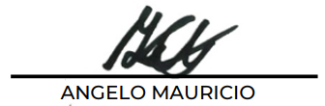

**JHAN MAR D.**

**MERGAL**



C O N T A C T

 09152070169

 jhanmar.mergal.d@bulsu.edu.ph

 Bagbaguin, Meycauayan, Bulacan

S K I L L S

* Time Management
* Resourcefulness
* Flexibility
* Planning
* Microsoft Office (Excel, Word, PowerPoint)
* Basic Programming (C++ & Java)
* Web Development (PHP, CSS, WordPress)

T R A I N I N G S / S E M I N A R S

A T T E N D E D :

* StackLeague University Series: Bulacan State University Edition (2022)

E X P E R I E N C E

* Special Program of the Employment of Students (SPES) – 2018
* Team Leadership at Versaman Chemical Solutions
* Freelance Full Stack Developer

I Hereby to certificate that the above information is true and correct to the best of my knowledge and ability

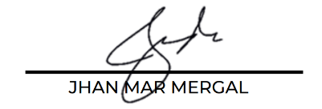

E D U C A T I O N

Meycauayan National High School

2013-2019

SECONDARY SCHOOL

Bulacan State University

2019-2023 (Anticipated Graduation)

BACHELOR OF SCIENCE IN INFORMATION TECHNOLOGY

**F U L L S T A C K D E V E L O P E R &**

**S Y S T E M A D M I N I S T R A T O R**

P E R S O N A L

I N F O R M A T I O N

**Age:** 21 years’ old

**Birthday:** March 22, 2001

**Citizenship:** Filipino

**Civil** **Status**: Single

**Gender:** Male

**Languages (Speak):** Tagalog, and English

**Mother’s Name:** Janette D. Mergal

**Father’s Name:** Marvin N. Mergal

**KRISTINE JOY S. NACIONAL**



**T E A M L E A D E R &**

**F U L L S T A C K D E V E L O P E R**

S K I L L S

* Ability to work under pressure
* Good problem solver
* Good decision-maker
* Resourcefulness
* Flexibility
* Microsoft Office (Excel, Word, PowerPoint)
* Basic Programming (C++ & Java)
* Web Development (PHP, CSS)

C O N T A C T

 09361685997

 kristinejoy.nacional.s@bulsu.edu.ph

 Bignay, Valenzuela City

E X P E R I E N C E

* Special Program of the Employment of Students (SPES) – 2015
* Work Immersion

T R A I N I N G S / S E M I N A R S

A T T E N D E D :

* StackLeague University Series: Bulacan State University Edition (2022)

I Hereby to certificate that the above information is true and correct to the best of my knowledge and ability



E D U C A T I O N

ACLC College of Meycauayan

2017-2019

SECONDARY SCHOOL

Bulacan State University

2019-2023 (Anticipated Graduation)

BACHELOR OF SCIENCE IN INFORMATION TECHNOLOGY

P E R S O N A L

I N F O R M A T I O N

**Age:** 22 years’ old

**Birthday:** June 03, 2000

**Citizenship:** Filipino

**Civil** **Status**: Single

**Gender:** Female

**Languages (Speak):** Tagalog, and English

**Mother’s Name:** Elena Marie S. Nacional

**Father’s Name:** Francy P. Nacional

C O N T A C T

 09612947453

 rovikeith.navarro.y@bulsu.edu.ph

 Macabebe, Pampanga

S K I L L S

* Time Management
* Multitasking
* Resourcefulness
* Flexibility
* Planning
* Basic Programming (C++, Java, JavaScript, & Python)
* Web Development (PHP, CSS, Bootstrap)

T R A I N I N G S / S E M I N A R S

A T T E N D E D :

* IT week seminars
* StackLeague University Series: Bulacan State University Edition (2022)
* Research seminar in Pampanga Colleges

E X P E R I E N C E

* Work Immersion
* Assistance to the Administrator in STI

P E R S O N A L

I N F O R M A T I O N

**Age:** 21 years’ old

**Birthday:** January 21, 2001

**Citizenship:** Filipino

**Civil** **Status**: Single

**Gender:** Male

**Languages (Speak):** Tagalog, and English

**Mother’s Name:** Cristina Y. Navarro

**Father’s Name:** Robert B. Navarro

E D U C A T I O N

Pampanga Colleges

2017-2019

SECONDARY SCHOOL

Bulacan State University

2019-2023 (Anticipated Graduation)

BACHELOR OF SCIENCE IN INFORMATION TECHNOLOGY

I Hereby to certificate that the above information is true and correct to the best of my knowledge and ability

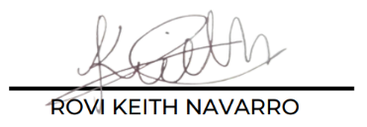

**F R O N T – E N D D E V E L O P E R**

**ROVI KEITH Y.**

**NAVARRO**



E D U C A T I O N

La Consolacion University

2017-2019

SECONDARY SCHOOL

Bulacan State University

2019-2023 (Anticipated Graduation)

BACHELOR OF SCIENCE IN INFORMATION TECHNOLOGY

I Hereby to certificate that the above information is true and correct to the best of my knowledge and ability

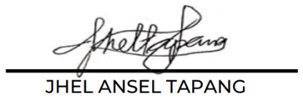

**D O C U M E N T E R**

**JHEL ANSEL D.**

**TAPANG**

C O N T A C T

 09125216212

 [jhelansel.tapang.d@bulsu.edu.ph](mailto:jhelansel.tapang.d@bulsu.edu.ph)

 Lugam Malolos, Bulacan



P E R S O N A L

I N F O R M A T I O N

**Age:** 21 years’ old

**Birthday:** August 14, 2001

**Citizenship:** Filipino

**Civil** **Status**: Single

**Gender:** Male

**Languages (Speak):** Tagalog, and English

**Mother’s Name:** Amelia D. Tapang

**Father’s Name:** Jesus V. Tapang

S K I L L S

* Time Management
* Flexibility
* Planning
* Microsoft Office (Excel, Word, PowerPoint)
* Basic Programming (C++ & Java)

T R A I N I N G S / S E M I N A R S

A T T E N D E D :

* StackLeague University Series: Bulacan State University Edition (2022)
* CICT Week
* IT Seminars

E X P E R I E N C E

* Work Immersion

 Republic of the Philippines

**BULACAN STATE UNIVERSITY**

OFFICE OF THE UNIVERSITY LIBRARY

Guinhawa, City of Malolos, Bulacan 3000

Trunk line: (o44) 919-7800 loc.1063

email: library@bulsu.edu.ph

**THESIS/DISSERTATION OPEN ACCESS PERMISSION**

I/We, **Claro, Sharvien Paul M., Gabutina, Carlo Elijah R., Mauricio, Angelo D., Mergal, Jhan Mar D., Nacional, Kristine Joy S., Navarro, Rovi Keith Y.,** and **Tapang, Jhel Ansel D.** of the thesis/dissertation entitled **“VIRTUALSHRINE: AN INTERACTIVE MUSEUM WEBSITE FOR CASA REAL SHRINE”** submitted to the **College of Information and Comunications Technology** as partial requirement for the

degree of **Bachelor Of Science in Information Technology** do hereby grant to the University Library a “non- exclusive worldwide, royalty-free license to reproduce, publish and publicly distribute copies of said thesis/dissertation in whatever form subject to the provisions of applicable laws. Specifically, the following rights are hereby granted to the University Library:

1. To upload a copy of this work in BulSU thesis/dissertation database and in any other of its databases available on the public internet;
2. To publish the work of its subsequent journal publications, both in print format and online; and
3. To give open access to above-mentioned work, thus allowing “fair use” as defined in the *Intellectual Property Code of the Philippines*, that**,**I/Webe properly acknowledged and cited as the author of the work.

**KRISTINE JOY S. NACIONAL**

SIGNATURE OVER PRINTED NAME/DATE